Budget Preparation & Maintenance (BPM)
Quick Tips

Table of Contents

To jump directly to a section of interest, press the Ctrl key and click on the content title or page number.

OVERVIEW 3
PURPOSE 3
WHAT IS THE BUDGET PREPARATION & MAINTENANCE SYSTEM? 3
BPM FLOW CHART 3
HOW TO REQUEST ACCESS TO BPM? 4
GENERAL BUDGETING 5
IMPORT 5
SALARY SETTING 6
REPORTS 6
BUDGET ANALYST CONTACT LIST 9

OVERVIEW

PURPOSE
The purpose of this quick tips reference guide is to provide users with responses to a list of frequently asked questions.

WHAT IS THE BUDGET PREPARATION & MAINTENANCE SYSTEM?
The Budget Preparation & Maintenance System was designed for the following:
- To develop and record the detailed July 1st budget for the University.

- Includes position-level budgeting at the account and object code level for itemized employees.

- Develops itemized position budgets based on the salary of the individual who is in the position.

- Serves as one mechanism to adjust the July 1st funding of itemized employee salaries in the Payroll and Human Resource System (PHR).

- Provides, in years that COLA and merit increases are effective July 1st, a mechanism to update the itemized employees’ salaries in PHR for these increases.

BPM FLOW CHART
The chart below details how data is extracted from PHR & KFS and loaded into BPM prior to the start of the working budget. Once BPM opens, the data is updated by the units before BPM closes. Once BPM data is updated and verified, it is then extracted from BPM and used to load PHR & KFS with updated data.
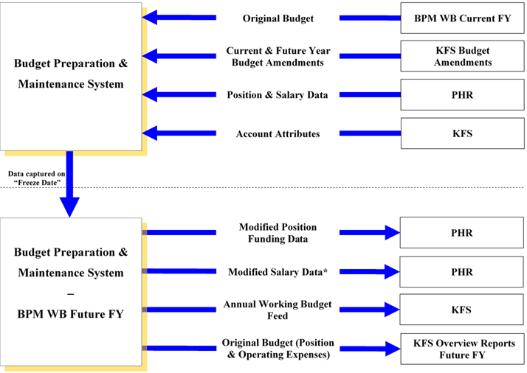

HOW TO REQUEST ACCESS TO BPM?
All users must request access to the Budget Preparation and Maintenance System by completing the following steps:
1. Email College Business Officer (CBO) / Division Business Office (DBO) asking approval to submit an access request for BPM.
2. Once approval has been received; the user should forward CBO/DBO approval along with the following information to your division’s assigned Budget Analyst. (Refer to end of guide for Budget Analyst contact list.)
- Name
- UID
- Email
- Division
- Indicate type of Access: Update & Inquiry or Inquiry Only
- Indicate if you need Department Access (include dept #), Sub-Department Access (include sub-department #) or Account Access (include account #).

GENERAL BUDGETING
- Budgets for most accounts are required to balance to zero (revenues = expenses + transfers). The exception to this account balancing rule is auxiliary accounts that begin with a 3 must balance to zero at the department level.

- BPM FY21 Original Budget is FY20 Proposed Budget. FY21 Revised Budget is the FY20 Original Budget + Current Year Budget Amendments. Beginning FY21, Proposed Budget is FY20 Original Budget + Future Year Budget Amendments.

- Typical revenue object codes beginning with ‘0’ should be entered as negative and typical expense budgets should be entered as positive. Transfers In (99xx) should be entered as negative, Transfers Out should be entered as positive. The transfer object codes in the proposed budget column have been set to zero in BPM at the opening of the working budget cycle.

- Operating expense budgets can be allocated based on prior year actuals by clicking the ‘Allocate’ button. These allocated budgets can be edited as necessary.

- Overall BPM FTE by division cannot be increased or decreased without prior written approval of the University Budget Office.

IMPORT
- BPM has an Import option to upload and process a spreadsheet (one-sided or two-sided entries allowed). The value of the spreadsheet is that it has a description column which provides a permanent record and audit trail of “why” the budget was adjusted. File name must be 25 characters or less and tab at the bottom of the template should not be updated.

- The Manual Entry and Transfer Object Codes options are similar to the Import option; however, the entries are processed one line at a time and must be balanced.

For further explanation on Import Excel Worksheets, please refer to page 18 in the FY 2021 BPM Manual.

SALARY SETTING
- Position-level budgeting by KFS account and object code (aka subcode) for itemized employees (salaries & budget for OCs 1011-1016; budget for OCs 1018 & 1020).

- When setting salaries or budgets on a position that is funded by accounts that cross departments or divisions, users MUST coordinate with the other dept/division BEFORE making any changes that impact the accounts of the other dept/division.

- Itemized salary setting screen is split into two sides. The left side of the screen is for salary changes from the PHR freeze in early April through June 30th. The right side of the screen is for salary changes effective July 1. *Note in years with a mid-year COLA (usually January), COLA is added to current and future year state-supported operating position budgets via a Position Budget Amendment.

For further explanation on Salary Setting, please refer to pages 8 and 31 in the FY 2021 BPM Manual.

REPORTS
- Due to the transition of BPM to a virtual workspace, reports cannot connect directly to adobe acrobat on user machines. The HTML format option should be selected for immediate viewing as a web page. The best format for running pivot tables would be to save the report in the csv format.

Most commonly used Reports:
  - Budget Summary
    - Provides a high-level summary of Proposed Budget, BPM FTE and PHR FTE for the organization selected in ‘Main Category’. Potential Use: serves as an ‘at-a-glance’ of overall proposed budget reference for internal budget discussions.

  - Working Budget Changes Summary
    - Summarizes revised and proposed budget, including total dollar, percent changes and BPM FTE. Potential Use: reconcile proposed budget entered into BPM Working Budget to University Budget Office (or college’s) Budget Tracking Sheet. Also used to research reconciliation differences between the proposed budget and the University Budget Office (or college’s) Budget Tracking Sheet.

  - Working Budget Changes Detail
    - Provides a break-out of summarized revised and proposed budget, including total dollar, percent changes and BPM FTE. Potential Use: Research reconciliation differences between the proposed budget and the University Budget Office (or college’s) Budget Tracking Sheet.

  - Subcode Summary
    - Summarizes revised and proposed budget dollars by object code with the percentage and dollar change. Also presents FTE for the proposed budget. Potential Use: Use to compute turnover and compare to budget guidelines. Confirm expected object code changes are accurate and research reconciliation differences.

  - Itemized Position Details
Provides revised and proposed budget details by account then object code, position number, and title code along with BPM FTE, dollar and percentage change. Potential Use: Confirm budgets have been updated for each position and assess the reasonableness of the budgets.

  - Detail Budget (in csv format)
    - Provides details of budget by account, object code, itemized positions, non-itemized positions and operating (non-salary and wages) budget. Potential Use: Research details of summarized budget. For future reference purposes, print or save an electronic version when the working budget is finalized.

  - Salary Variance by Position
    - Compares position-level proposed budget to proposed salary and BPM FTE to PHR FTE. Potential Use: Research salary to budget comparison variances, and assess reasonableness of budget.

  - Audit Trail Report
    - Details changes made to the working budget. Potential Use: Research adjustments made to the working budget.

  - Salary Certification Summary
    - Provides proposed salary details (COLA, merit, etc.) in the organizational level selected in ‘Main Category.’ If the employee’s funding spans multiple organizations, the report only shows the portion of the salary within the organization selected. The first four summarize by employee and then provide the details for the accounts within the organization. The last report “By Account” is ordered by the accounts within the organization and then by the employees within that account. Potential Use: Verify proposed salaries have been set for employees appropriately; i.e., Total salary is equal to base salary.

  - Salary Adjustments
    - Provides changes to salaries made by users to total proposed salary (all accounts paid on) for all persons who have all or a portion of their salary within the organization selected in ‘Main Category. Potential Use: Identify persons for whom salary changes were made and verify salary changes inputted are accurate.

For further explanation on the BPM Reports Menu, please refer to page 80 in the FY 2021 BPM Manual.

BUDGET ANALYST CONTACT LIST
