BUDGET PREPARATION & MAINTENANCE SYSTEM USER MANUAL
FY 2021 WORKING BUDGET

University Budget Office
UNIVERSITY OF MARYLAND

UNIVERSITY BUDGET OFFICE
3115 CHESAPEAKE BUILDING

Danny Catalano
University Budget Office
Telephone: 301-405-7827
Email: dannyc@umd.edu

Ben Choy
University Budget Office
Telephone: 301-405-5635
Email: bcoy@umd.edu

Erica Farrish
University Budget Office
Telephone: 301-405-9816
Email: efarrish@umd.edu

Patrice Sheffield Jackson
University Budget Office
Telephone: 301-405-2747
Email: psheffie@umd.edu

Johnny Li
University Budget Office
Telephone: 301-405-3020
Email: johnnyli@umd.edu

Joe Miller
University Budget Office
Telephone: 301-405-1916
Email: jmille58@umd.edu

Many colleges and divisions have designated ‘super users’ whose role is to assist others within their college or division with working budget questions, including those related to BPM. Please contact your college or divisional business officer for your designated ‘super user’.

BUDGET PREPARATION & MAINTENANCE SYSTEM (BPM)

TRAINING MANUAL CONTENTS
TABLE OF CONTENTS
TRAINING MANUAL CONTENTS 3
OVERVIEW 6
WHAT IS THE BPM WORKING BUDGET SYSTEM 6
OVERVIEW OF THE BUDGET SYSTEM 7
POSITION BUDGETING AND SALARY SETTING IN BPM 8
FY 2021 WORKING BUDGET SCHEDULE 9
BPM TECHNICAL REQUIREMENTS 11
BPM LOG-ON & NAVIGATION 12
MENU OPTIONS SCREEN 16
IMPORT 17
IMPORT EXCEL WORKSHEETS 17
PROCESSING AN UPLOADED FILE 21
MANUAL ENTRY 24
PROCESSING A TWO-SIDED MANUAL ENTRY 24
TRANSFER OBJECT CODES 26
PROCESS TRANSFER OBJECT CODES (9xxx) ONLY 26
ACCOUNT SELECT SCREEN 28
ACCOUNT BUDGET SUMMARY SCREEN 29
SET SALARY & POSITION BUDGETS 30
SET BY ACCOUNT - SINGLE FUNDED - NON-EXEMPT 30
SET BY ACCOUNT—SINGLE FUNDED - EXEMPT 33
SET BY ACCOUNT—SINGLE FUNDED - FACULTY 35
REALLOCATE SALARY TO MULTIPLE FUNDING SOURCES 37
REALLOCATE BUDGET DETAILS 39
SET SALARY BY EMPLOYEE—MULTIPLE FUNDING SOURCES 40
SET WITH NON- 44
SET SALARY USING SALARY SPREADSHEET 52
EMPLOYEE TERMINATING PRIOR TO JULY 1 56
VACANT BUDGETED POSITIONS 58
CREATE/DELETE PENDING BUDGET POSITIONS 58
LINK EMPLOYEE RECORD TO VACANT BUDGETED POSITION 59
UPDATE TITLE CODE/SUBCODE, BUDGET, NAME, AND COMMENTS 61
SETTING BUDGETS FOR POOLED POSITIONS 62
LECTURERS, FACULTY CONTRACTUAL, CONTINGENT II, AND GRADUATE ASSISTANTS 62
OTHER SALARY & WAGES BUDGET ADJUSTMENTS 67
OPERATING EXPENSE BUDGET ADJUSTMENTS 69
SETTING BUDGETS—EDUCATIONAL AND GENERAL (E&G) – DESIGNATED ACCOUNTS (BEGIN WITH 294 OR 295) 74
BPM REPORTS MENU 79
REPORT DESCRIPTIONS 80
BUDGET SUMMARY 84
BUDGET SUMMARY DETAILS 85
BUDGET SUMMARY DETAILS BY ACCOUNT 86
WORKING BUDGET CHANGES SUMMARY 87
WORKING BUDGET CHANGES DETAIL 88
SUBCODE SUMMARY 89
SUBCODE SUMMARY (CONTINUED) 90
ITEMIZED POSITION DETAILS 91
TITLE CODE SUMMARY 92
POSITION VACANCY 93
DETAIL BUDGET 94
BPM FTE > 1 95
SALARY VARIANCE SUMMARY 96
SALARY VARIANCE SUMMARY DETAILS 97
SALARY VARIANCE BY POSITION 98
AUDIT TRAIL 99
TWO-SIDED AUDIT TRAIL 100
SALARY CERTIFICATION SUMMARY - ALL EMPLOYEES 101
SALARY CERTIFICATION BY ACCOUNT - ALL EMPLOYEES 102
SALARY SUMMARY BY EMPLOYEE - ALL - % INCR > 15.00 103
SALARY DETAILS BY EMPLOYEE - ALL ACCOUNTS 104
SALARY DETAILS BY EMPLOYEE - ALL ACCOUNTS 105
INCREMENTS ABOVE BASE DETAILS BY EMPLOYEE - ALL ACCOUNTS 106
SALARY ADJUSTMENTS 107
ADJUSTMENTS TO CURRENT BASE SALARY - ALL ACCOUNTS–FACULTY 108
ADJUSTMENTS TO CURRENT BASE SALARY - ALL ACCOUNTS–EXEMPT 109
ADJUSTMENTS TO CURRENT BASE SALARY - ALL ACCOUNTS–NON-EXEMPT 110
SALARY NOT SET BY ACCOUNT - ALL POSITIONS & 111
SALARY NOT SET BY EMPLOYEE - ALL POSITIONS 111
APPENDIX 112
SALARY SETTING SCREEN FIELD DEFINITIONS 112
SALARY SETTING SCREEN DEFINITIONS 113

OVERVIEW

WHAT IS THE BPM WORKING BUDGET SYSTEM

• Designed to develop and record the detailed July 1st budget for the University;

• Includes position-level budgeting at the account and object code level for itemized employees;

• Develops itemized position budgets based on the salary of the individual who is in the position;

• Serves as one mechanism to adjust the July 1st funding of itemized employee salaries in the Payroll and Human Resource System (PHR); and

• Provides, in years that COLA and merit increases are effective July 1st, a mechanism to update the itemized employees’ salaries in PHR for these increases.

OVERVIEW OF THE BUDGET SYSTEM

Budget Preparation &
Maintenance System

Data captured on “Freeze Date”

Account Attributes
Position & Salary Data
Original Budget
Modified Position Funding Data
Original Budget (Position & Operating Expenses)
Current & Future Year Budget Amendments
Budget Preparation &
Maintenance System
–
BPM WB Future FY

PHR
PHR
KFS
KFS Overview Reports Future FY
KFS
BPM WB Current FY
PHR
KFS Budget Amendments
Annual Working Budget Feed
Modified Salary Data*

*Modified Salary Data will only be sent to PHR in years where there is a July merit.

OVERVIEW

POSITION BUDGETING AND SALARY SETTING IN BPM

Set Salary Amount:

When COLA/Merit are not applicable:
- For all regular status employees, COLA and merit will be blocked from edit on the set salary screens.
- The “Salary Set?” flag will be set at “No” when BPM is opened to users. Users will need to set salaries for itemized employees (Object 1011 to 1016) who have other types of salary adjustments or funding changes.
Default Is Make Position Budget at the July 1, 20xx Salary Amount:

- The “position budget” will equal “salary” on the “set salary” screen if “make new budget amount” is checked on budgetable accounts (likewise for the “reallocate salary” screen and the “salary spreadsheets”).
Payroll Conversion:
When COLA and Merit are not applicable:
- Only the funding changes effective July 1st for employees will be sent from BPM WB to PHR.
- Users will need to input all other July 1st salary adjustments in PHR manually.

REMINDER: When setting salaries or budgets on a position that is funded by accounts that cross departments or colleges, users MUST coordinate with the other department/college BEFORE making any changes that impact the accounts of the other department/college.

FY 2021 WORKING BUDGET SCHEDULE

DAY | DATE | TIME | WORKING BUDGET PHASE
Monday | February 17 |  | Divisions will receive security access instructions for their FY21 Working Budget BPM users from their Budget Analyst.
Friday | February 28 | 5:00 PM | Divisions return to Budget Office user access sheets.
Monday | March 2 | 8:00 AM | Budget 101 training will be made available to the campus via pre-recorded video on the Budget Office and Finance webpages.
Friday | March 6 | 12:00 Noon | Last day to request new accounts or account modifications in order to be processed for the freeze data for Working Budget Phase I.
Friday | March 6 | 12:00 Noon | Last day to process KFS Future Year Only Budget Amendments prior to freeze of Live Budget data for BPM Working Budget (due by Noon). After this date, future year budget adjustments should be made in BPM.
Monday-Tuesday | March 16-17 |  | Spring Break
Friday | March 27 | 12:00 Noon | Open BPM Phase I. Budget System open to Divisions and Colleges to begin budgeting OPERATING activity ONLY.
Tuesday | April 7 | 5:00 PM | Last day for approved updates to PHR prior to freeze of data for BPM Working Budget. Appointments that expire on or before 6/30/20 will not be included in BPM WB. Future-dated appointment changes--effective on or before June 30 for 12-month employees, and effective on or before Pay Period 04 (beginning August 2) for academic year faculty--will be included in the FY 21 Working Budget System.
Friday | April 10 | 5:00 PM | Close BPM Phase I. Remove access for Divisions and Colleges.
Tuesday | April 15 |  | Budget Office staff to continue training campus users on navigation and functionality of the Budget System.
Wednesday | April 22 |  | Budget Office staff to continue training campus users on navigation and functionality of the Budget System.
Thursday | April 23 | 12:00 Noon | BPM Phase II Open. Budget System open to Divisions and Colleges. Budget Office send out tracking control sheets to Colleges.
Monday | May 4 | 12:00 Noon | Budget System open to Departmental users.
Wednesday | May 13 | 5:00 PM | Budget System closed to Departmental users.
Tuesday | May 26 | 5:00 PM | BPM Phase II Close. Budget System closed to Divisions and Colleges. Tracking control sheets due to Budget Operations Office.
Tuesday | June 16 |  | Payroll distributes payroll conversion reports to units for verification and correction in PHR.
Monday | June 29 | 11:00 PM | Last day for units to make payroll corrections in PHR for July1 salaries and funding/account.
 | August |  | BFA loads working budget into KFS.

BPM TECHNICAL REQUIREMENTS

Below is a list of technical requirements that will help to optimize BPM performance. Attempts to use unsupported browsers, or a lack of enabled JavaScript, will result in an error message containing instructions for installing minimally acceptable software. Please contact your System Administrator if you need assistance updating your software or settings.
- Use of the latest version of Firefox is strongly recommended. Other allowed browsers include the latest versions of Internet Explorer.
- Do not use the browser’s “Back” or “Forward” buttons to navigate through BPM, as this could result in error messages or incorrect data being displayed. Instead, use linked buttons on BPM screens and the “Back” button located at the bottom of the BPM screen.
- BPM provides reports in the following formats: Portable Document Format (PDF), MS Excel, Rich Text Format (RTF), Hyper-Text Mark-up Language (HTML), and Comma-Separated Values Format (CSV). To view reports, you will need to select view using HTML or download using local directory.
- Log out of BPM by clicking on BPM’s “Exit” button, located at the bottom of the screen. Otherwise, BPM will not properly log you out of the system.
Please refer to the latest version of the FAQ related to BPM login issues that may arise. The FAQ can be found on the BFA site and the Finance Site on the links below.

BFA Link : The BPM Citrix Virtual Workspace Login FAQ can be found under BFA Announcements by following the path below:
ARES Home > Budget & Fiscal Analysis > BFA Announcements > BPM - Citrix Virtual WorkSpace-FAQ

Finance Site Link: The BPM Citrix Virtual Workspace Login FAQ can be found on the Finance site by following the path below:
Home > Budget > Budget Planning Resources > BPM > Login FAQs - Revised 02-21-2020

BPM LOG-ON & NAVIGATION

BPM System Citrix Workspace Connection: The Budget Preparation and Maintenance System (BPM) implemented the Citrix Workspace connection on January 27, 2020. This additional login layer is necessary to properly protect the BPM System from potential security threats. Both layers of login will be using the University of Maryland’s Central Administration Service (CAS), which requires multi-factor authentication (MFA).
To accommodate this change, the BPM links on the BFA website (http://otcads.umd.edu/bfa/) and Finance website (https://finance.umd.edu/) will be updated to direct through the new login portal. Follow the below steps for the login process:

The suggested internet browser for BPM is Mozilla Firefox
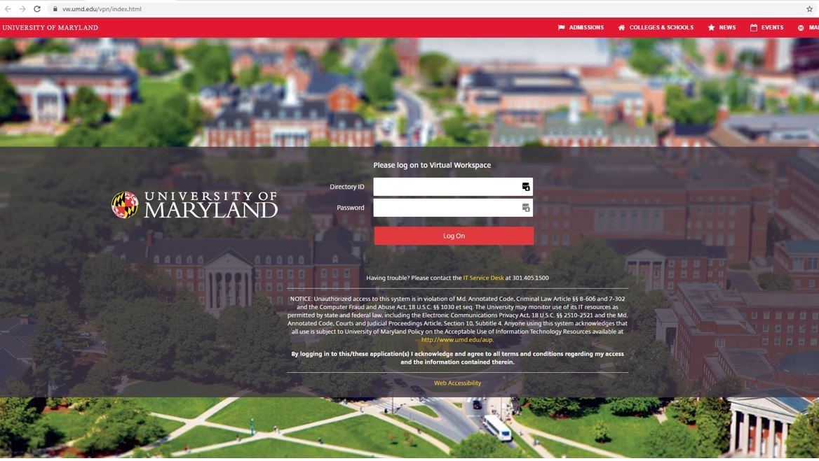
- Go to: 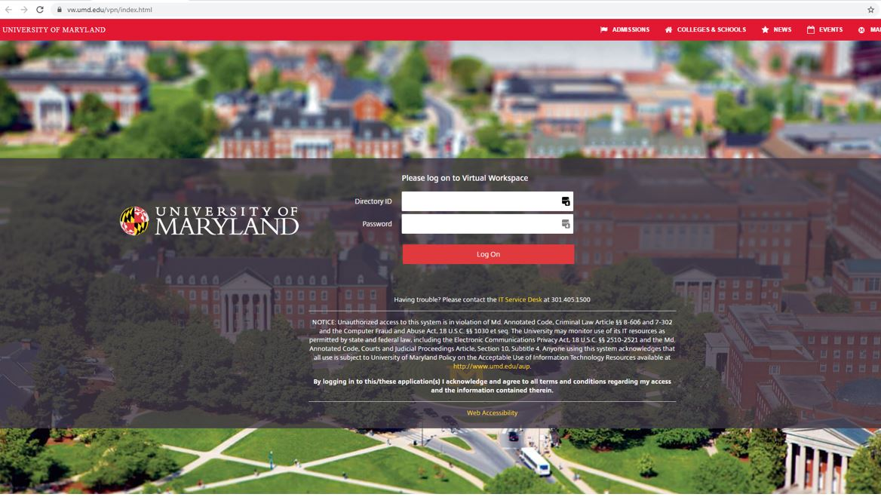https://vw.umd.edu/ (same link on the BFA and Finance websites labeled as ‘BPM System’)

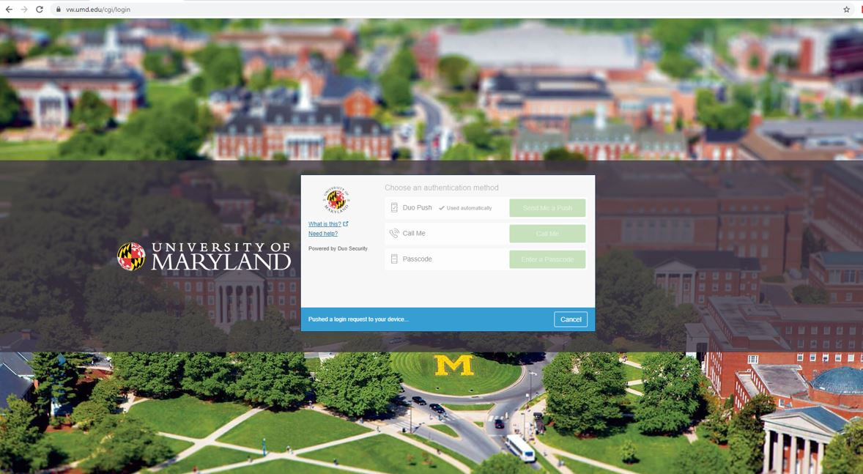
CAS- Central Authentication Service

- Click on ‘Detect Receiver’ (when prompted to open link for the Citrix Receiver, Click ‘Open’)
(If you have not installed the Citrix Receiver before, refer to ‘Note 1’ at the bottom of this document for installation instructions before continuing)
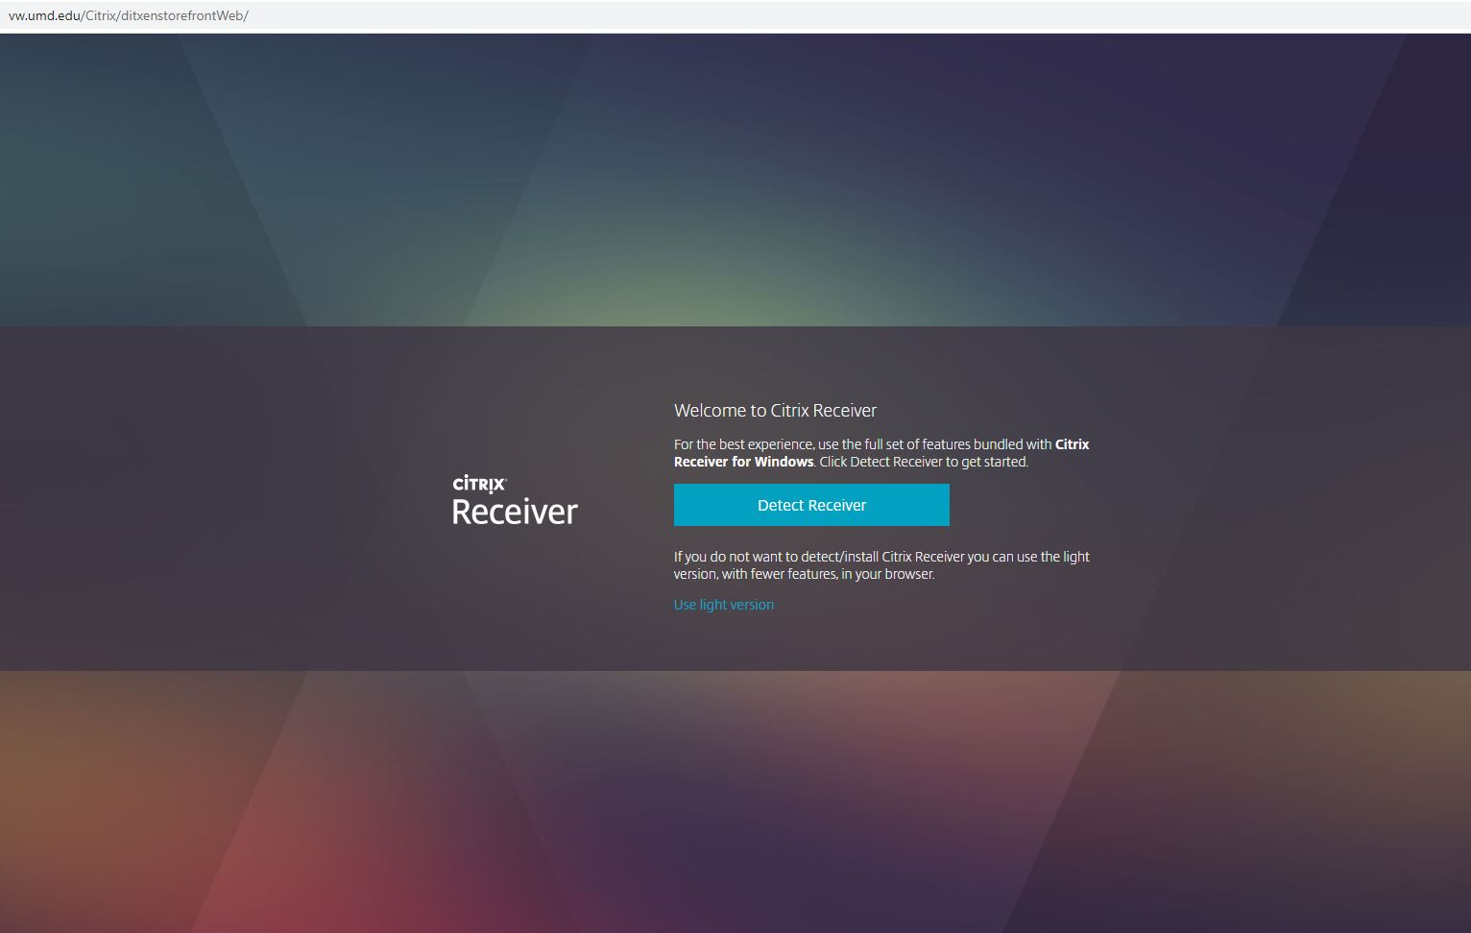
(If you do not get the below ‘Detect Receiver’ message, refer to ‘Note 2’ at the bottom of this document to detect the receiver)

- Click on APPS tile –
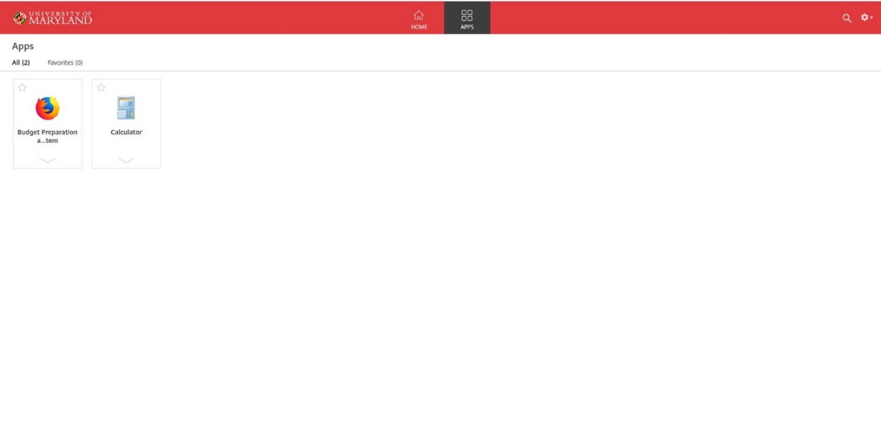

- Click on Budget Preparation and Maintenance System
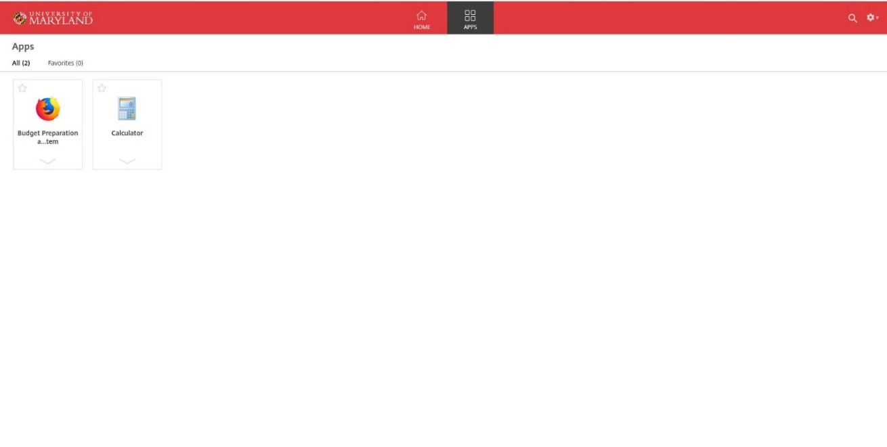

- Enter Directory ID and Password
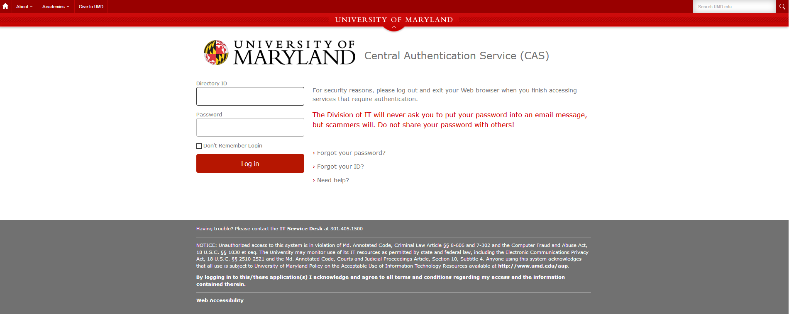

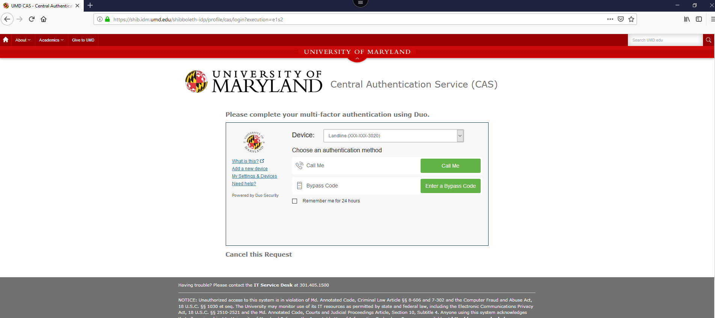
CAS- Central Authentication Service

- After authentication, the user is directed to the BPM Main Menu screen. From the BPM Main Menu Screen:
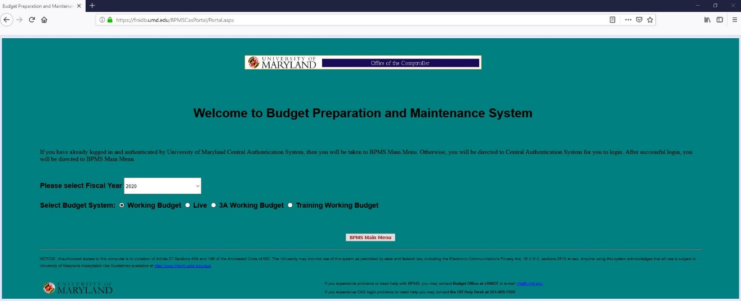

- When finished using BPM, please exit the application by Clicking the ‘Exit’ Button and log off of Citrix by Clicking the ‘Log off’ button located under the gear icon in the upper right-hand corner of Citrix

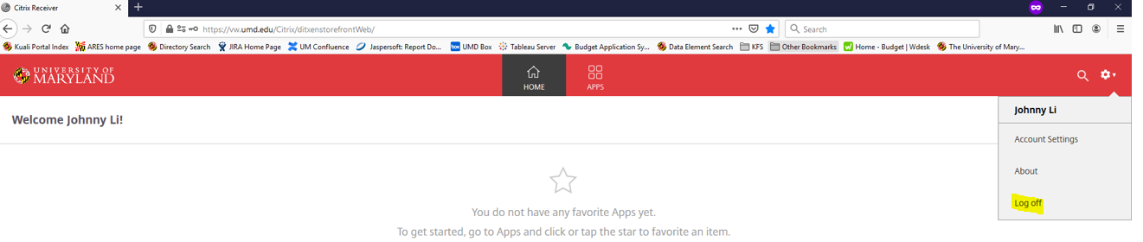

If you have bookmarked the BPM site, you may need to update the link for the new login screen. If you have questions, please feel free to email the Budget Office at BFA@umd.edu or call at (301) 405-5627.

For further information on installing Citrix Receiver please refer to the Multi-Factor Authentication (MFA) - Citrix and CAS Login document which can be found on the Finance and BFA websites.

MENU OPTIONS SCREEN

From the Menu Options, click on:
- Account Select or Account Select/Edit to access the Account Select screen to set salaries, and revenue, operating, and salary budgets,
- Import or Import Excel Worksheets to access the Import Data screen to set load your data file and make changes to the working budget data,
- Manual Entry or Process All Object Codes Manually to access the Manual Data Entry screen to set load your data file and make changes to working budget data,
- Transfer Object Codes or Process Transfer Object Codes (9xxx) Only to access the Manual Data Entry screen to manually enter transfer object codes,
- Report Menu or Reporting Options/Query to view and/or print reports, or
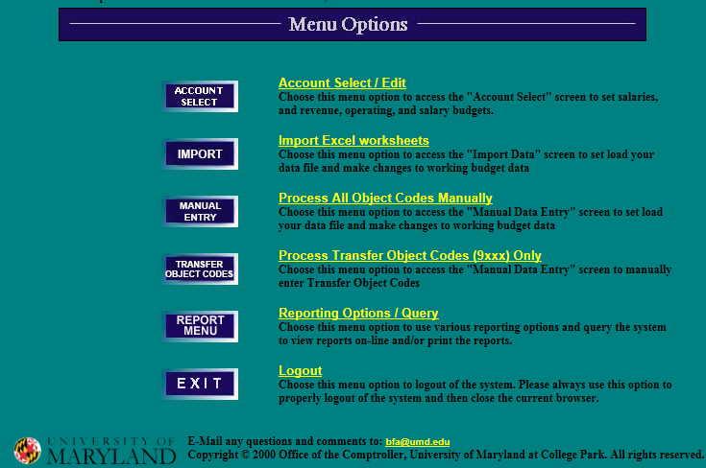
- Exit or Logout to log out of BPM

IMPORT

IMPORT EXCEL WORKSHEETS

From the Menu Options Screen, click on Import or Import Excel Worksheets to access the Uploaded Excel Files Detail screen.

- To import a file, click on Download Template.
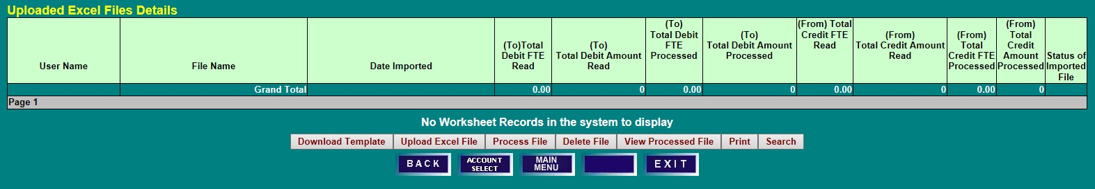
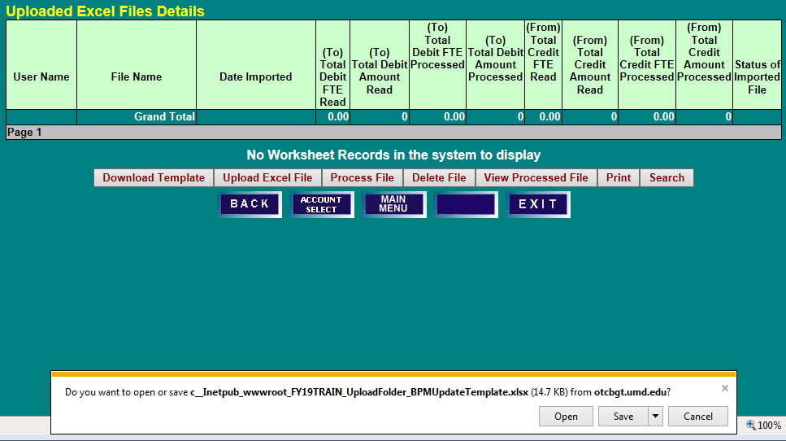
- A message box will appear. Click on Open to access a template.

- Click File and Save As to save a copy of the template on your computer. The saved file name is restricted to 30 characters including the .xlsx and should include your Division acronym and brief description to aid in identification. Each template file name must be unique as BPM will not upload duplicate file names. It should be noted that only this template can be used to import data into BPM. Changes cannot be made to the column headings, and columns cannot be rearranged. Also, the BPM Updates worksheet tab on the bottom of the template cannot be changed because it will prevent the file from uploading properly.
- The template has some built-in edits for each column field to assist in proper data entry. It should be noted that the description field is limited to 70 characters. Negative amounts, commas, or dollar signs ($) are not permitted. Also, position moves to a new account must be done in the Reallocate screen. In addition, use the To and From philosophy when determining how to make entries. The To is where the budget is going, and the From is where it will be taken.

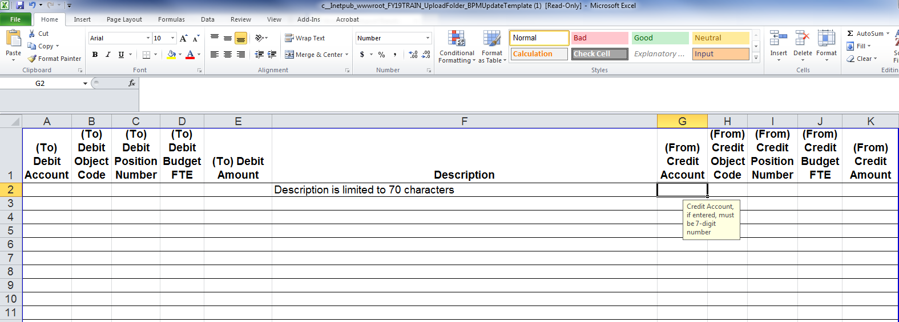

- Complete template with appropriate information.
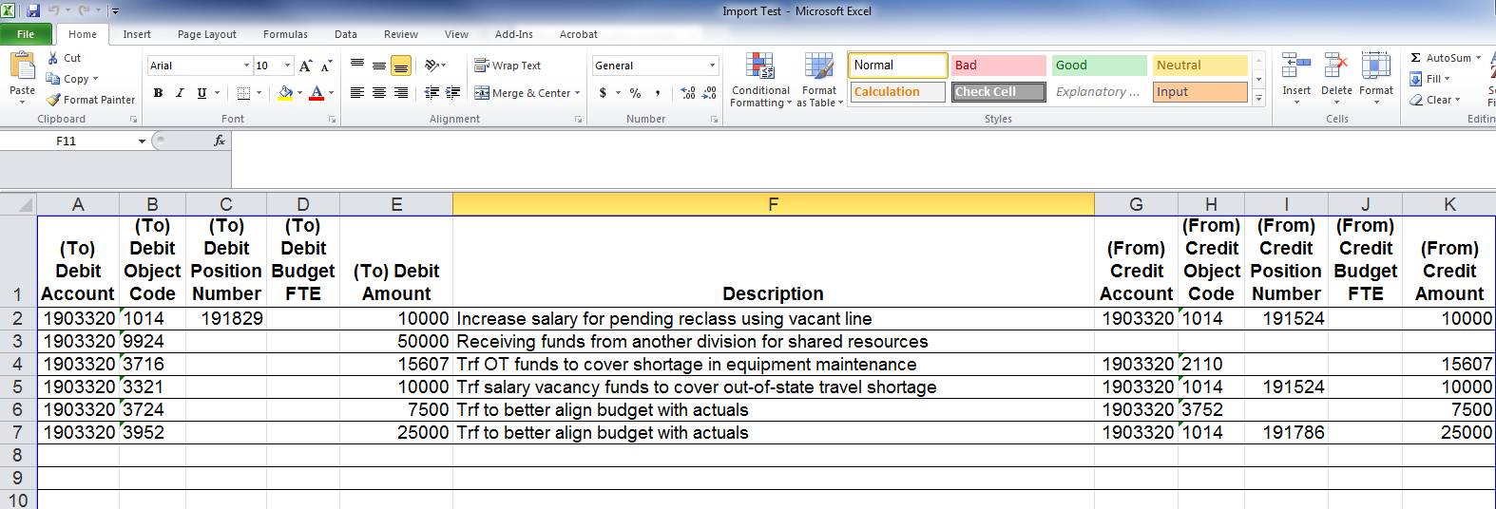

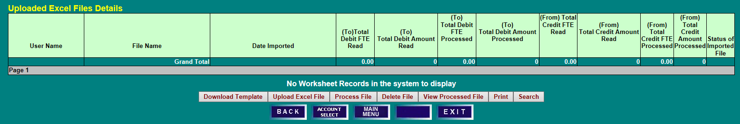
- Return to the Uploaded Excel Files Details screen and click on Upload Excel File

- A Worksheet Upload Bar section will appear. Click on Browse to search for the desired file to upload.
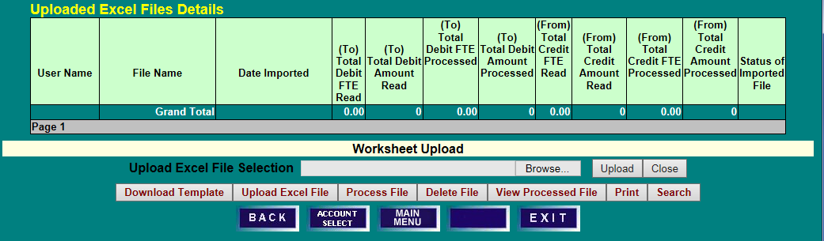

- Choose a file to upload.
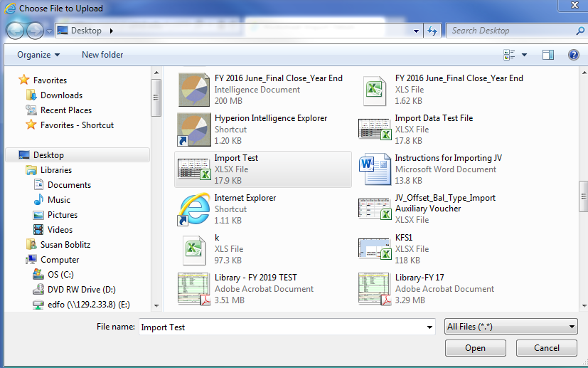

- Return to the Uploaded Excel Files Details screen and click on Upload.
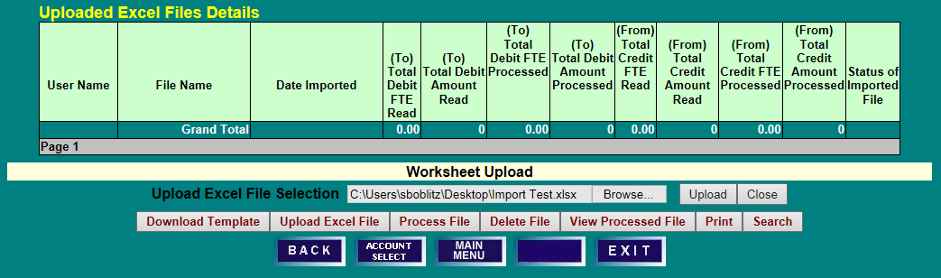

PROCESSING AN UPLOADED FILE

- If the file uploaded successfully, the file will appear on the Uploaded Excel Files Details screen, and the Status of Imported File will be Ready.
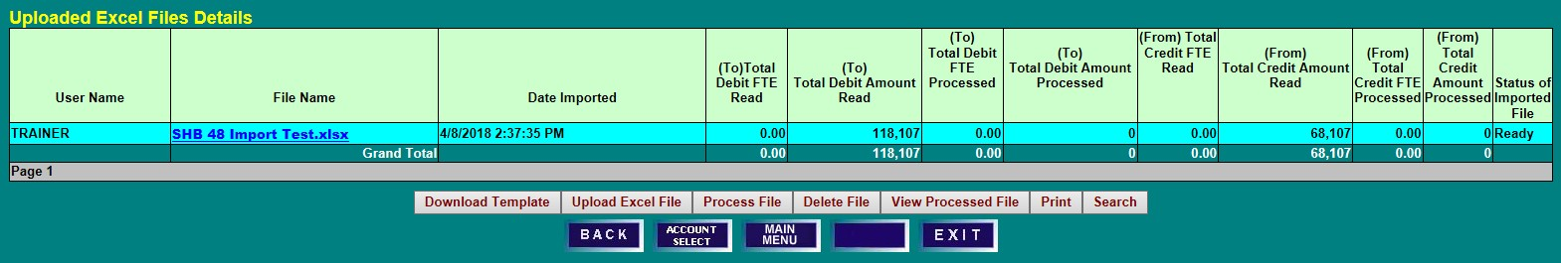
- To select a file to be processed, click on the blue File Name which will highlight the line, and click Process File.

- If the file does not contain any errors, the Status of Imported File will read Processed with the applicable date and time. If there is an error on any of the lines, the Status of Imported File will read Partial with a note that the file could not process all lines with the applicable date and time.
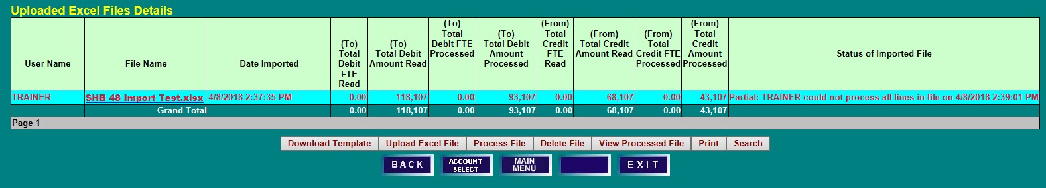
- To view the Processed or Partial file, select the File Name and click View Processed File.

- Each line in the template will be displayed. If the line is correct, Processed will be noted on the Status of Line column.
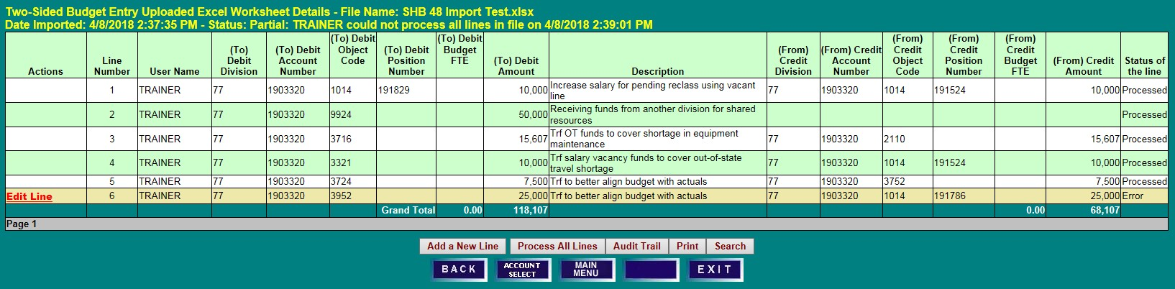
- If the line is incorrect, Edit Line will appear in the Actions column, and Error will appear in the Status of the Line column. Click on Edit Line to open an edit box.

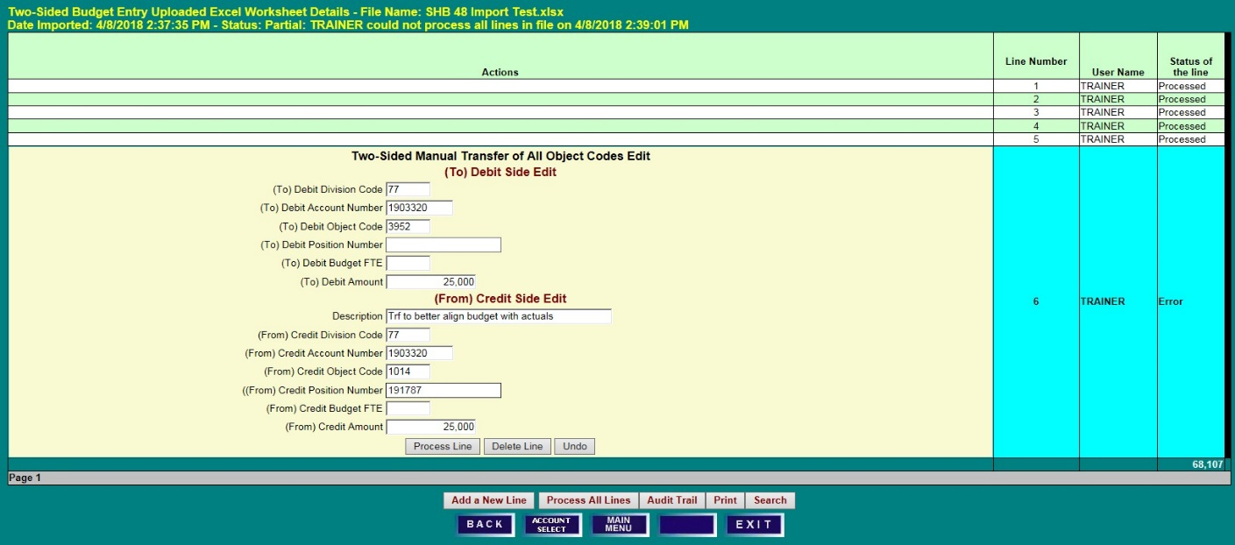
- Review the entry to identify the error and make the necessary correction. Then click Process Line.

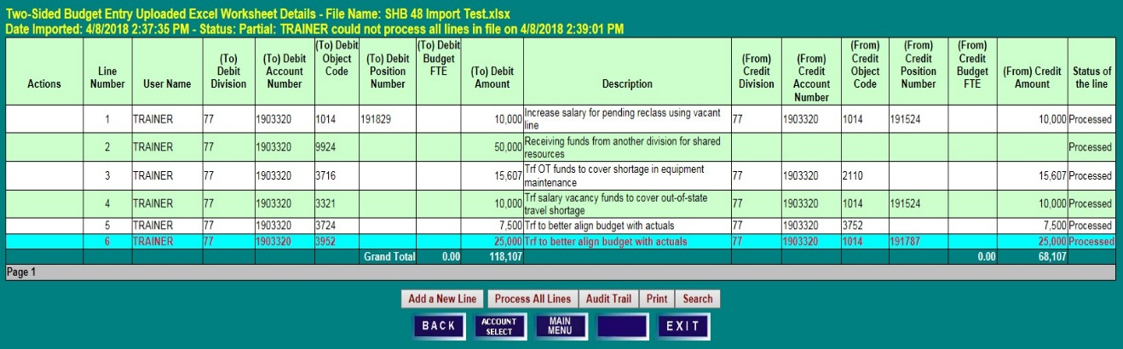
- When properly corrected, the Status of the Line column will read Processed.

- Click Back to return to the Uploaded Excel Files Details screen.
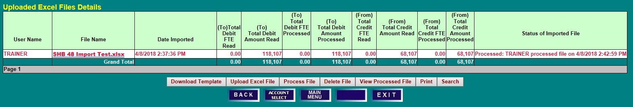
- The Status of Imported File will now display that the file has been Processed.

To view your Imported File entries, access the account via the Account Select option on the Menu
Options screen. Enter the appropriate account number to access the Account Budget Summary screen.

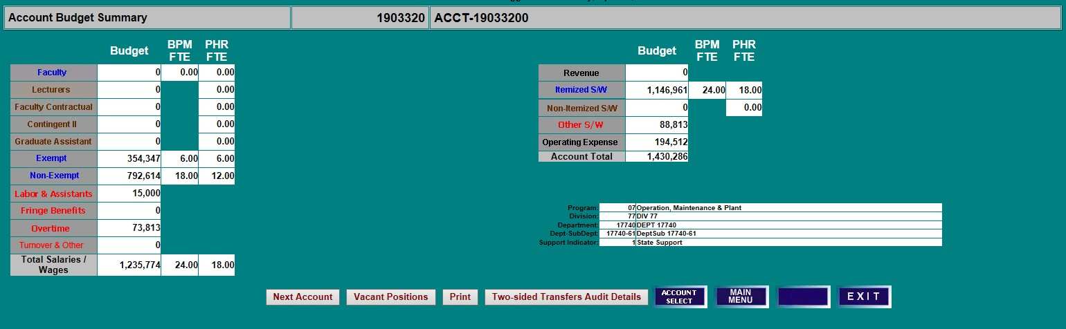
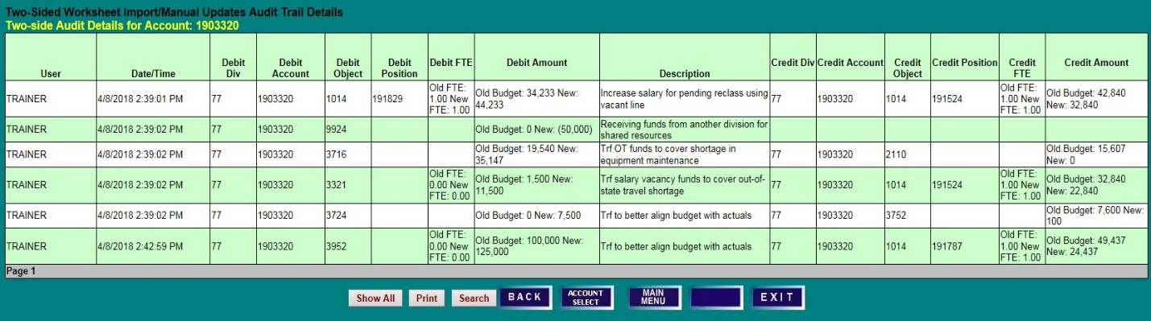
- Click on Two-sided Transfers Audit Details to view the audit trail two-sided entries made to the account.

MANUAL ENTRY

PROCESSING A TWO-SIDED MANUAL ENTRY

From the Menu Options Screen, click on Manual Entry or Process All Object Codes Manually to access the Two-Sided Manual Transfers of All Object Codes Details screen.

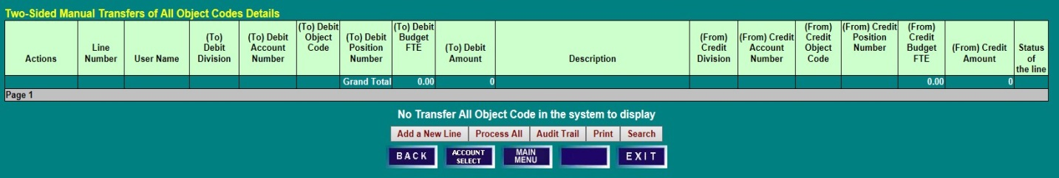
- Click Add a New Line to make a Two-Sided Manual entry. It should be noted that this form does allow for one-sided entries. A blue Edit Line will appear in the Actions column.

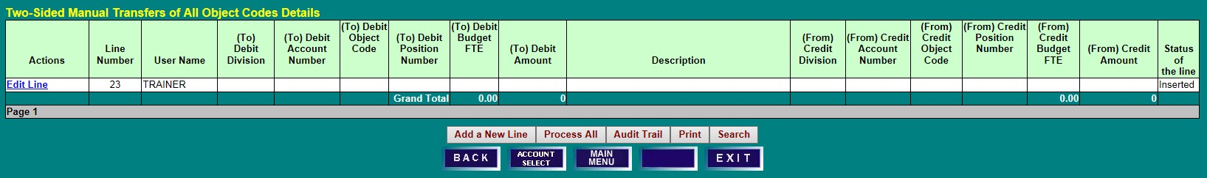
- Click the blue Edit Line to open an edit box, and complete all applicable lines. Use the To and From philosophy when determining how to make entries. The To is where the budget is going, and the From is where it will be taken.

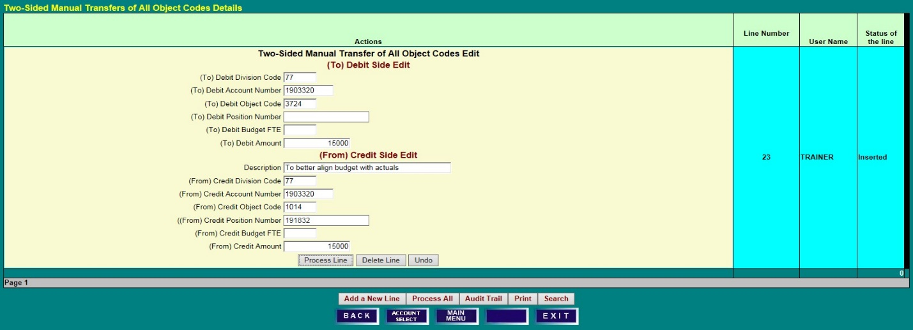
- Upon completion, click Process Line.

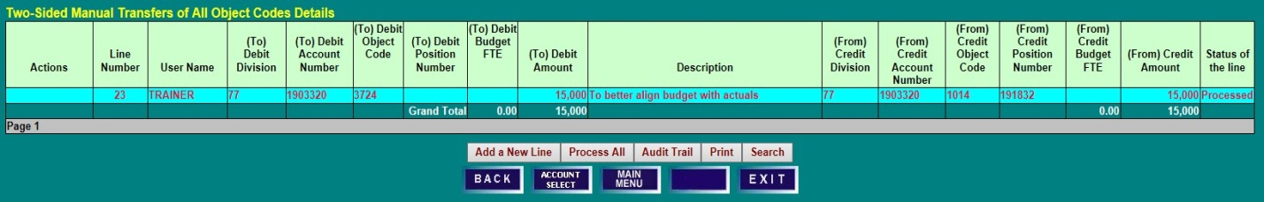
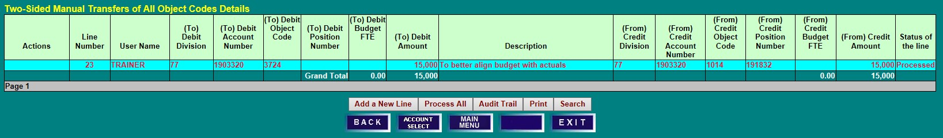
- If completed successfully, the Status of the line will display Processed.

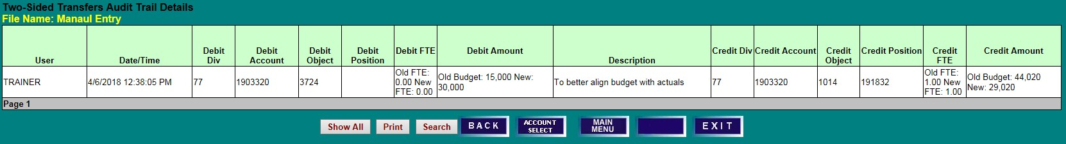
- Click on Audit Trail to view the entry.

TRANSFER OBJECT CODES

PROCESS TRANSFER OBJECT CODES (9xxx) ONLY
PROCESSING A TRANSFER ENTRY

From the Menu Options Screen, click on Transfer Object Codes or Process Transfer Object Codes
(9xxx) Only to access the Two-Sided Manual Transfer of 99xx Object Codes Details screen.
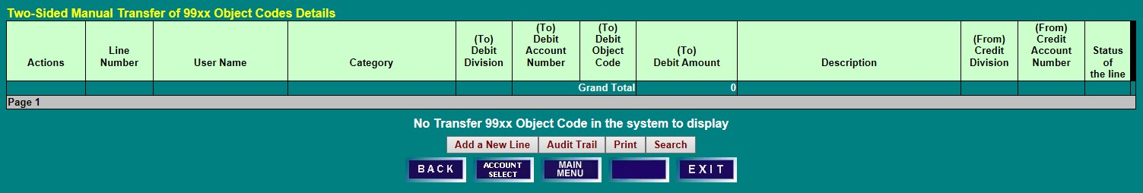

- Click Add a New Line to make a Two-Sided Manual Transfer entry. A blue Edit Line will appear in the Actions column.
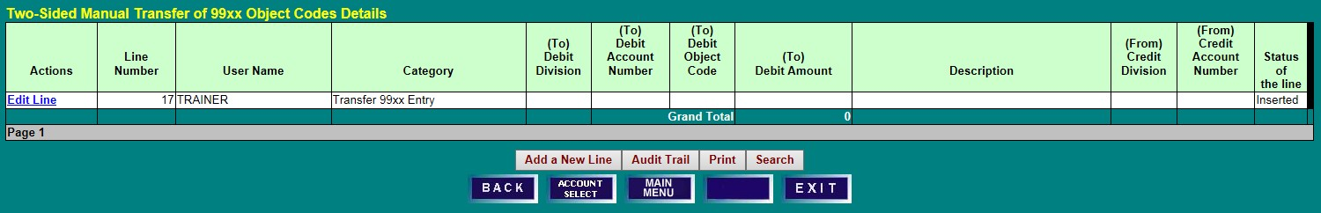
- Click the blue Edit Line to open an edit box, and complete all applicable lines. Use the To and From philosophy when determining how to make entries. The To is where the budget is going, and the From is where the budget will be taken. The To and From object codes must be the same to use this form. It different transfer object codes are needed, use either the Import function or the Two-Sided Manual Entry function.

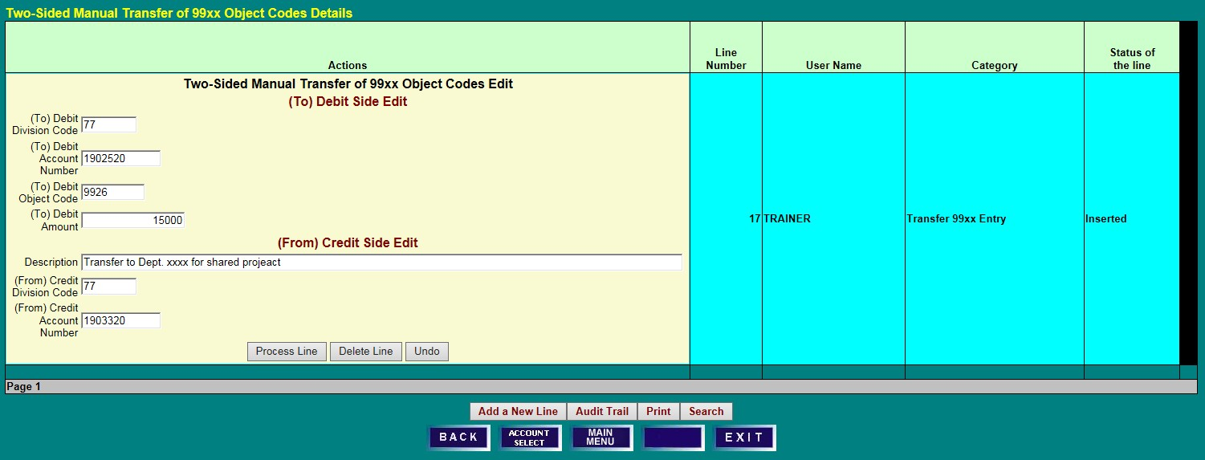
- Upon completion, click Process Line.

- If completed successfully, the Status of the line will display Processed.
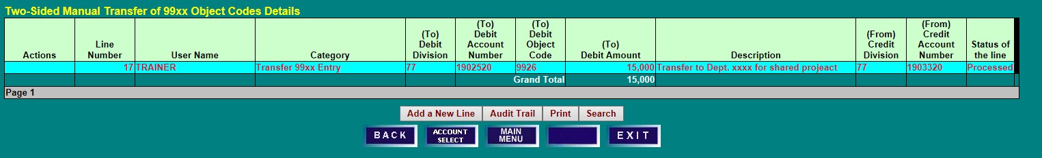
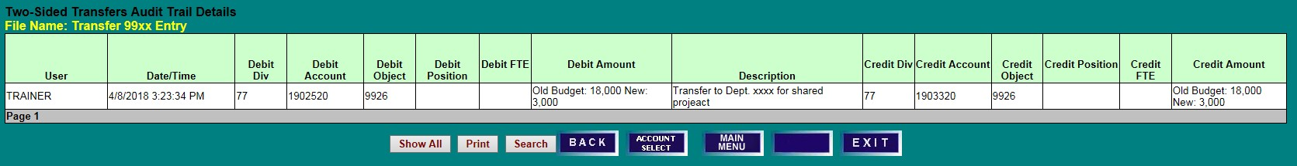
- Click on Audit Trail to view the entry.

ACCOUNT SELECT SCREEN

- To access an Account Budget Summary screen, type an account number in the Account field and click on Select, or
- Using the scroll bar, highlight an account and click on Select.
- To display accounts within a Division, Department, or SubDept, click on the desired unit.
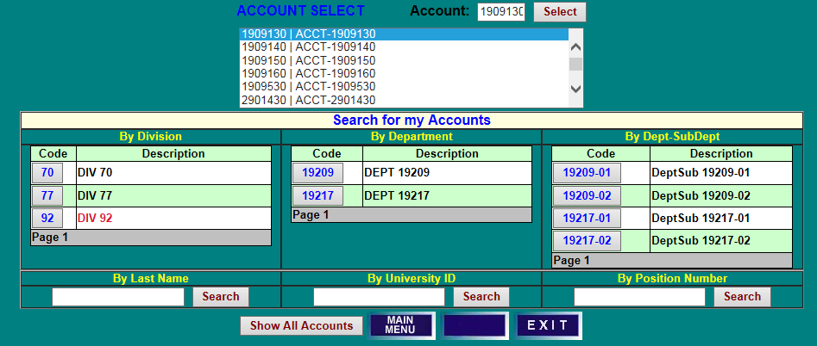
- To return to a display of all accounts that you may access, click Show All Accounts.

- To locate account information for a specific employee, enter Last Name or University ID number in the associated field and click on Search. To locate account information for an individual position, enter the Position Number and click Search.
- In the search results, click on Select in the Details column to go directly to the Position/Employee
Details screen for the selected employee and account, or
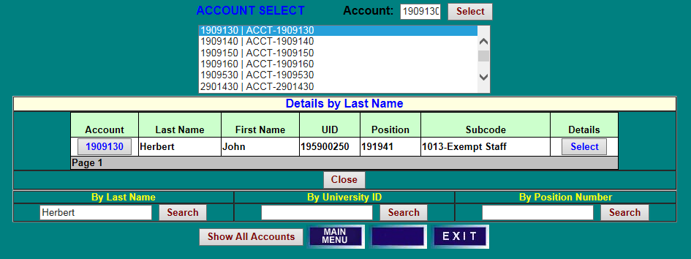
- In the search results, click on an Account number to access the Account Budget Summary screen for the selected account.

ACCOUNT BUDGET SUMMARY SCREEN

- To set Itemized salaries and position budgets, click on a blue Faculty, Exempt, or Non-Exempt field name to access the related Position/Employee Details screen.
- Click on a brown Lecturers, Faculty Contractual, Contingent II, or Graduate Assistant field name to access the related worksheet for setting budget for Non-Itemized S/W.
- To set budget amounts for Labor & Assistants, Fringe Benefits, Overtime, or Turnover & Other, click on the associated red field name, or on Other S/W in the right-hand column.
- To access object code-level budget detail and to set revenue and operating budgets, click on the Revenue or Operating Expense field names in the right-hand column.
- Click on Vacant Positions to view and edit Vacant Position data for the account.
- Note the account attribute information, including Program, Division/Department, and Support Indicator.
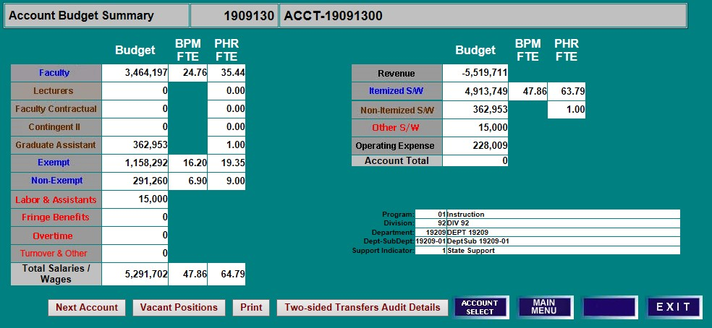
- Click on Two-Sided Transfers Audit Details to view two-sided entries made on the account.

SET SALARY & POSITION BUDGETS

SET BY ACCOUNT - SINGLE FUNDED - NON-EXEMPT

ACCOUNT BUDGET SUMMARY SCREEN
From the Account Budget Summary screen, click on Non-Exempt to access the Non-Exempt Position/
Employee Details screen.

POSITION EMPLOYEE DETAILS SCREEN
- Employees are listed in position number order, but can be sorted by any column heading. Click on the Name column heading to sort the data by name.
- To select an employee for salary setting, click on the associated Position or UID number. The selected row will be highlighted.
- Click on Set Salary to access the Salary Setting screen for the employee.
- COLA and Merit are not applicable, Salary Set? has been set to No automatically. Users will need to set salaries for itemized employees.

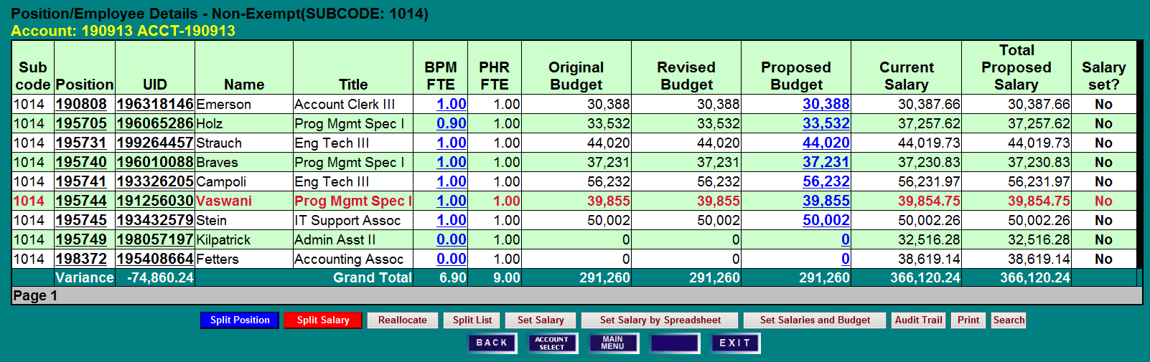
At system opening all salaries are set to No when COLA and Merit are not applicable:

SALARY SETTING SCREEN
(Please note that salary setting screen field definitions can be found in the Appendix.)
- COLA and Merit are not applicable for the fiscal year, these fields are blocked from user edit. Mandatory Merit Adjustment maybe required.
- Enter Adjustments to Current Base Salary, if applicable.
- The BPM system will default to setting Proposed Budget equal to Total Proposed Salary (Proposed Base Salary plus Increments Above Base) on budgeted accounts. To override the default, remove (click on) the check mark from the Make New Budget Amount box next to Total Proposed Salary.
- Click Set Salary to update the record.

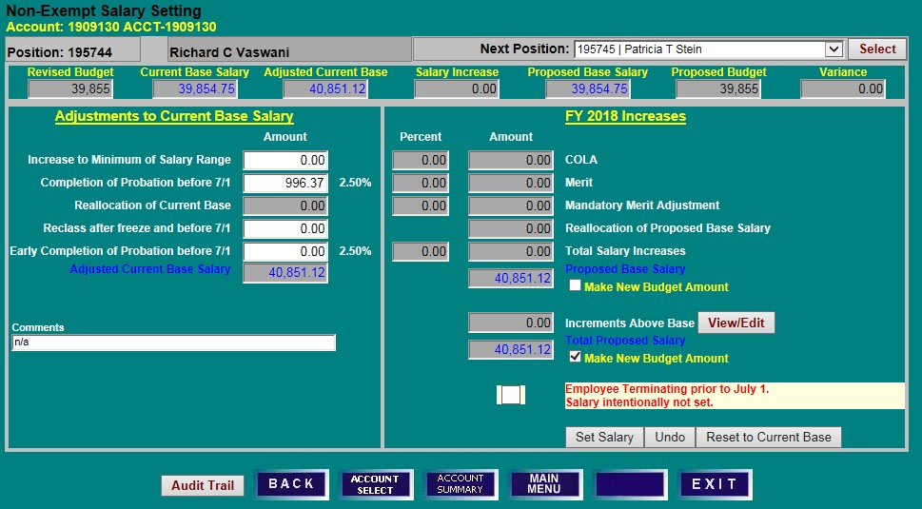
When COLA and Merit are not applicable:

- After the update has saved, Proposed Budget and Proposed Base Salary on the summary line will display the updated amounts.
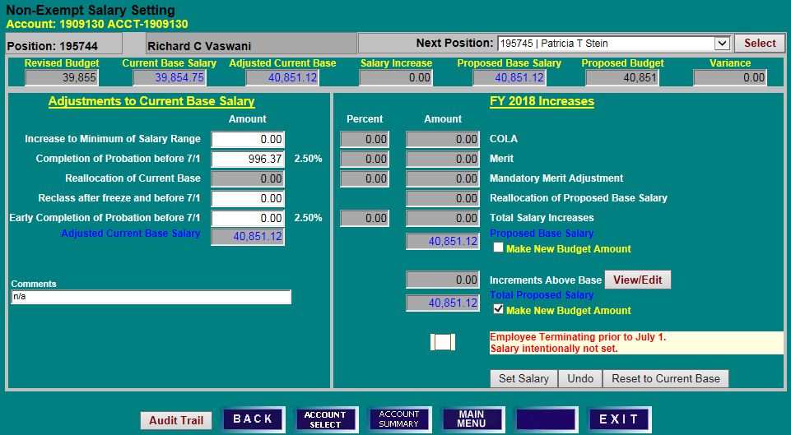
- Click Back to return to the Position/Employee Details screen.

POSITION EMPLOYEE DETAIL SCREEN

- Confirm that the employee’s Proposed Budget and Total Proposed Salary have been updated.
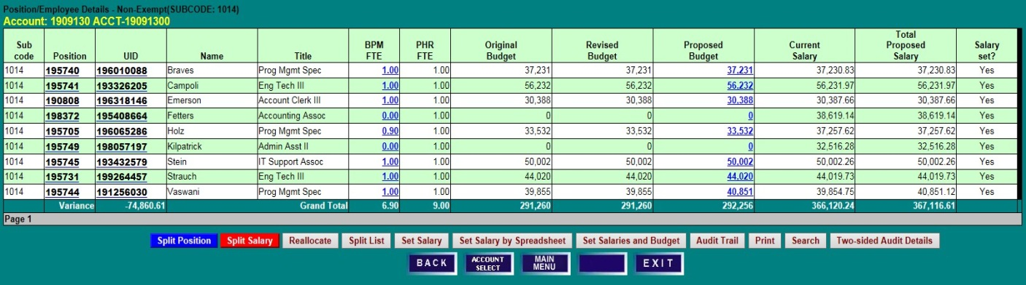
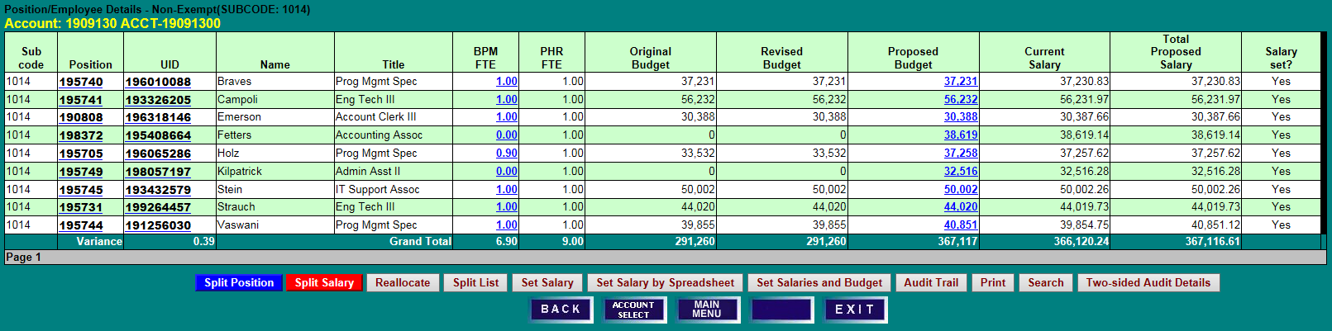
- Clicking the Set Salaries and Budget button will set Proposed Budget equal to Total Proposed Salary for all Non-Exempt employees listed.

SET BY ACCOUNT—SINGLE FUNDED - EXEMPT

ACCOUNT BUDGET SUMMARY SCREEN
Click on Exempt to navigate to the Position/Employee Details screen.

POSITION EMPLOYEE DETAILS SCREEN
Click on the Position or UID number of an employee, and then click Set Salary.

SALARY SETTING BY ACCOUNT SCREEN
- Enter Adjustments to Current Base Salary and related Comments, if applicable. Adjustments should reflect activity in PHR from the BPM freeze date through June 30th.
- Enter applicable salary increases (Retention, Equity, and Other). If an employee has no other salary changes, users do not need to take any further action on the employee’s salary as BPM has, by default, set salaries as unchanged.
- Click Set Salary to update the record.

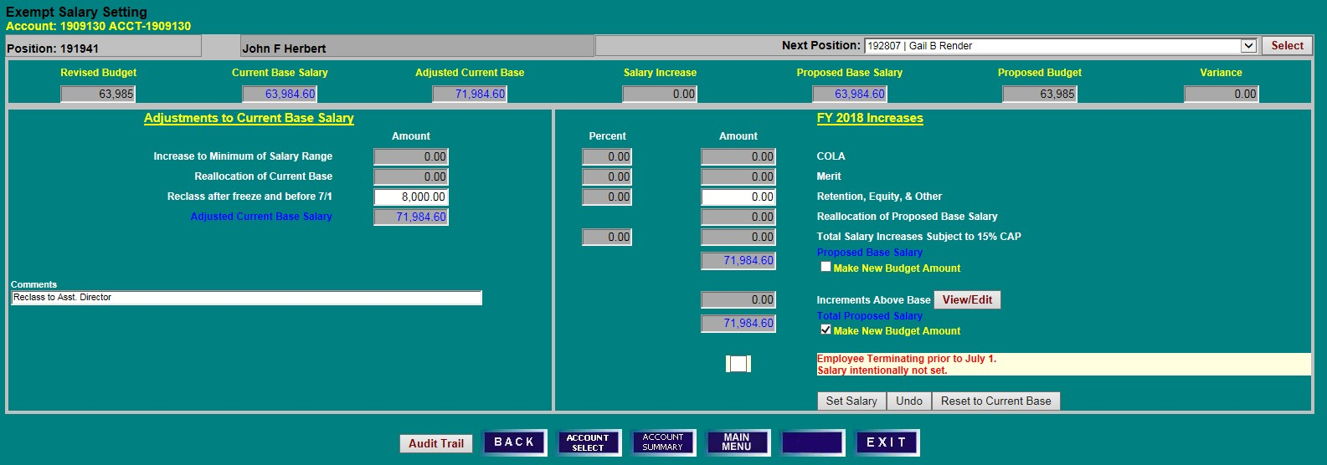
When COLA and /or Merit are not applicable:

- After the record is saved successfully, Proposed Budget and Proposed Base Salary on the summary line will display the updated amounts.
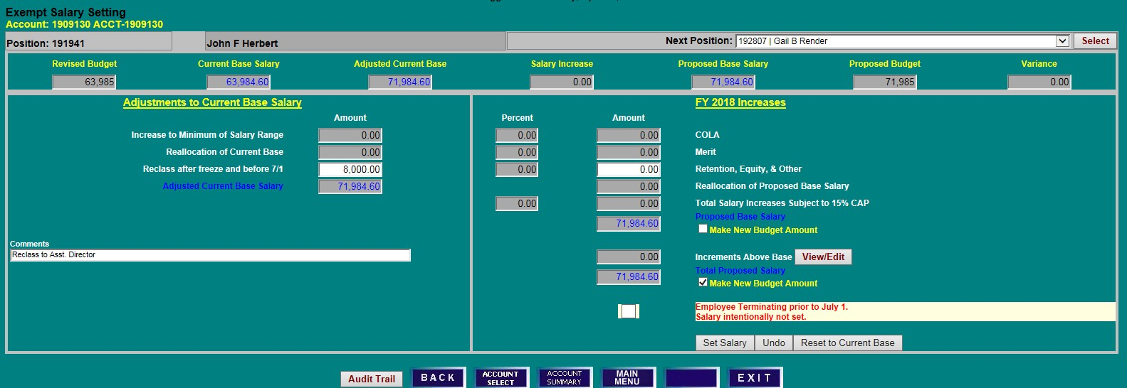
- To move to another position, choose a name from the Next Position drop down menu and click Select.

SET BY ACCOUNT—SINGLE FUNDED - FACULTY

ACCOUNT BUDGET SUMMARY SCREEN
Click on Faculty to navigate to the Position/Employee Details screen.

POSITION EMPLOYEE DETAILS SCREEN
Click on the Position or UID number of an employee, and then click on Set Salary.

SALARY SETTING BY ACCOUNT SCREEN
- Enter Adjustments to Current Base Salary and related explanation, if applicable.
- Enter Retention, Equity & Other or Faculty Promotion, if applicable. If the combination of these items (excluding Faculty Promotion) exceeds 10% -15% (percentage will vary depending on the year’s instructions) of the adjusted current base salary, the Total Proposed Salary Increases Subject to Cap fields will turn red to indicate that a salary requires approval of the President.
- Click on View/Edit Increments Above Base, if applicable. Increments above base must be set at the account level and are only used for budgeting purposes.
- If applicable, enter the new increment amount and click Update Budgeted Increments Above Base.
- Click Set Salary to update the record. Note that, by default, the Make New Budget Amount box is checked and the increment amount will be included in the new budget figure. If this is not desired, de- select the box before clicking Set Salary.

When COLA and /or Merit are not applicable:
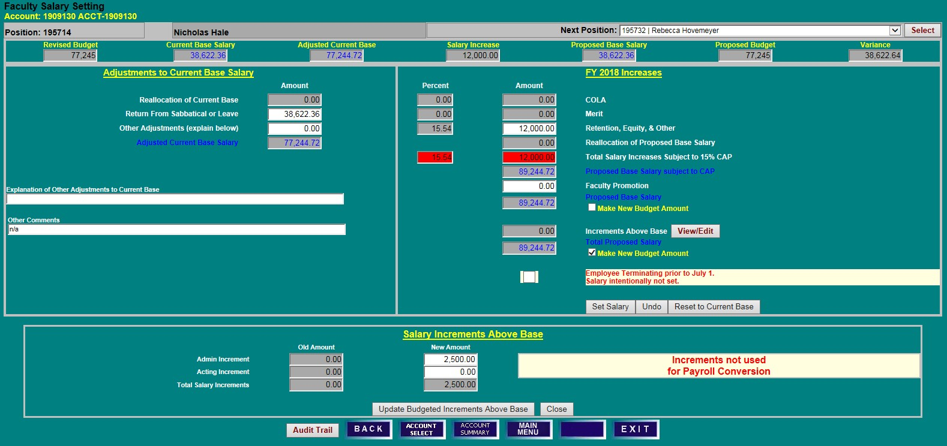

- Review updated Proposed Base Salary and Proposed Budget figures on the summary line.
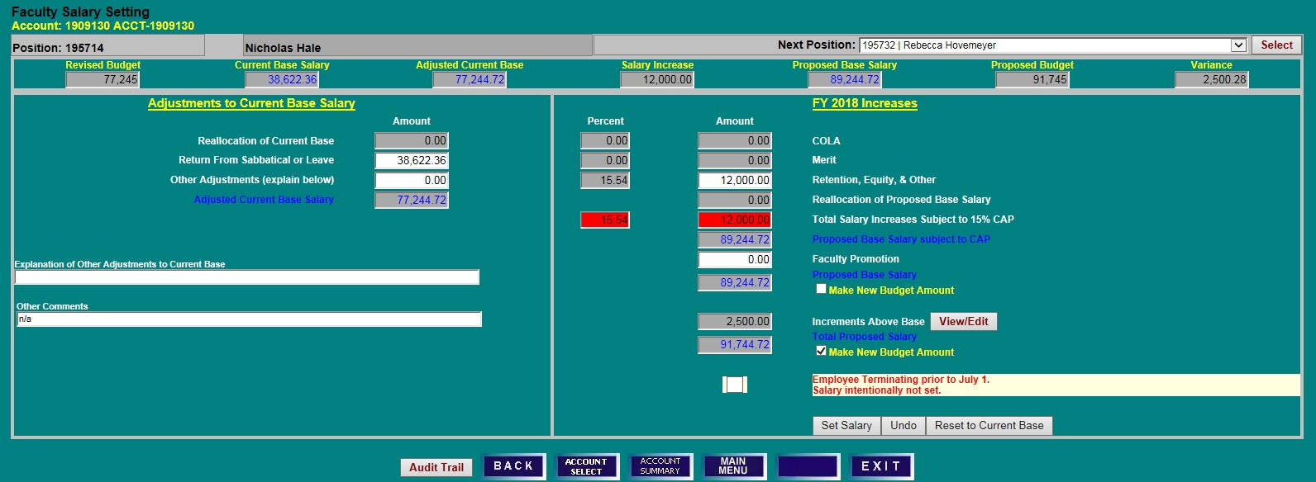

REALLOCATE SALARY TO MULTIPLE FUNDING SOURCES

POSITION/EMPLOYEE DETAILS SCREEN
- To reallocate a single-funded employee to one or more accounts, select an employee on the Position/Employee Details screen by clicking on a Position or UID number.
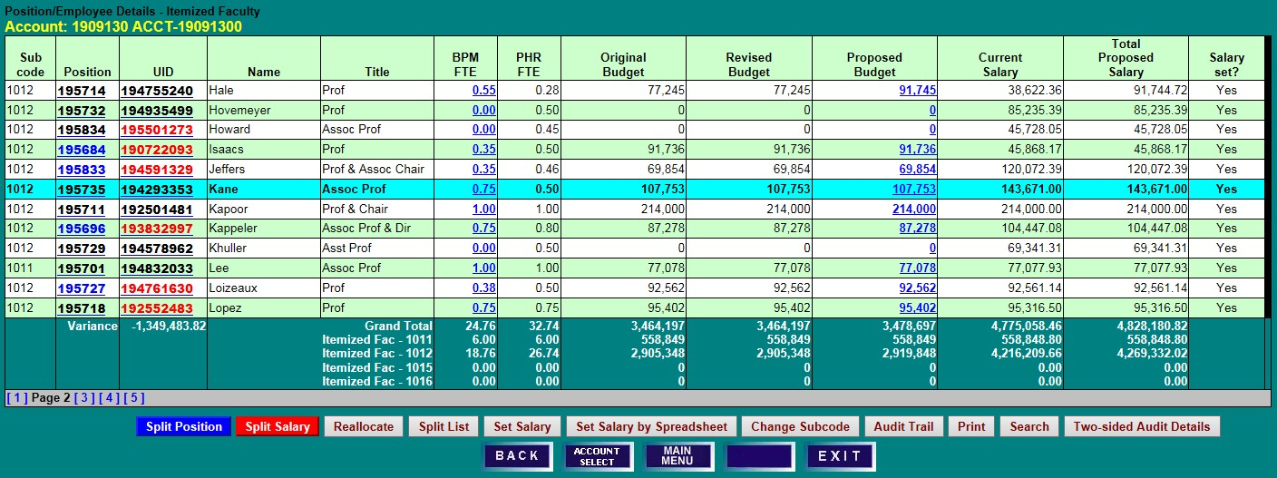
- Click on Reallocate to access the Split Employee Details screen. Split Position and Split Salary will also navigate to the Split Employee Details screen. Split Position means that a position’s budget is split among multiple accounts. Split Salary means an employee’s salary is split among multiple accounts.

SPLIT EMPLOYEE DETAILS SCREEN
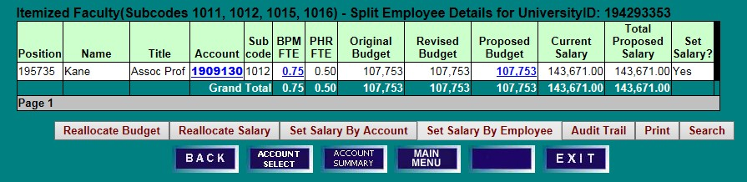
- Select Reallocate Salary to move an employee’s entire salary to a new account or to split an employee’s salary among two or more accounts.

REALLOCATE SALARY DETAILS SCREEN
- Click on Add a Line Item to open a new row.
- Select the appropriate Internal ID from the drop-down list, enter the new Account number, and tab out of the field.
- To move the entire salary, enter 100 in the new account’s Percent Base Salary field, and 0 in the initial account’s Percent Base Salary field. If the employee is being split, rather than completely moved, enter appropriate percentages or amounts of base salary in the corresponding fields. COLA, merit, and other increases, when applicable, cannot be added on this screen, only reallocated. Increases to salary must be added on a salary setting screen.
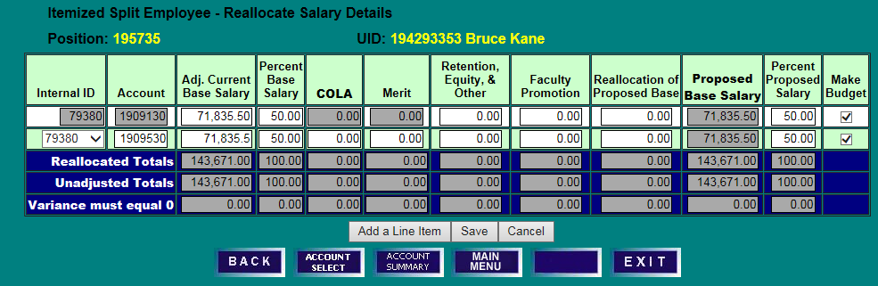
- The Make Budget box is checked by default. Uncheck the Make Budget box to leave budget unchanged. Ensure that salary variances equal zero on the bottom row and click Save. When Save is clicked, the salary is set on the accounts as well.

SPLIT EMPLOYEE DETAILS SCREEN
- Review the revised salary and budget figures on the Split Employee Details screen. Note that the Proposed Budget was updated to equal the reallocated salary on the account.
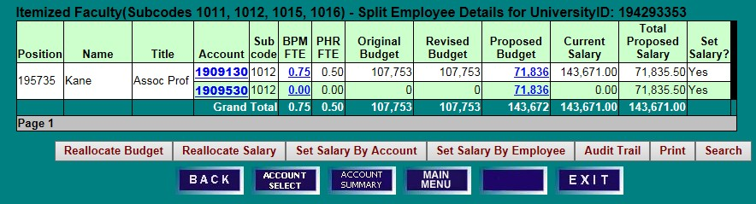
- Click Reallocate Budget to make any other necessary adjustments to BPM FTE and/or Proposed Budget.

REALLOCATE BUDGET DETAILS

REALLOCATE BUDGET DETAILS SCREEN
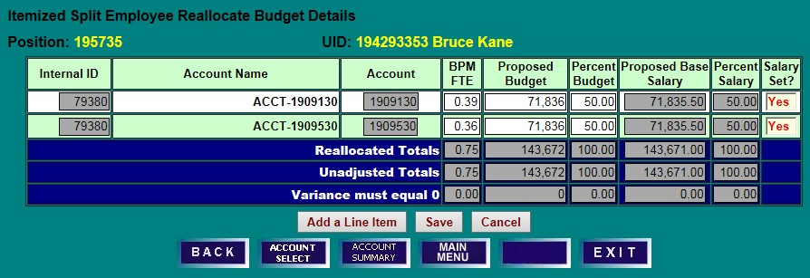
- Make changes to BPM FTE, Proposed Budget, and/or Percent Budget as needed; ensure that all variances equal zero on the bottom row, and click Save.

SPLIT EMPLOYEES DETAILS SCREEN
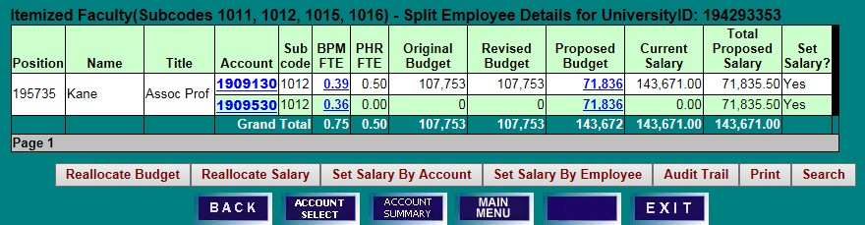
- Review reallocated BPM FTE and Proposed Budget figures for accuracy.

SET SALARY BY EMPLOYEE—MULTIPLE FUNDING SOURCES

REALLOCATE AND SET WITH BUDGETABLE ACCOUNTS

POSITION EMPLOYEE DETAIL SCREEN
- Click on a Position or UID number to select an employee for salary setting. Note that UIDs in red indicates an employee’s salary is split among multiple accounts. Positions in blue indicate a position budget is split among multiple accounts.
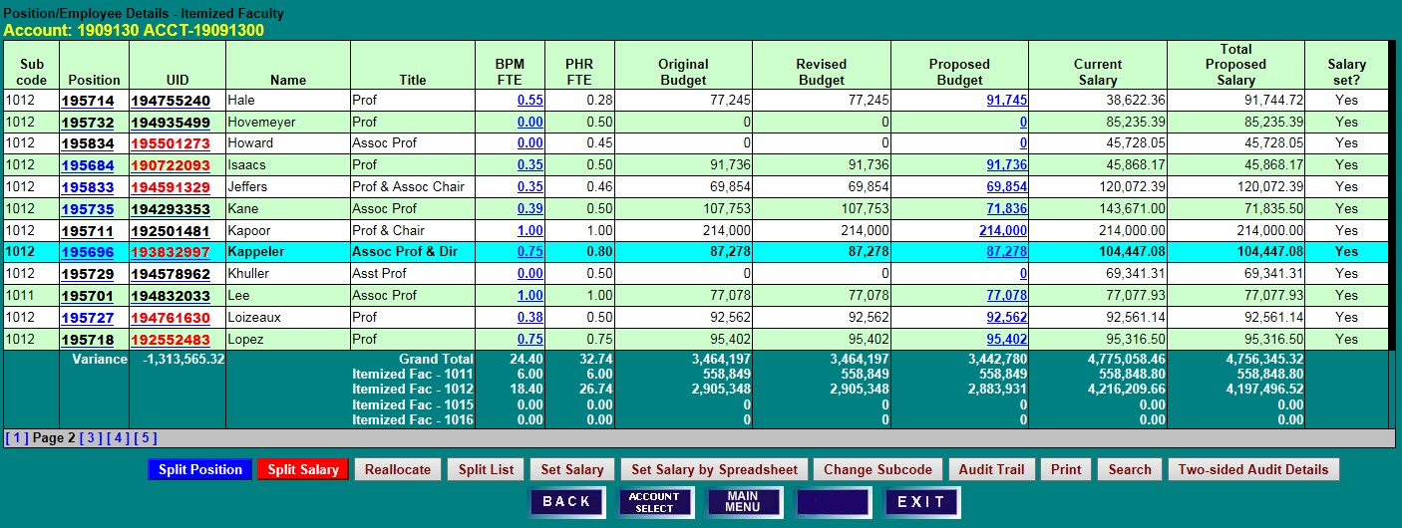
- Click on Split Salary or Set Salary to access the Split Employee Details screen.

SPLIT EMPLOYEE DETAILS SCREEN
- Note the current Proposed Budget and Total Proposed Salary figures brought into BPM after the PHR freeze. A Proposed Budget that is blue indicates the account is budgetable.
- Salaries for employees split among multiple funding sources may be set By Employee (if the salary has no increment above base) or By Account. If an employee’s salary and budget distribution will remain the same, click on Set Salary by Employee to access the employee-level salary setting screen. Salary changes will then be pro-rated among existing accounts in the same proportion as the account’s adjusted current base salary. Budget will be pro-rated based on the proposed budget before the change. If the salary allocation among accounts will change, reallocate the base salary first by clicking on Reallocate Salary.
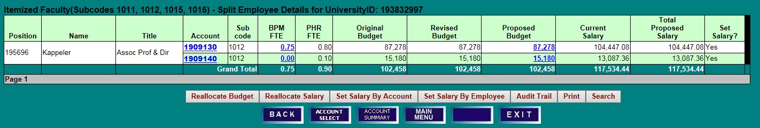

REALLOCATE SALARY DETAILS SCREEN
- Click Add a Line Item if a new KFS Account is needed for salary reallocation.
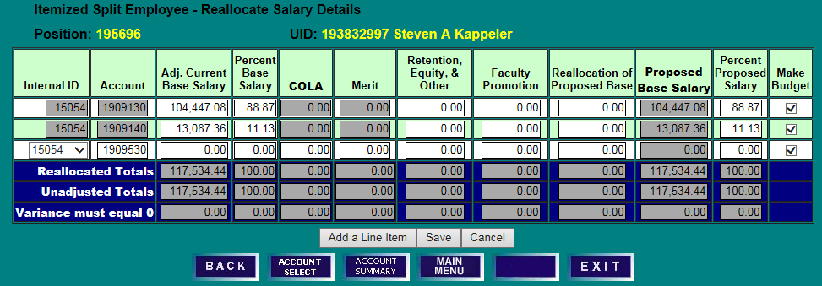
- Select an appropriate Internal ID from the drop-down list, enter the Account number, and reallocate Adjusted Current Base Salary dollars or percentages to reflect the new fiscal year distribution.

- Review the bottom row to ensure that no variances remain, and check Make Budget if you would like budget to be distributed in the same proportion as the base salary. Click Save to return to the Split Employee Details screen to review the new salary and budget allocations.
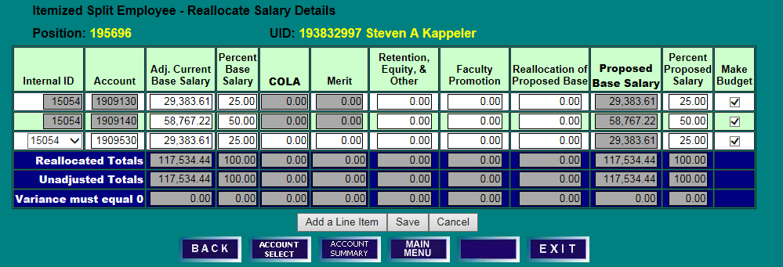
- Confirm the distribution of salary and budget have been updated appropriately.

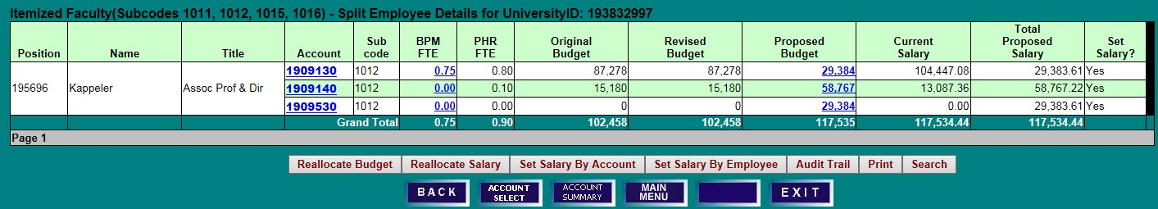
- Click Set Salary By Employee to add any necessary salary increases that should pro-rate according to the new distribution.

SALARY SETTING BY EMPLOYEE SCREEN
- Enter any appropriate salary increases and click Set Salary. The salary changes will be distributed pro-rata based on the adjusted current base salary allocation established on the Reallocate Salary Details screen. If all accounts are budgetable in BPM, the budget will also be distributed pro-rata based on the proposed budget allocation prior to the change when the Make New Budget Amount box is checked. (If non-budgetable accounts are included in the allocation, the Make New Budget Amount box will not be accessible. See next example.)
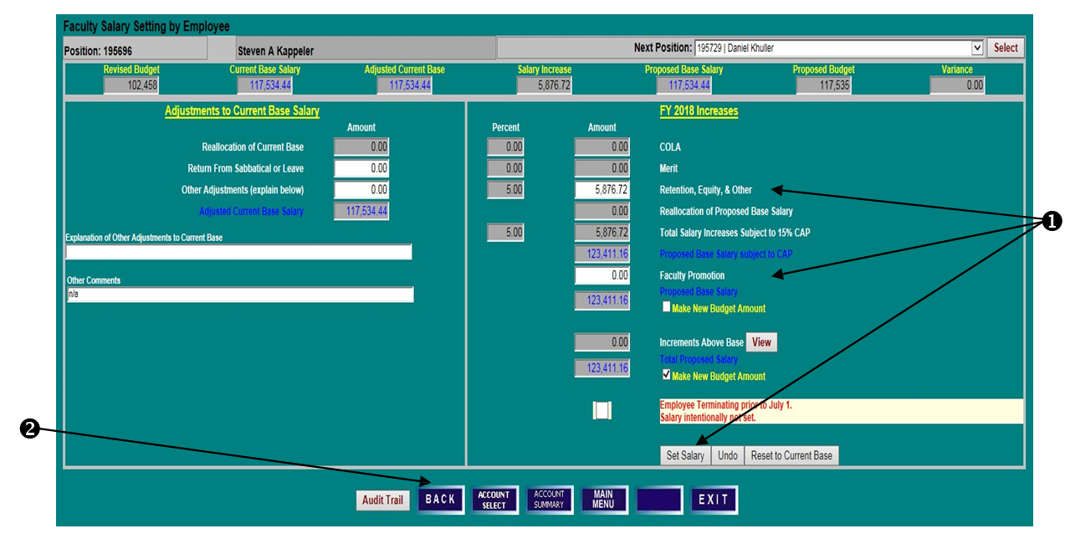
- Click Back to review salary and budget allocations after the salary increase has been set.

SPLIT EMPLOYEE DETAILS SCREEN
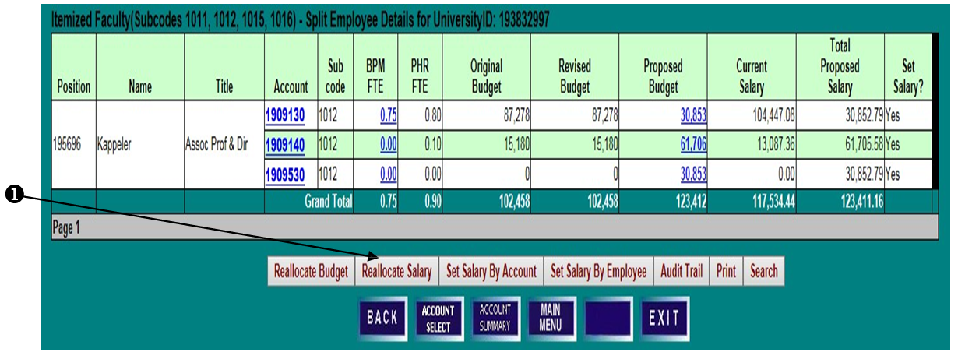
- Click on Reallocate Salary to see further detail of the pro-rata distribution of the increase and Proposed Base Salary.

REALLOCATE SALARY DETAILS SCREEN
- Note that the Retention, Equity, and Other increase is split pro-rata among the accounts and that the percentage of proposed salary has remained the same as when reallocated at the beginning of the example.
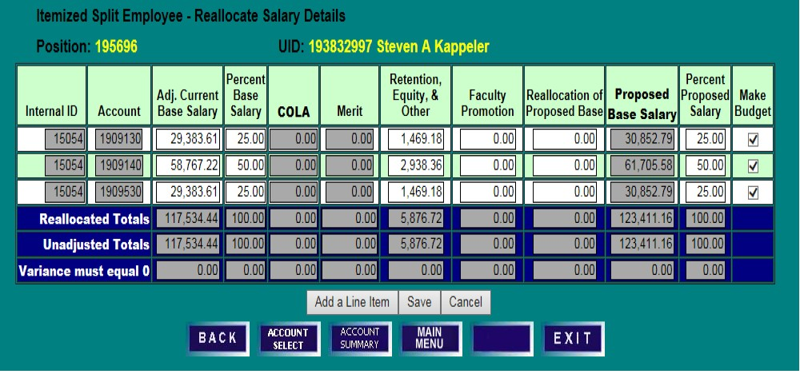

SET WITH NON-BUDGETABLE ACCOUNTS

POSITION/EMPLOYEE DETAILS SCREEN
- Click on a Position or UID number to select an employee for salary setting.
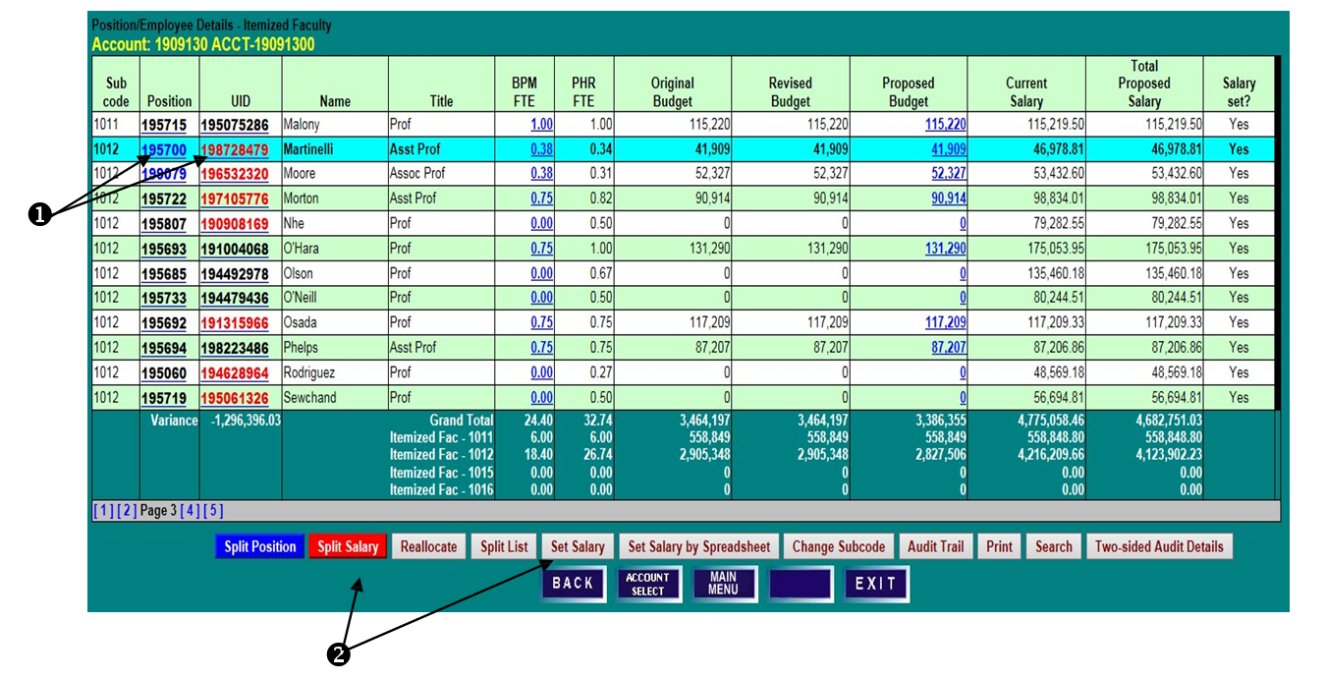
- Click on Split Salary or Set Salary to access the Split Employee Details screen.
SPLIT EMPLOYEE DETAILS SCREEN
- Note the current Proposed Budget and Total Proposed Salary allocations brought into BPM after the PHR data freeze, and that the ledger 5 account is not budgetable in BPM as its Proposed Budget is black, not blue.
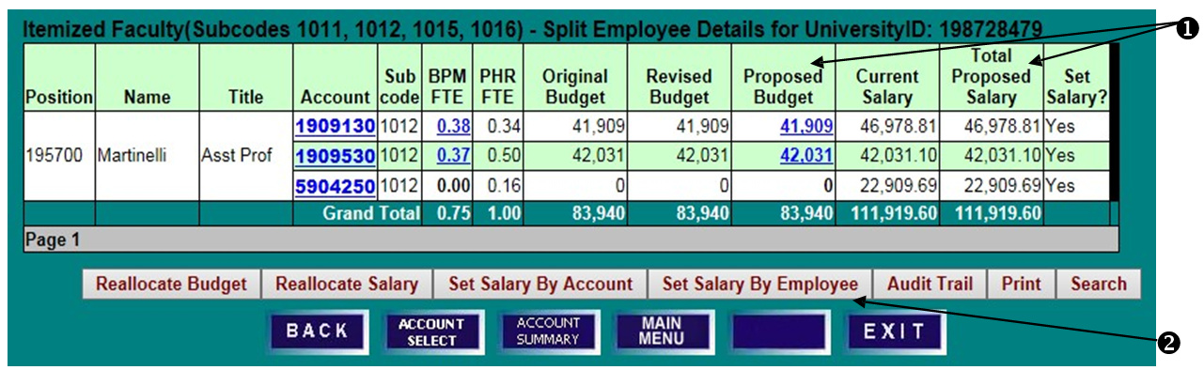
- Salaries for employees split among multiple funding sources may be set By Employee (if the salary has no increment above base) or By Account. If an employee’s salary and budget distribution will remain the same, click on Set Salary By Employee to access the employee-level salary setting screen.

SET SALARY BY EMPLOYEE SCREEN
- Enter any appropriate salary increases, noting that salary changes will be distributed pro-rata based on the adjusted current base salary allocation. When an employee’s salary distribution includes a non-budgetable account, the Make New Budget Amount boxes will not be accessible, and the budget must be manually updated via reallocation, setting salary by account, or direct budget adjustment.
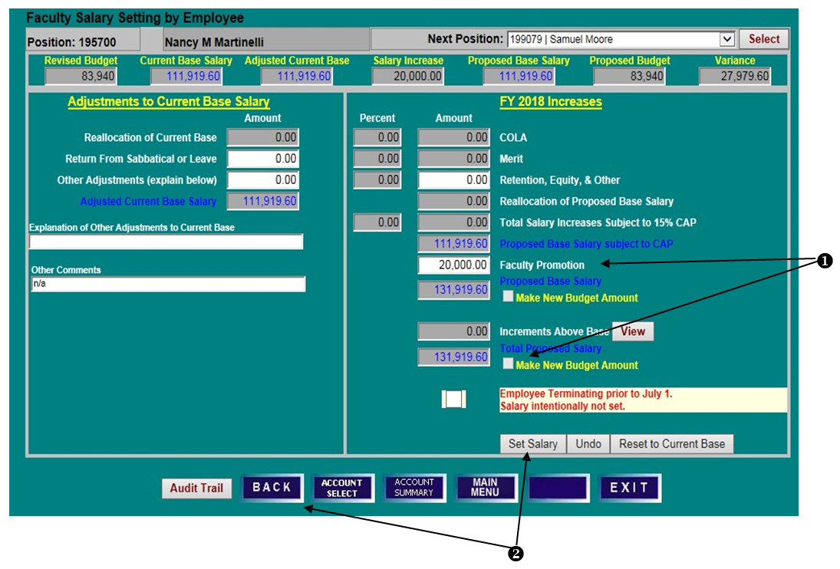
- Click Set Salary and then Back to review the salary allocation and to adjust budget as needed.

DIRECT ADJUSTMENT OF POSITION BUDGET AND BPM FTE

SPLIT EMPLOYEE DETAILS SCREEN
ADJUSTMENT OF POSITION BUDGET
When a position is funded on budgetable and non-budgetable accounts, there are three ways to update the
budget on the budgetable accounts based on the new salary we just set: A) Use the Reallocate Salary
Screen, B) Set Salary by Account, or C) Direct Budget Adjustment.

SPLIT EMPLOYEE DETAILS SCREEN
- Click on A) Reallocate Salary, B) Set Salary By Account, C) or a blue Proposed Budget amount to open an edit box.
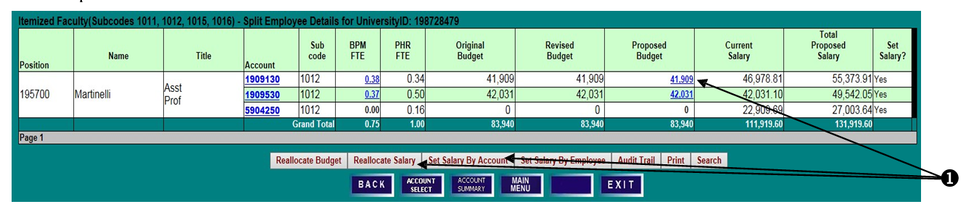
- REALLOCATE SALARY SCREEN
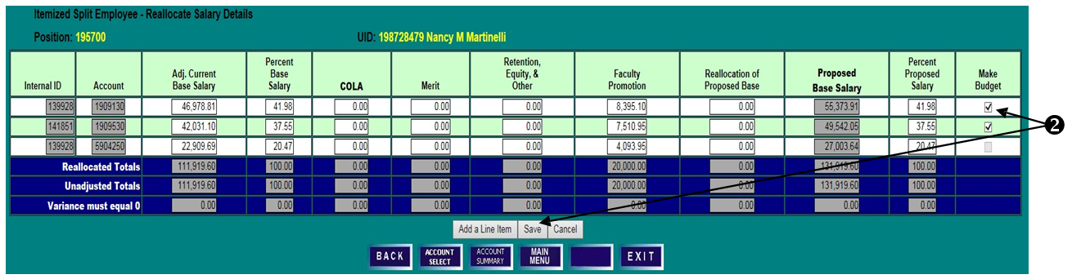
- Click on Save with the Make Budget check mark on each budgetable account.
- SET SALARY BY ACCOUNT SCREEN
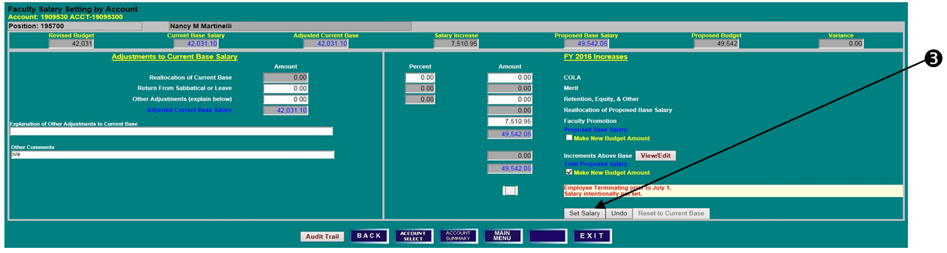
- Click on Set Salary

- DIRECT BUDGET ADJUSTMENT - SPLIT EMPLOYEE DETAILS SCREEN
- Enter New BPM FTE, if applicable.
- Enter New Proposed Budget amount, or change by percent or dollars.
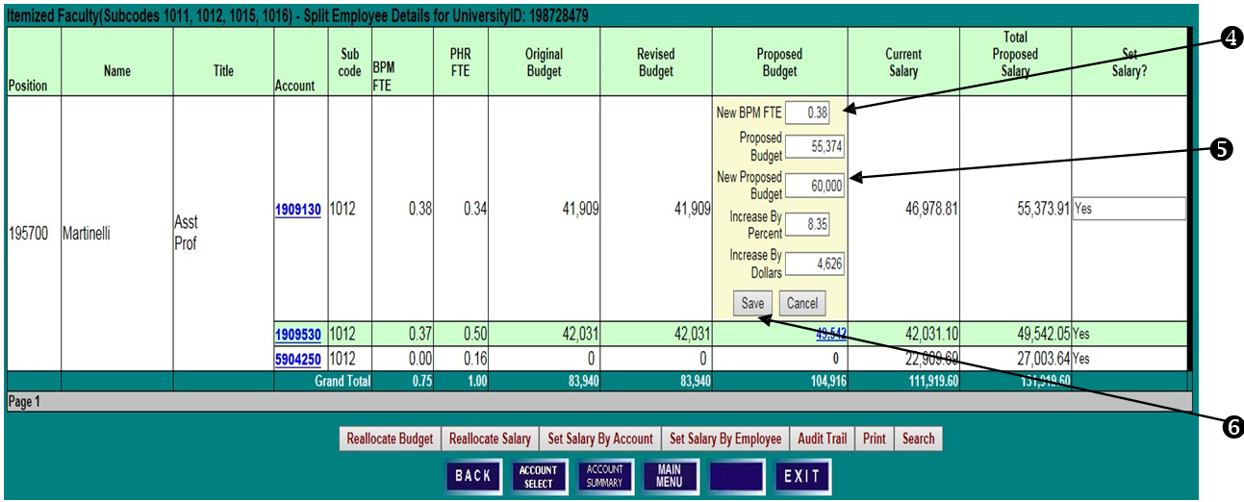
- Click Save to create the new budget figure, or Cancel to leave the budget amount unchanged and close the edit box.

SET WITH INCREMENTS ABOVE BASE

POSITION EMPLOYEE DETAILS SCREEN
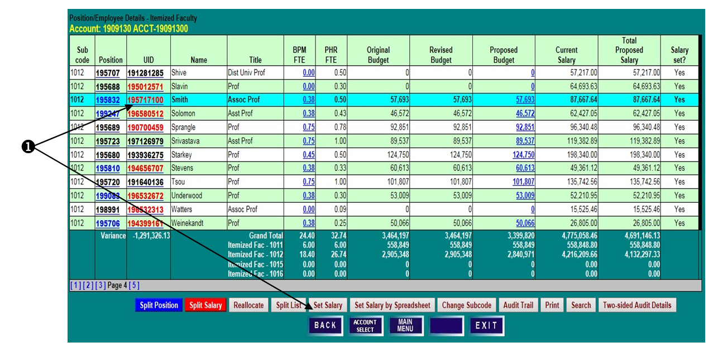
- Select an employee’s UID and click Set Salary.
SPLIT EMPLOYEE DETAILS SCREEN
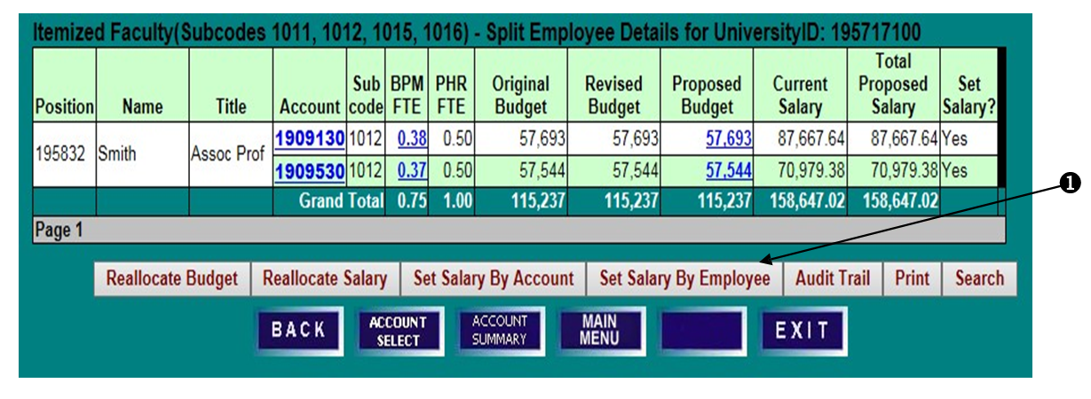
- Increments must be set at the account level. Click on an account number to select it, and then Set Salary by Account, or, to distribute the base salary increases pro-rata automatically between the accounts first, click on Set Salary by Employee. After setting salary, return to Set Salary by Account to adjust the account on which the increment is budgeted.

SALARY SETTING BY EMPLOYEE SCREEN
- Enter any applicable salary increases. Changes to base salary will be distributed to each account pro-rata based on its respective share of the Adjusted Current Base Salary.
- Increments above base may be viewed at the employee-level but must be set at the account level. Click on View to open the Salary Increments Above Base edit box.
- The New Amount field is blocked from edit. A mouse-over tool tip will remind users that Increments must be set at the account level. Click Close.
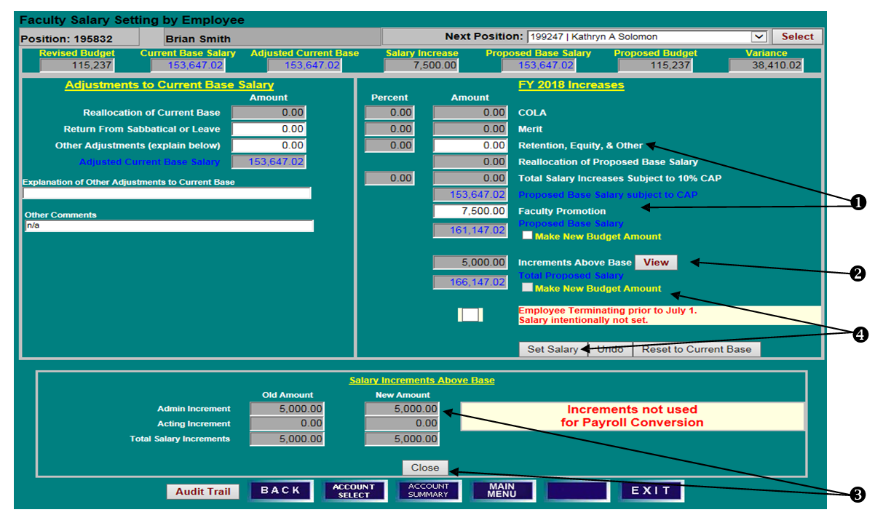
- The Make New Budget Amount box next to Total Proposed Salary is unchecked and not accessible for split employees with salary increments. The Make New Budget Amount box next to Proposed Base Salary may be checked to make the budget equal to the proposed base salary. Click Set Salary.

SPLIT EMPLOYEE DETAILS SCREEN
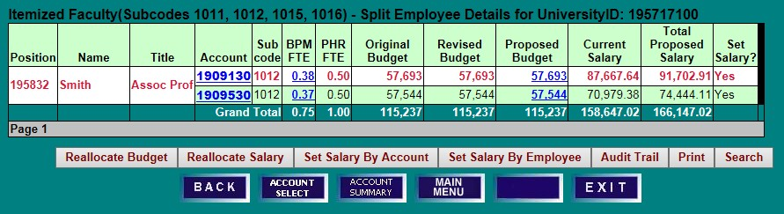
- To adjust an increment above base, click on an account number, and then click Set Salary by Account.

SALARY SETTING BY ACCOUNT SCREEN
- Click on View/Edit to open the Salary Increments Above Base edit box.
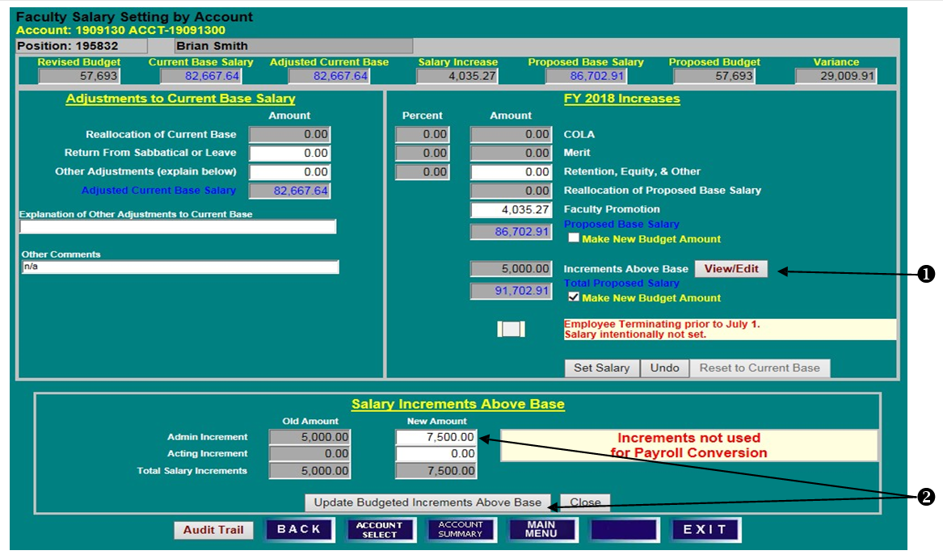
- Enter a New Amount and click Update Budgeted Increments Above Base. Note that increments above base are not fed into PHR and are included in BPM for budgeting purposes only.

SALARY SETTING BY ACCOUNT SCREEN
- Note the change to the increment amount.
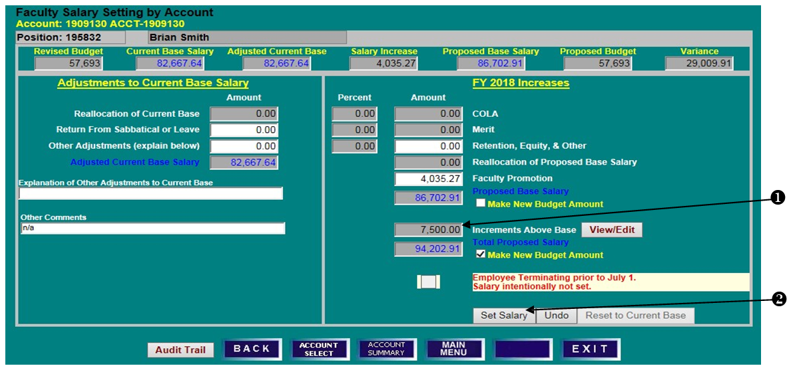
- With the Make New Budget Amount checked, click on Set Salary.
SPLIT EMPLOYEE DETAILS SCREEN
- Note that Proposed Budget has been updated to equal Total Proposed Salary including the increment.
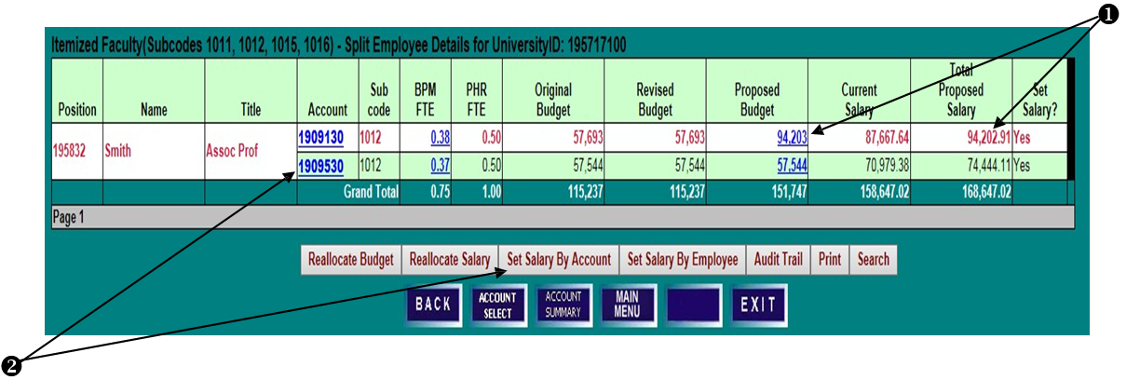
- If necessary, click on the next account number and then Set Salary by Account to update that account’s budget and increment.

SET SALARY USING SALARY SPREADSHEET

POSITION EMPLOYEE DETAILS SCREEN
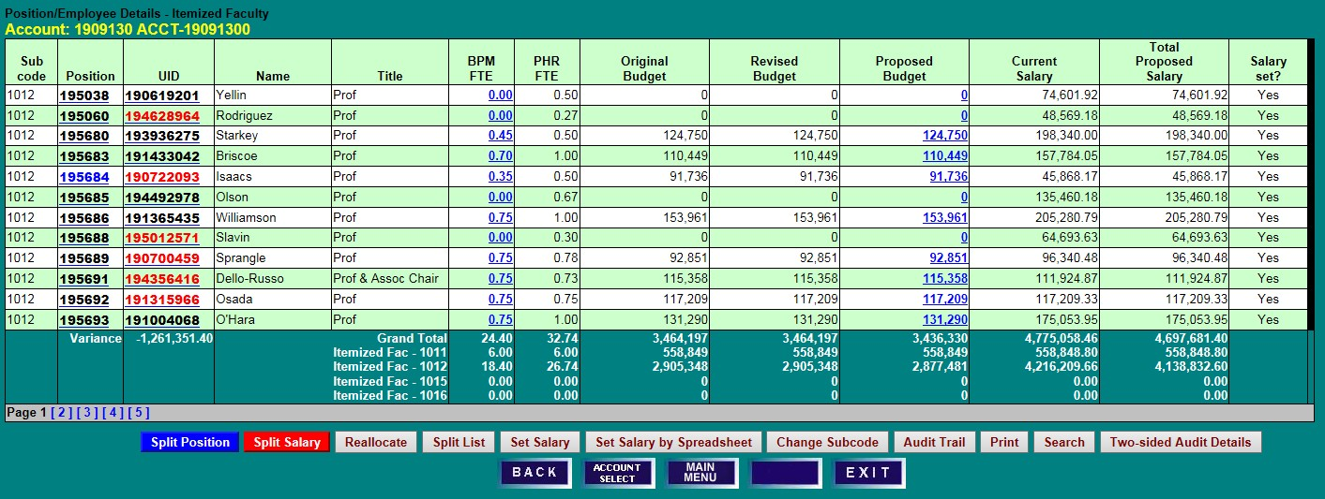
- Salaries may be set utilizing a spreadsheet format. Click Set Salary by Spreadsheet from any Position/Employee Details screen (Itemized Faculty, Exempt, or Non-Exempt).

SET SALARY BY SPREADSHEET
- Click Show/Hide Columns to open column selection box.
- Click on a checkbox () in the Show column to remove columns from current view.
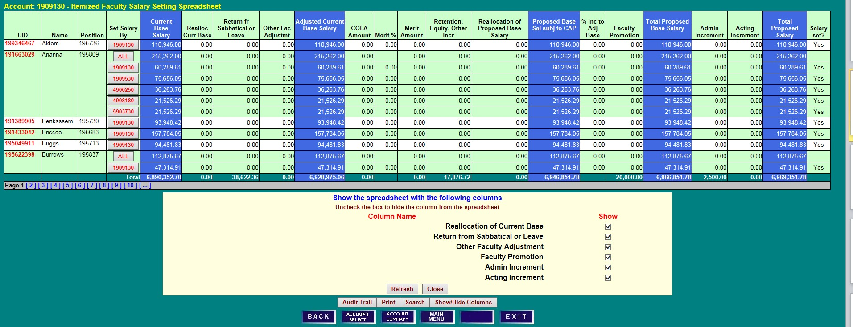
- Click Refresh.

- As on the Position/Employee Details screens, sort and search functions are available on the Salary Setting Spreadsheet. To find an employee by Last Name, click on Search, enter the name and click Search again. Users may also sort the spreadsheet data by clicking on any column heading. Clicking on Search after selecting a column will allow searches by that column description.
- Salary may be set at the employee level (ALL) or by account. Click on ALL or an account number in the Set Salary By column to open a row for editing.
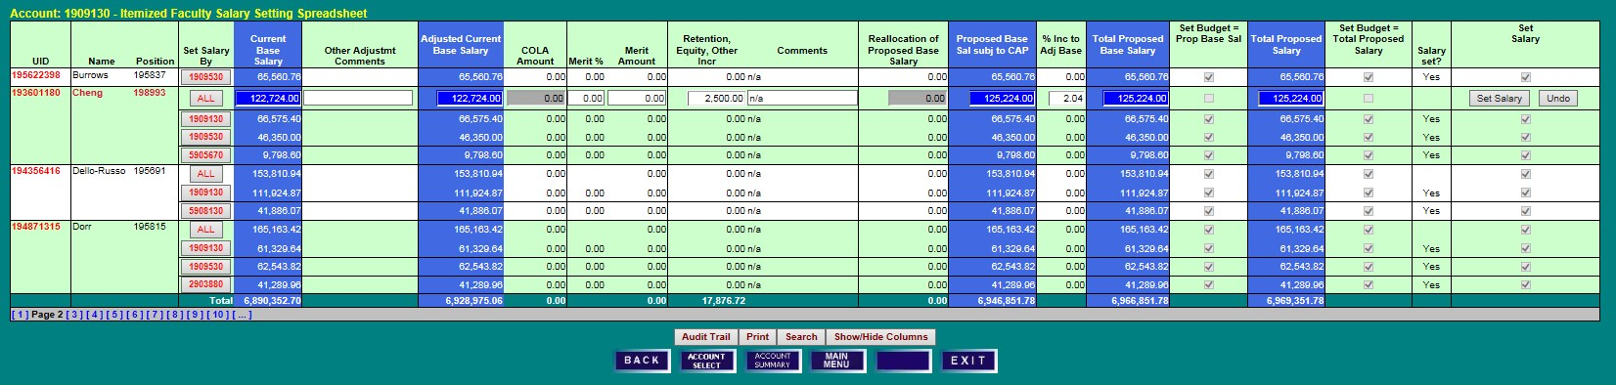
- Enter salary changes, noting the default checkbox that will Set Budget equal to Total Proposed Salary (deselect if necessary), and click on Set Salary at the end of the row.

- After Set Salary is clicked, BPM distributes the increases pro-rata based on the account’s adjusted current base salary.

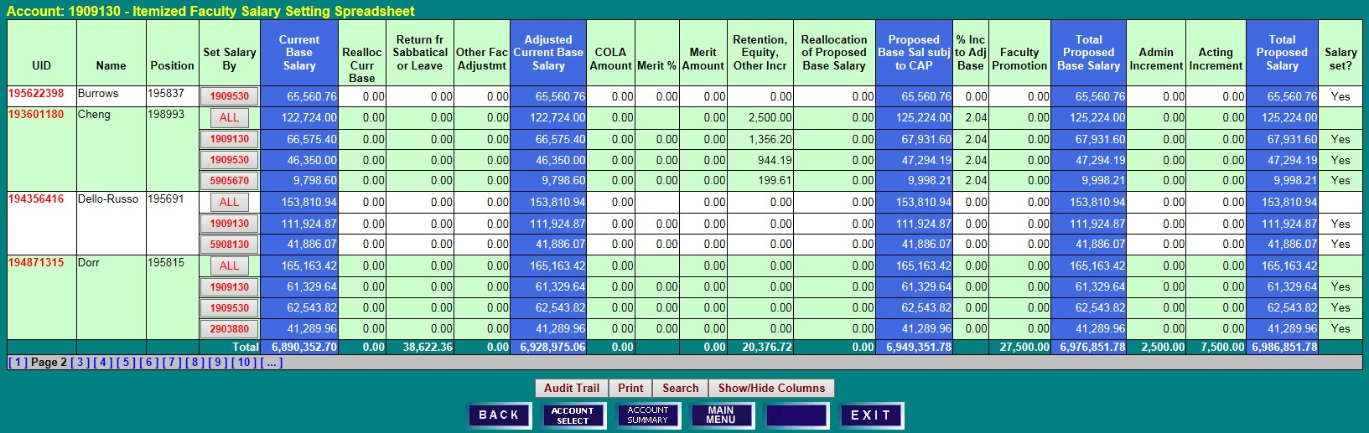

EMPLOYEE TERMINATING PRIOR TO JULY 1

SALARY SETTING BY EMPLOYEE SCREEN
- To zero out the salary of an employee who will be terminating before the new fiscal year, click Employee Terminating Prior to July 1 on the Salary Setting by Employee screen.
Note: Terminations are an employee-level function and are not available on the Salary Setting by Account screens. The termination must also be processed in PHR to be effective.
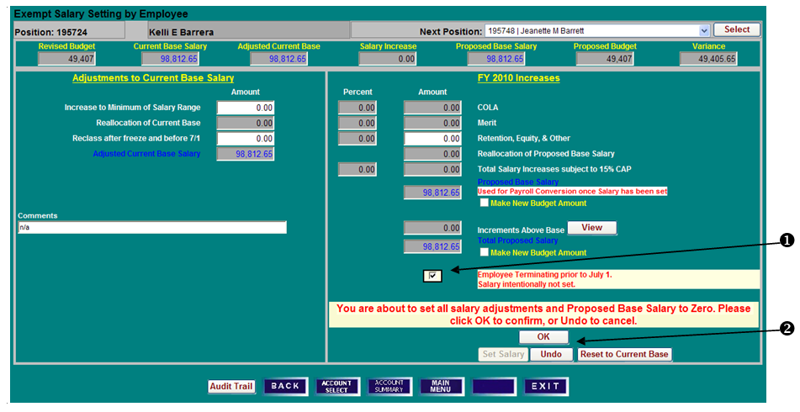
- Click OK to confirm, or Undo to cancel.
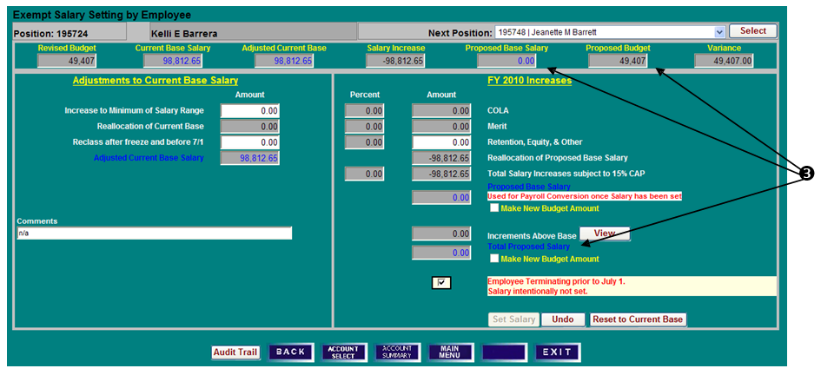
- Note that the Total Proposed Salary and Proposed Base Salary are set to zero, but the Proposed Budget amount remains unchanged.

RESET TO CURRENT BASE

- To remove the Termination Flag checkmark, click Employee Terminating Prior to July 1 again. Click OK to confirm that you intend to set salary for the employee.
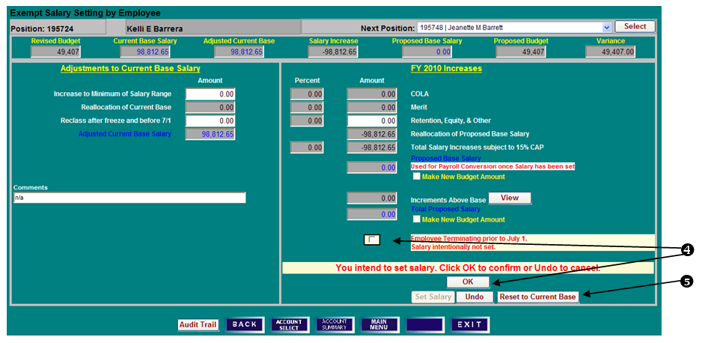
- After removing the Termination flag, click Reset to Current Base to restore all values to the starting point of the working budget process.
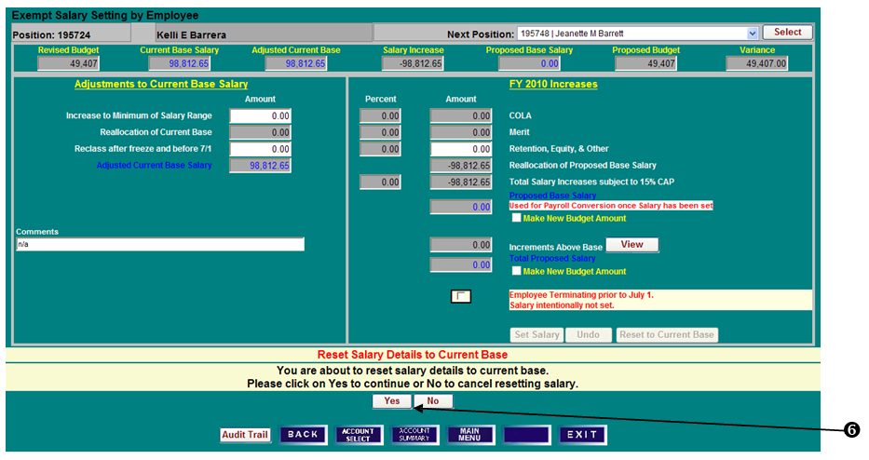
- Click Yes to confirm the salary reset, and proceed with salary setting for the employee as usual.

VACANT BUDGETED POSITIONS

CREATE/DELETE PENDING BUDGET POSITIONS

ACCOUNT BUDGET SUMMARY SCREEN
- Click Vacant Positions to access a list of vacant budgeted positions.

VACANT BUDGETED POSITIONS SCREEN
- Click on Create Vacant Position.
- Select appropriate Category Status and Title Code from the drop-down boxes.
- Enter the BPM FTE and Budgeted Amount.
Note: Any BPM FTE or Amount entered here must be reduced elsewhere in your budget unless you have been given an allocation to increase your budget FTE or dollars.
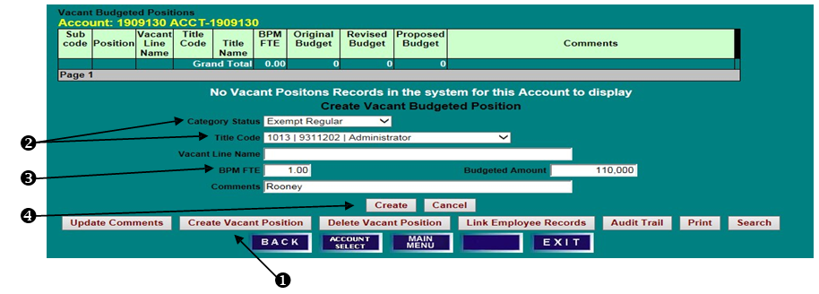
- Click Create to save the position and return to Vacant Budgeted Positions screen.
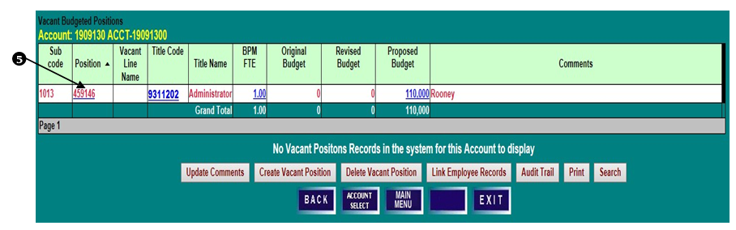
- The Pending position has been assigned a temporary 4XXXXX number. Pending positions exist only in BPM and are intended to be a temporary place to budget until the permanent position is created in PHR. Once the permanent position is created in PHR, users should process an KFS Budget Amendment to move the budget from the temporary position to the permanent position.
DELETE PENDING BUDGETED POSITION
- Click on a pending Position number. Only pending positions assigned numbers beginning with “4” or “9” may be deleted as long as the position has BPM FTE, Original Budget and Revised Budget all equal to zero.
- Click Delete Vacant Position. Click Delete to confirm the deletion or Cancel to leave the Vacant Budgeted Positions data unchanged.

LINK EMPLOYEE RECORD TO VACANT BUDGETED POSITION

ACCOUNT BUDGET SUMMARY SCREEN
- Click Vacant Positions to access a list of vacant budgeted positions.

VACANT BUDGETED POSITIONS SCREEN
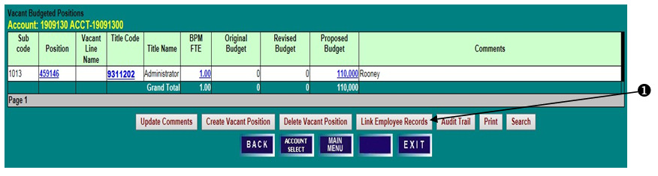
- To view PHR employee records available to link to a vacant budgeted position, click on Link Employee Records. Only employees with zero budget FTE and dollars are available to link.
AVAILABLE PHR POSITIONS TO LINK SCREEN
- Select an employee record to link by clicking the Position number.
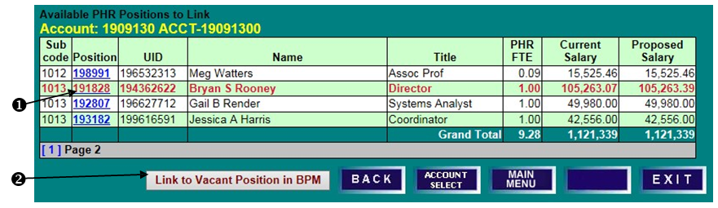
- Click on Link to Vacant Position in BPM.
LINK AVAILABLE POSITION IN PHR TO A VACANT POSITION IN BPM SCREEN
- Select from the list of Available BPM Positions to link. Click on a Position number.
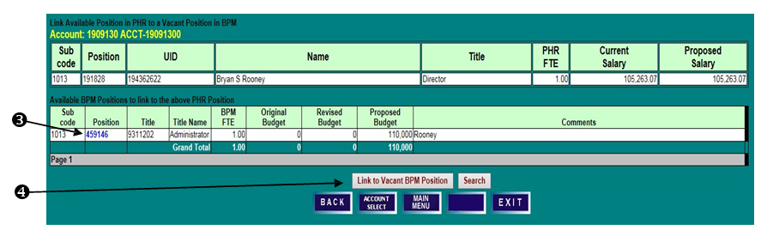
- Click on Link to Vacant BPM Position. The selected BPM position will be removed from the Vacant Budgeted Positions list and its budget will be moved to the selected available PHR position.
⬥

ACCOUNT SUMMARY SCREEN
- To view the linked budgeted position on the Position/Employee Details Screen, click on Faculty, Exempt, or Non-Exempt from the Account Summary Screen depending on the employment category of the linked employee.

POSITION/EMPLOYEE DETAILS SCREEN
- Note that the PHR position number, Category Status, Title, and subcode have superseded those of the vacant BPM position. The vacant BPM position has been deleted.
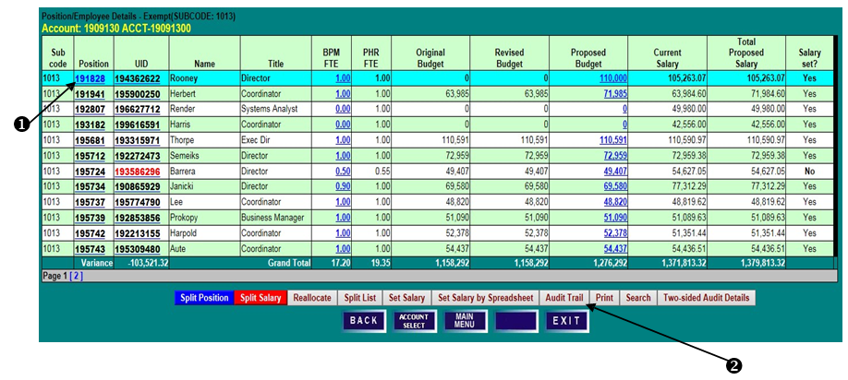
- This can be verified by selecting Audit Trail from the Position/Employee Details screen for the original BPM position Category/Status.

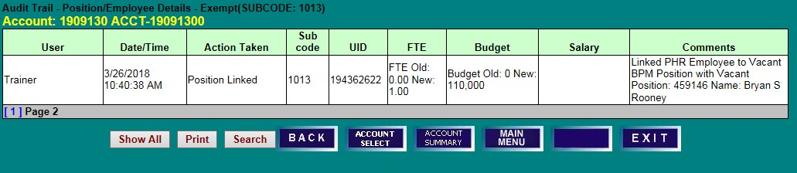
AUDIT TRAIL SCREEN

UPDATE TITLE CODE/SUBCODE, BUDGET, NAME, AND COMMENTS

VACANT BUDGETED POSITIONS SCREEN
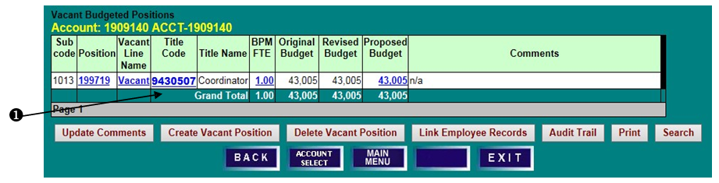
- To change the Title Code, Category Status, and Subcode, of a Vacant Position, click on the blue Title Code of a position to open an edit box.
- Select the appropriate Category Status and Title Code, and enter any necessary Comments.
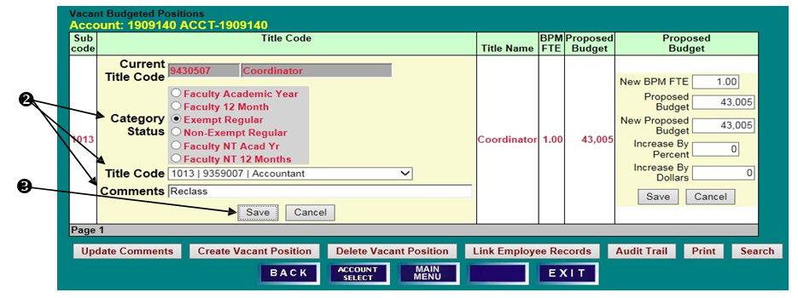
- Click Save to save changes or Cancel to reset the data. Please note that a title code change in BPM will not feed to PHR.
- Review changes to the Vacant Position’s attributes.
- To update the BPM FTE and/or Proposed Budget for the position, click on the blue Proposed Budget amount to open an edit box. 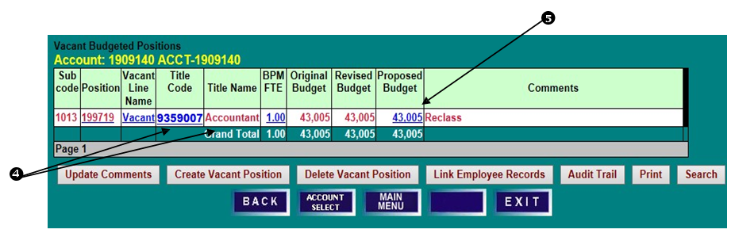

SETTING BUDGETS FOR POOLED POSITIONS

LECTURERS, FACULTY CONTRACTUAL, CONTINGENT II, AND GRADUATE ASSISTANTS

VACANT BUDGETED POSITIONS SCREEN
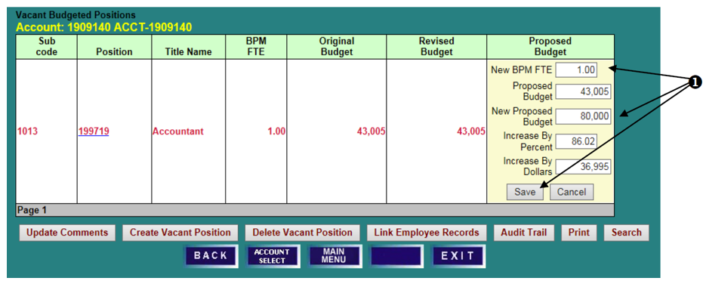
- Enter a New BPM FTE and/or change the position's Proposed Budget by percentage or dollars, and click Save.
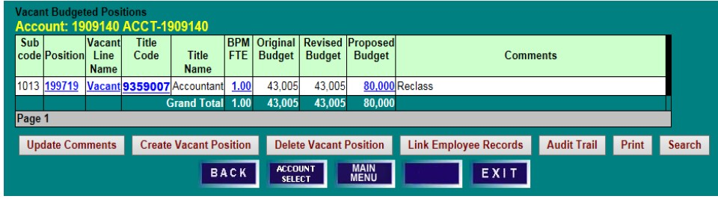

VACANT BUDGETED POSITIONS SCREEN
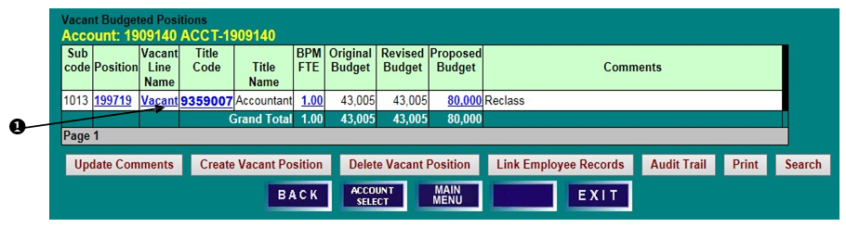
- To change the Vacant Line Name on a Vacant Position, click on the blue Vacant Line Name to open an edit box.
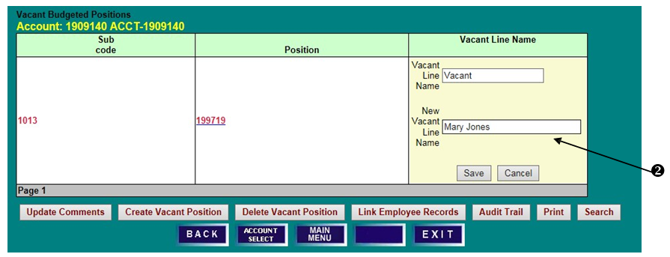
- Enter a New Vacant Line Name and click Save.
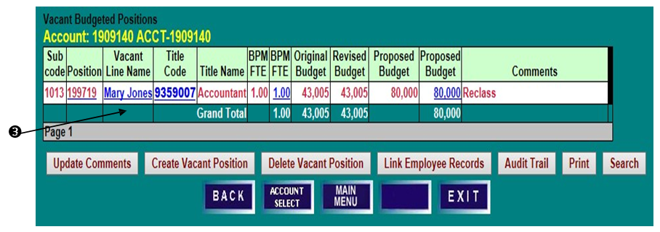
- Review changes to the Vacant Line Name attribute.

POOLED POSITION WORKSHEETS

Each pooled detail screen can be used as a worksheet to help set pooled salary budgets. New employees may
be added and deleted, and projected salaries can be changed on the worksheets. Use of the worksheets is optional. Projected salary information IS NOT fed to PHR for payroll conversion. Worksheet functionality is the same for each pooled detail screen and is described below, using the Graduate Assistant worksheet as the example.

ACCOUNT BUDGET SUMMARY SCREEN
- Access the worksheet for Lecturers, Faculty Contractual, Contingent II, or Graduate Assistants from the Account Budget Summary screen by clicking on the respective brown field name.

GRADUATE ASSISTANT DETAIL SCREEN
- Note that the Proposed Budget amount matches the budget figure on the Account Budget Summary screen, but that Projected Salary may reflect a different figure.
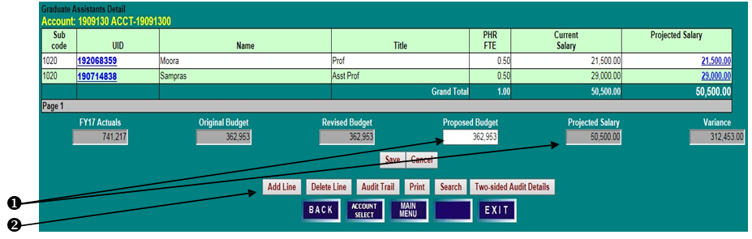
- To add a new line, click Add Line.
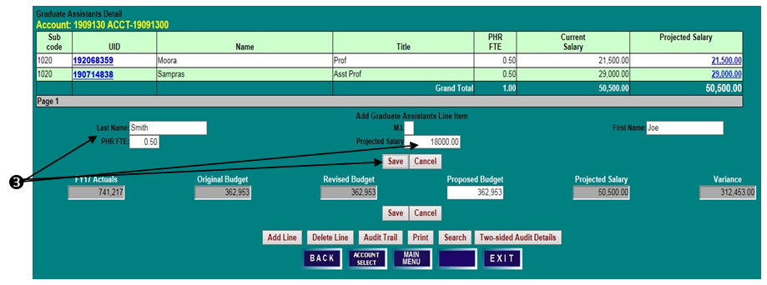
- Enter the Name, PHR FTE, and Projected Salary for the employee, and click Save.
⬥

- Confirm that the employee has been added.
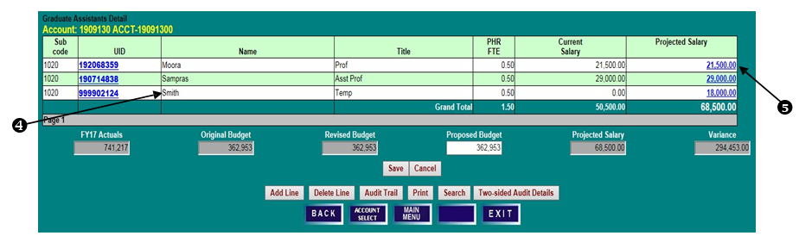
- To update the PHR FTE or Projected Salary for an employee, click on the blue Projected Salary amount to open an edit box.
- Enter a new New Projected Salary, or change by percentage or dollars, and click Save.
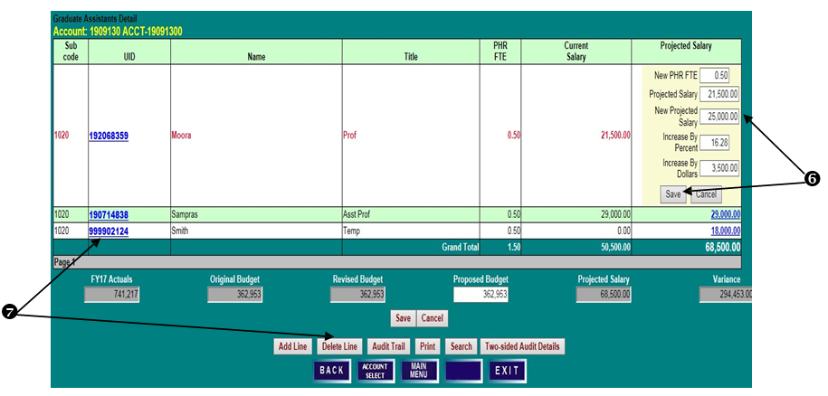
- To delete a line, click on the UID to highlight the row, and then click Delete Line. An employee line with Current Salary cannot be deleted, but that employee’s Projected Salary can be reduced to zero.

- To update the pool budget, enter the new Proposed Budget amount and click Save.
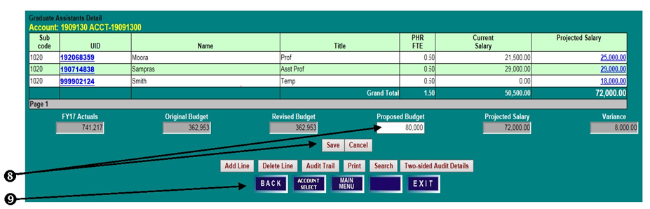
- Click Back to return to the Account Budget Summary screen to review the updated budget.

OTHER SALARY & WAGES BUDGET ADJUSTMENTS

ACCOUNT BUDGET SUMMARY SCREEN
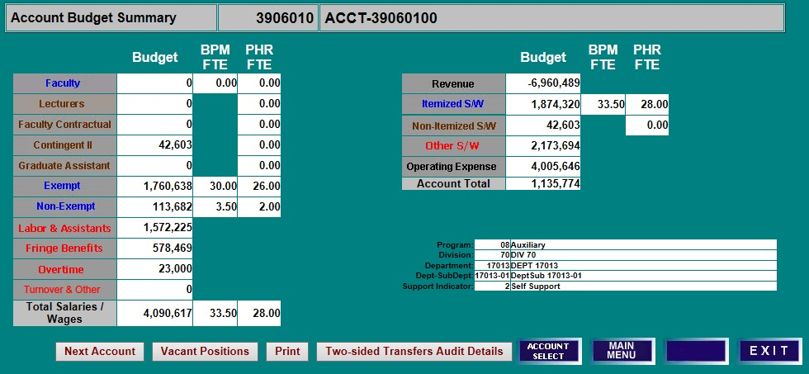
- Click on the red “Other S/W” field name to access the Other S/W Subcode Budget Details screen.

OTHER S/W SUBCODE BUDGET DETAILS
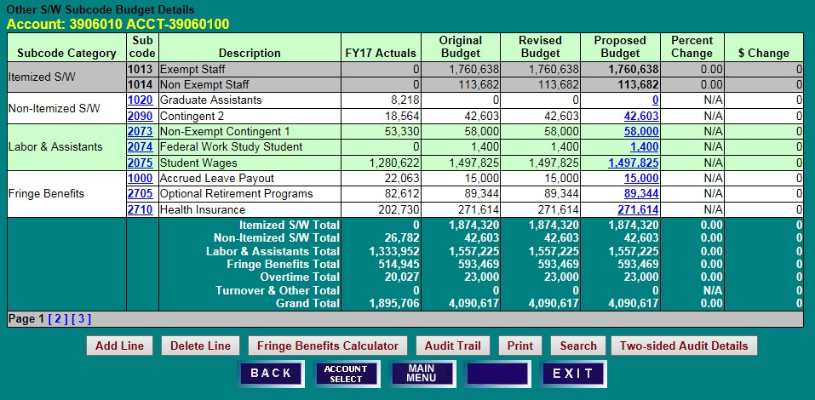
- Click on a blue “Proposed Budget” amount to open an edit box.

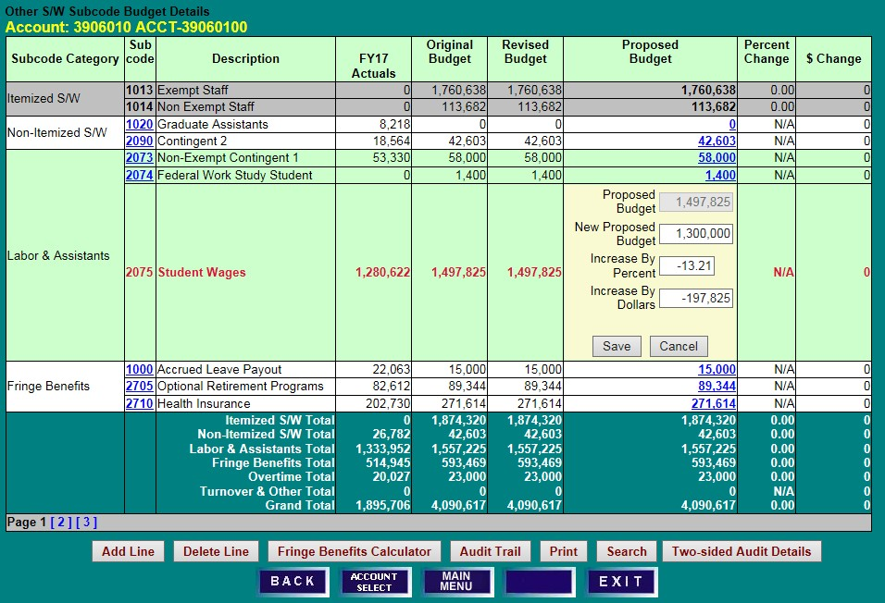
- Enter a “New Proposed Budget,” or make changes by percentage or dollars, and click “Save.”

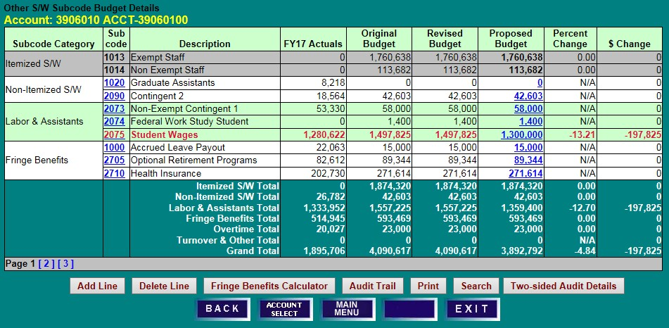
- Note the resulting “Proposed Budget” figure, as well as the “Percent Change” and “$ Change.”

OPERATING EXPENSE BUDGET ADJUSTMENTS

ACCOUNT BUDGET SUMMARY SCREEN
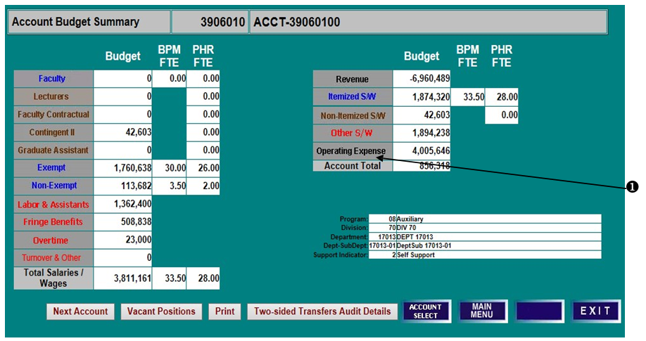
- From the Account Budget Summary screen, click on “Operating Expense” (or “Revenue”) to access the Operating Subcode Budget Details screen.

OPERATING SUBCODE BUDGET DETAILS SCREEN
- To adjust a subcode budget, click the “Proposed Budget” field to open an edit box. Enter changes and click “Save,” or click “Cancel” to leave the field unchanged.
- To add an operating budget expense subcode not already listed, click “Add Line.”
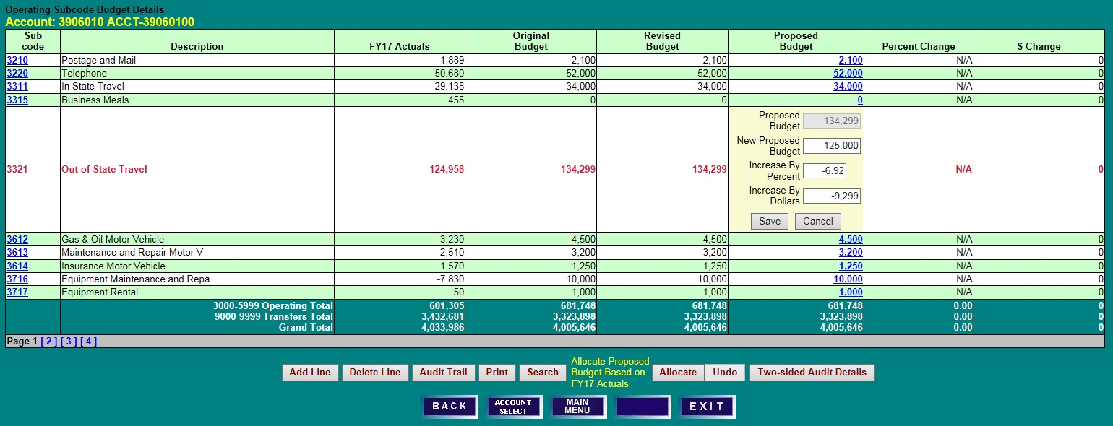

OPERATING SUBCODE BUDGET DETAILS SCREEN
- Select a “Subcode” from the drop-down box.
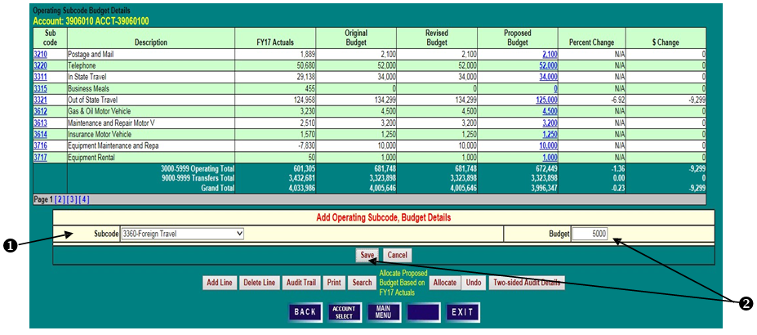
- Enter the Proposed Budget amount in the “Budget” field, and click “Save.”
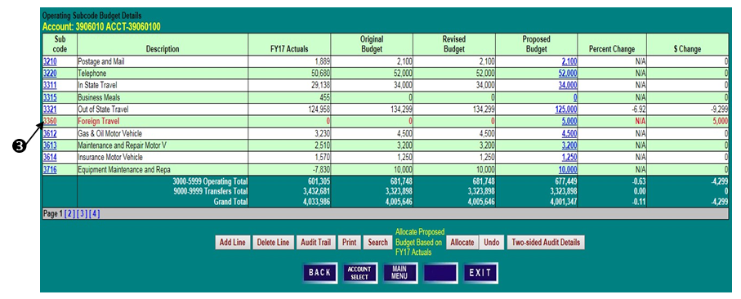
- Confirm that the new row and associated “Proposed Budget” have been added to the Operating Budget.

OPERATING SUBCODE BUDGET DETAILS SCREEN
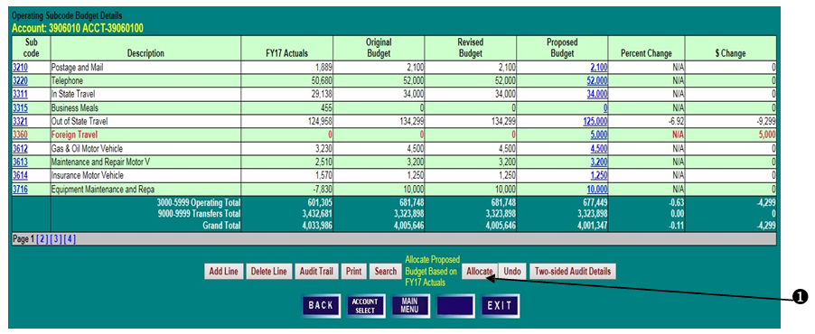
- In order to allocate “Proposed Budget” based on prior year actuals, click “Allocate.”
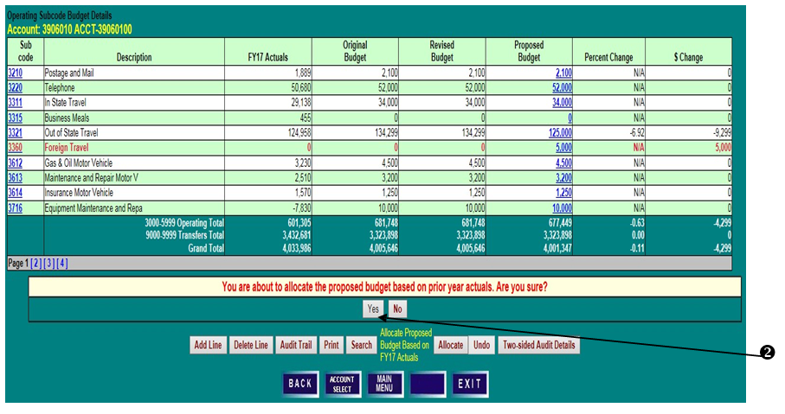
- BPM will spread the total proposed operating budget for subcodes 3000 – 5999 in the same proportion as prior year actuals were expended. Click “Yes” to proceed with the allocation or “No” to cancel the action.

OPERATING SUBCODE BUDGET DETAILS SCREEN
- Review the allocated subcode Proposed Budget amounts by subcode, as well as the percent and dollar changes.
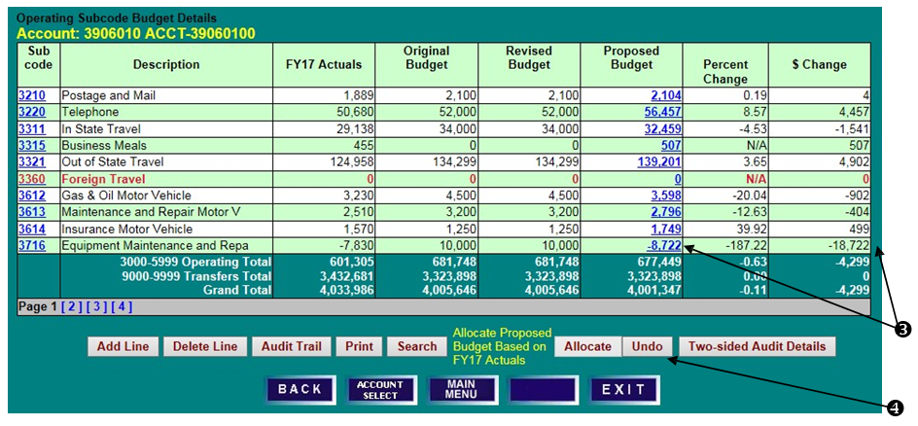
- The Allocation can be undone by clicking “Undo.” This will restore the operating subcode budgets to their original amounts.
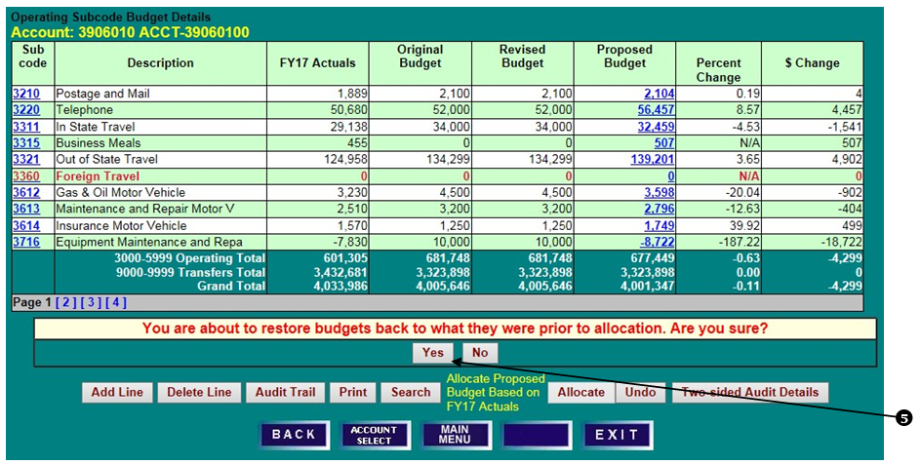
- Click “Yes” to confirm, or “No” to leave the operating budget allocation in place.

ACCOUNT BUDGET SUMMARY SCREEN
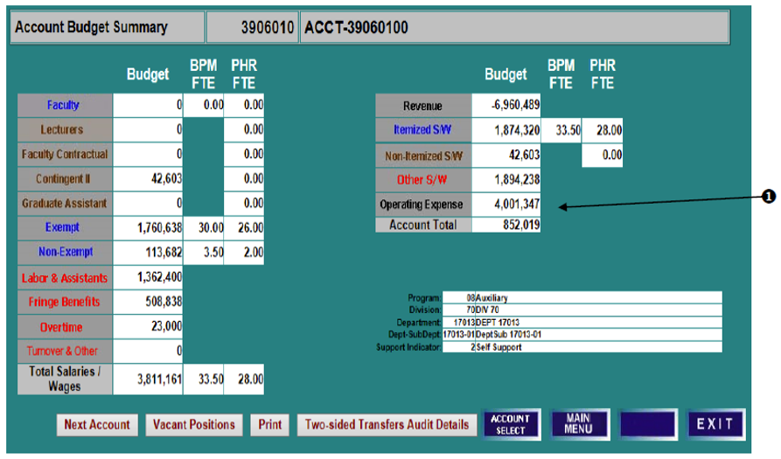
- Note that the “Operating Expense” budget figure has been updated on the Account Budget Summary screen. Also note that budget totals on this screen should agree to final BPM budget reports run for the account.

SETTING BUDGETS—EDUCATIONAL AND GENERAL (E&G) – DESIGNATED ACCOUNTS (BEGIN WITH 294 OR 295)

ACCOUNT BUDGET SUMMARY SCREEN
- E&G-Designated accounts are budgeted using the same BPM WB functionality that is available to other budgetable accounts.
- E&G-Designated accounts are non-state supported; therefore, the source of support should be budgeted, and the revenues and expenditures must net to zero at the account-level.
- If salaries will be charged to the account, both the anticipated salary and the related fringes should be budgeted.
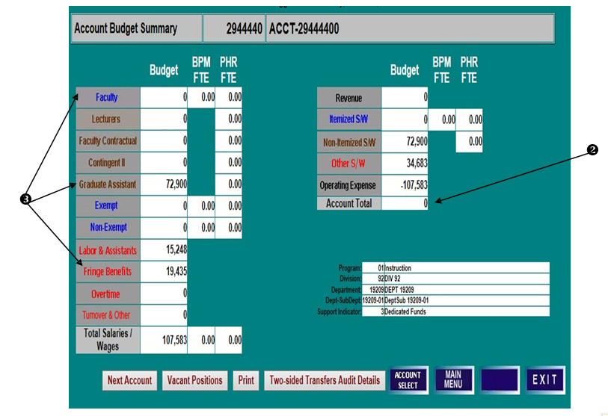

NO GROWTH OR USE OF FUND BALANCE
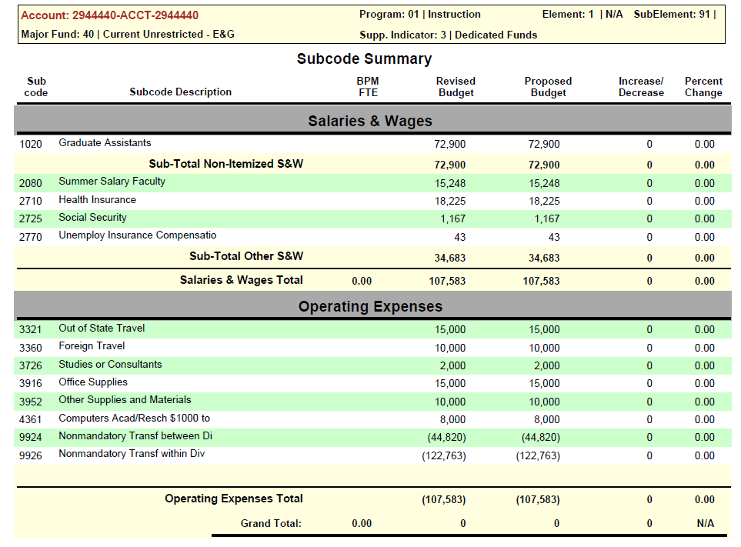
When it is anticipated that all revenue received for the current year will be expended in the current year, there will be no use of “budgeted growth” or “budgeted use” of fund balance. Please use the appropriate fringe object codes based on the FY 2021 Fringe Rates.

BUDGETED USE/GROWTH OF FUND BALANCE
If after budgeting all the expenditures expected to be incurred in FY 20XX and the revenues expected to be realized in FY 20XX, the unit determines that it is projected to add to (grow) or subtract from (use) fund balance, the unit may budget this plan in BPM.

In these situation please budget in the following object codes as appropriate:

Example | Object Code | Budget a Positive or  Negative Amount
The department expects to receive funding in FY 20XX but anticipates spending some or all of it in future years.  For example, a faculty member receives “start-up” funds in FY 20XX but expects to spend it over a three-year period. | 0966 – Budgeted  Growth of Fund Balance | Positive  For the amount of funding not expected to be expended in FY 20XX; i.e. revenues exceed expenditures
The department expects to spend into funding received in years prior to FY 20XX.  For example, a faculty member received start-up funds in a prior fiscal year and did not spend it all in that fiscal year, and expects to spend some or all of the remaining funds in FY 20XX. | 0968 – Budgeted Use of  Fund Balance | Negative  For the amount of funding from prior years expected to be  spent in FY 20XX;  i.e. expenditures  exceed revenues

These object codes may be used for any type of account budgetable in BPM WB. Object codes 0966 and 0968 are budget only object codes; i.e. no actuals should be recorded against them in KFS during the year.

BUDGETED GROWTH OF FUND BALANCE
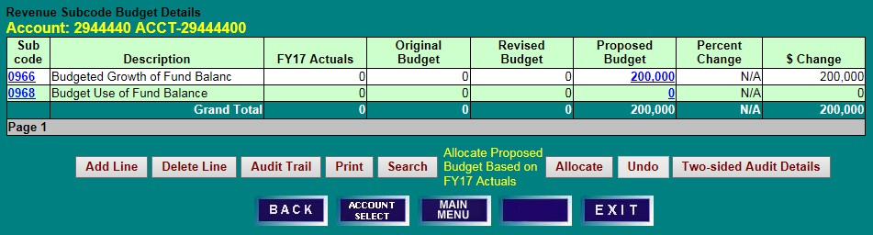
When revenues for the current year are expected to exceed expenditures, a “growth of fund balance” should be budgeted. The anticipated growth should be recorded as a positive amount in object code 0966.
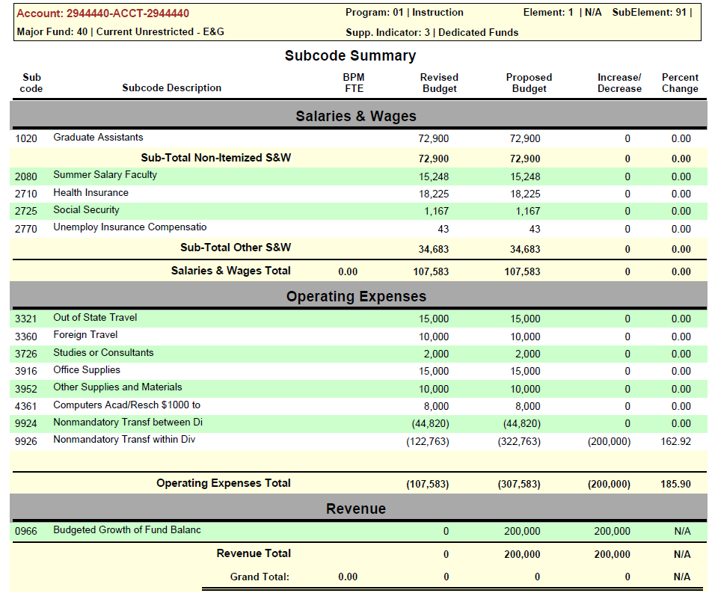

BUDGETED USE OF FUND BALANCE
When expenditures are expected to exceed revenues, a “use of fund balance” should be budgeted. The anticipated use should be recorded as a negative amount in object code 0968. Fund Balance must be available to use this object code.

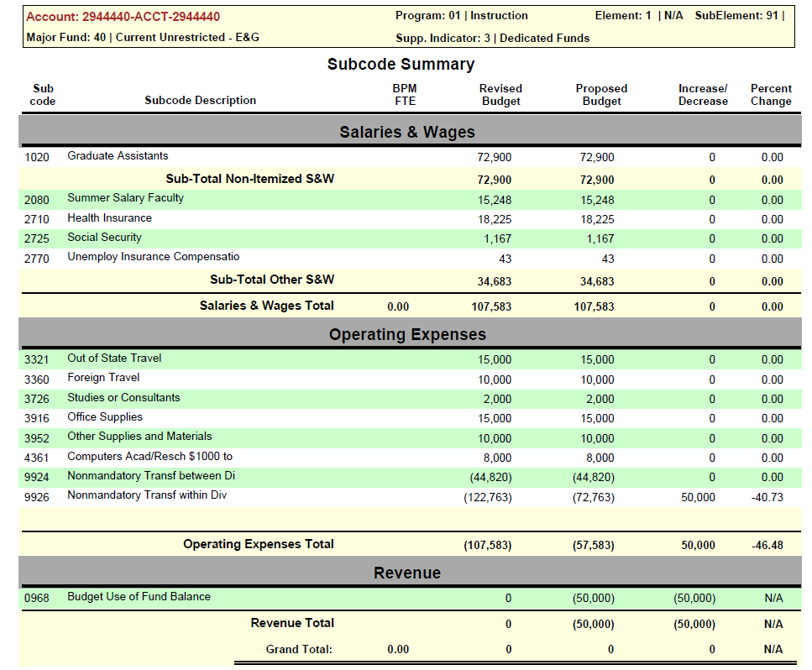
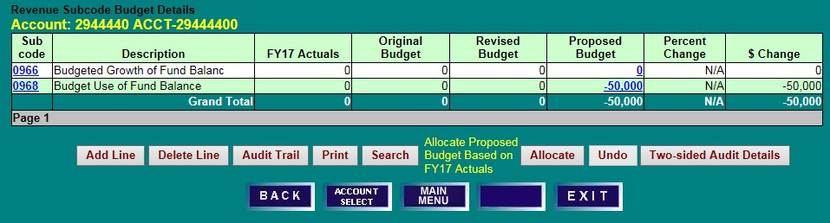

BPM REPORTS MENU

BPM MAIN MENU
- Click on “Report Menu” to access the BPM Report Menu screen.

BPM REPORTS MENU SCREEN
- Select from Executive Level, Division, Department, Sub-Department or FRS Account from the Main Category drop-down lists, and
- Select from Program, Element, Sub-Element, Major Fund Source or Support Indicator in the Secondary Category column, or
- Enter an KFS Account number, and
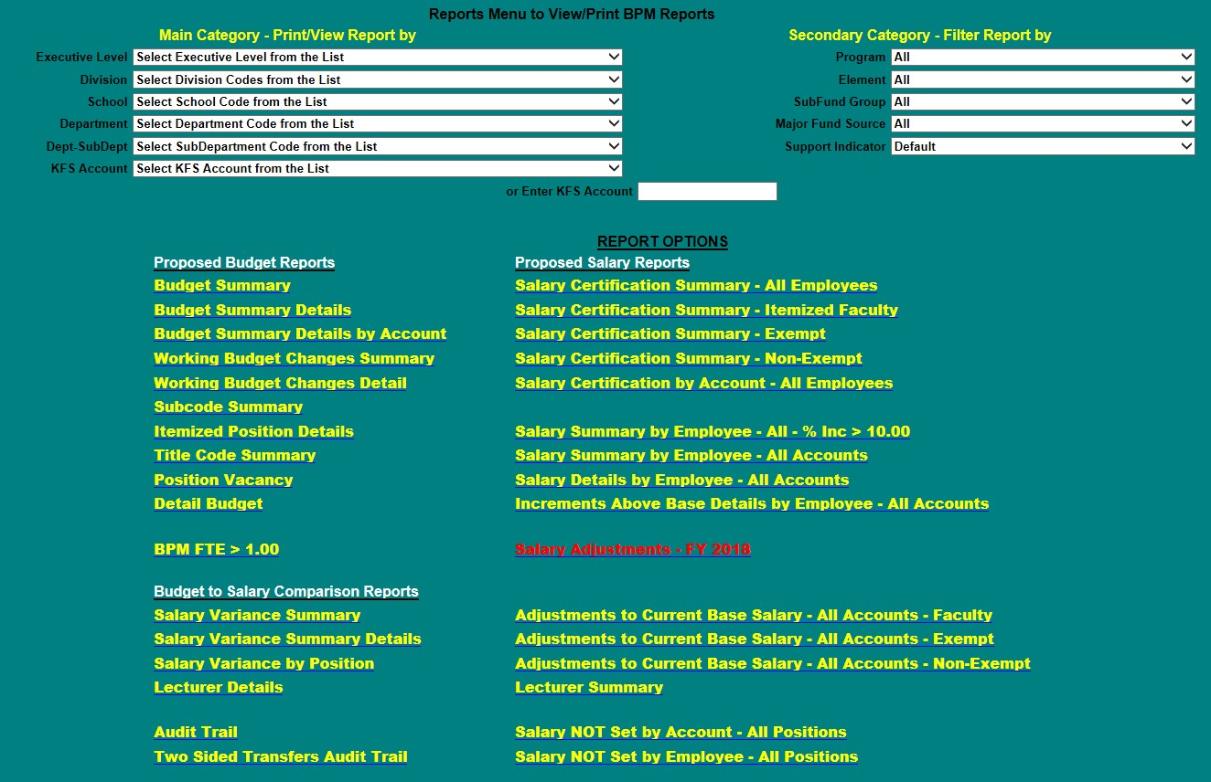
- Click on the desired report.

REPORT DESCRIPTIONS

Report Title | Description | Example Potential Use
Proposed Budget Reports
Budget Summary | Provides high-level summary of proposed budget, BPM FTE, and PHR FTE for the organization selected in ‘Main Category.’ Allows drill-down to Budget Summary Details, which shows details at the next lower organizational level than the one selected in ‘Main Category;’ i.e., departments within the division if division was selected in the ‘Main Category.’ | Serves as an ‘at-a-glance’ overall proposed budget reference for internal budget discussions.
Budget Summary Details | Provides a break-out of summarized proposed budget, BPM FTE, and PHR FTE by the next organizational level down for the one selected in the ‘Main Category.’ For example, if the organization selected in ‘Main Category’ is ‘Division,’ the Budget Summary details would show information for the departments that make up that division. Provides further drill-down to the next lower organizational level. | Research differences between proposed budget entered into BPM Working Budget and BFA’s (or college’s) Budget Tracking Sheet.
Budget Summary Details by Account | Presents Budget FTE, Salary and Operating Budgets at the account level, subtotaled by Division, Department, and Sub-Department, depending on “Main Category” selections. | Reconcile budget entered into BPM Working Budget to BFA (or college’s) budget tracking sheet.
Working Budget Changes Summary | Summarizes revised and proposed budget, including total dollar, percent changes, and BPM FTE. Also, presents BPM FTE for the proposed budget. Allows drill-down to Detail of Working Budget Changes, which shows information at lower organizational levels than the organization in ‘Main Category;’ i.e., departments within the division if division was the organizational level selected in ‘Main Category.’ | Reconcile proposed budget entered into BPM Working Budget to BFA (or college’s) Budget Tracking Sheet.  Research reconciliation differences between the proposed budget and the BFA (or college’s) Budget Tracking Sheet.  Required for Review Checklist
Working Budget  Changes Detail | Provides a break-out of summarized revised and proposed budget, including total dollar, percent changes, and BPM FTE, by the next organizational level down from the one selected in ‘Main Category;’ i.e., departments within the division if division was the organizational level selected in ‘Main Category.’ Provides further drill-down to the next lower organizational level. Also, displays BPM FTE for the proposed budget. | Research reconciliation differences between the proposed budget and the BFA (or college’s) Budget Tracking Sheet.
Subcode (Object Code) Summary | Summarizes revised and proposed budget dollars by object code with the percentage and dollar change. Also presents FTE for the proposed budget. | Use to compute turnover and compare to budget guidelines.  Confirm expected object code changes are accurate and research reconciliation differences.  Required for Review Checklist
Itemized Position Details | Provides revised and proposed budget details by account then object code, position number, and title code along with BPM FTE, dollar and percentage change. | Confirm budgets have been updated for each position and assess the reasonableness of the budgets.
Title Code Summary | Summarizes revised and proposed budget dollars by title code with the dollar and percentage change. Also presents BPM FTE for the proposed budget. | Assess overall reasonableness of proposed itemized personnel budget (dollars and FTE).
Position Vacancy | Provides revised and proposed budget for each vacant position, sorted by account then by object code. Also provides BPM FTE, dollar and percentage change, and comments. | Assess accuracy of vacant positions (whether truly vacant and appropriateness of budget).
Detail Budget | Provides details of budget by account, then object code, of itemized positions, non-itemized positions, and operating (non-salary and wages) budget. | Research details of summarized budget.  For future reference purposes, print or save an electronic version when the working budget is finalized.  Required for Review Checklist
BPM FTE > 1 | Provides positions whose BPM FTE in total is greater than 1.00. | Identify positions over budgeted that need to be fixed to not exceed 1 FTE.  Required for Review Checklist
Budget to Salary Comparison Reports
Salary Variance Summary | Compares summarized proposed budget to proposed salary and BPM FTE to PHR FTE. Provides drill-down to the Salary Variance Summary Details as well as the Salary Variance by Position report at the next lower organizational level. | Verify proposed salaries have been adequately budgeted.
Salary Variance  Summary Details | Provides a break-out of the comparison of summarized proposed budget to proposed salary and BPM FTE to PHR FTE by the next organizational level down for the one selected in the ‘Main Category.’ Provides further drill-down to the next organizational level or to the Salary Variance by Position report. | Research salary to budget comparison variances and assess reasonableness of budget.
Salary Variance by Position | Compares position-level proposed budget to proposed salary and BPM FTE to PHR FTE summarized at the next organizational level down for the one selected in the ‘Main Category.’ | Research salary to budget comparison variances, and assess reasonableness of budget.  Required for Review Checklist
Audit
Audit Trail Report | Details changes made to the working budget. | Research adjustments made to the working budget.
Proposed Salary Reports
Salary Certification Summary  - All Employees  - Itemized Faculty  - Exempt  - Non-exempt  - By Account | Provides proposed salary details (COLA, merit, etc.) in the organizational level selected in ‘Main Category.’ If the employee’s funding spans multiple organizations, the report only shows the portion of the salary within the organization selected. The first four summarize by employee and then provide the details for the accounts within the organization. The last report “By Account” is ordered by the accounts within the organization and then by the employees within that account. | Verify proposed salaries have been set for employees appropriately; i.e., Total salary is equal to base salary and increments in ARS PLUS approved COLA, merit, retention and promotion.
Salary Summary by  Employee – All - % Incr > 10.00 | Identifies persons whose proposed salary increase (the combination of COLA, merit, retention, equity, and other) on all accounts paid exceeds 10% of the person’s adjusted current base. | Identify persons whose proposed salaries may need the President’s approval as the increase exceeds 10% of the person’s adjusted current base.  Required for Review Checklist
Salary Summary by Employee –  All Accounts | Provides total proposed salary (all accounts paid on) for all persons who have all or a portion of their salary within the organization selected in ‘Main Category.’ | Verify total proposed salary for the employee is reasonable.
Salary Details by Employee – All Accounts | Breaks down an employee’s total proposed salary by account. Provides an account-level detail of the Salary Summary by Employee –All Accounts. | Research composition of an employee’s total proposed salary from all sources.  Required for Review Checklist
Increments Above Base Details by Employee – All Accounts | Provides detail of current and proposed administrative and acting salary increments. | Identify and verify employee administrative and acting increments that should be included in proposed salary budgets. Please note that increments are not used for payroll conversion.
Salary Adjustments | Provides changes to salaries made by users to total proposed salary (all accounts paid on) for all persons who have all or a portion of their salary within the organization selected in ‘Main Category.’ | Identify persons for whom salary changes were made and verify salary changes inputted are accurate.  Required for Review Checklist
Adjustments to Current Base Salary – All Accounts-Faculty | Provides a detail of current base adjustments to faculty salaries; i.e., moves, reallocations and terminations, return from sabbatical or leave, and other faculty adjustments. | Verify adjustments to current base are appropriate.  Required for Review Checklist in years when COLA and Merit are applicable
Adjustments to Current Base Salary – All Accounts-Exempt | Provides a detail of current base adjustments to exempt salaries; i.e., increases to salary range minimum, moves, reallocation or termination, and reclasses after freeze and before 7/1. | Verify adjustments to current base are appropriate.  Required for Review Checklist in years when COLA and Merit are applicable
Adjustments to Current Base Salary – All Accounts-Non-Exempt | Provides a detail of current base adjustments to non-exempt salaries; i.e., increase to salary range minimum, complete probation before 7/1, move, reallocation or termination, and early completion of probation before July 1st. | Verify adjustments to current base are appropriate.  Required for Review Checklist in years when COLA and Merit are applicable
Salary Not Set by Account – All Positions | Identifies persons whose salaries have not been set in the accounts belonging in the organization selected in ‘Main Category’. | Verify all salaries have been set in the accounts for which you are responsible.
Salary Not Set by Employee  – All Positions | Identifies persons whose salaries have not been set in the entirety. | Verify all salaries have been set (in total) for all employees.  Required for Review Checklist in years when COLA and Merit are applicable

BUDGET SUMMARY

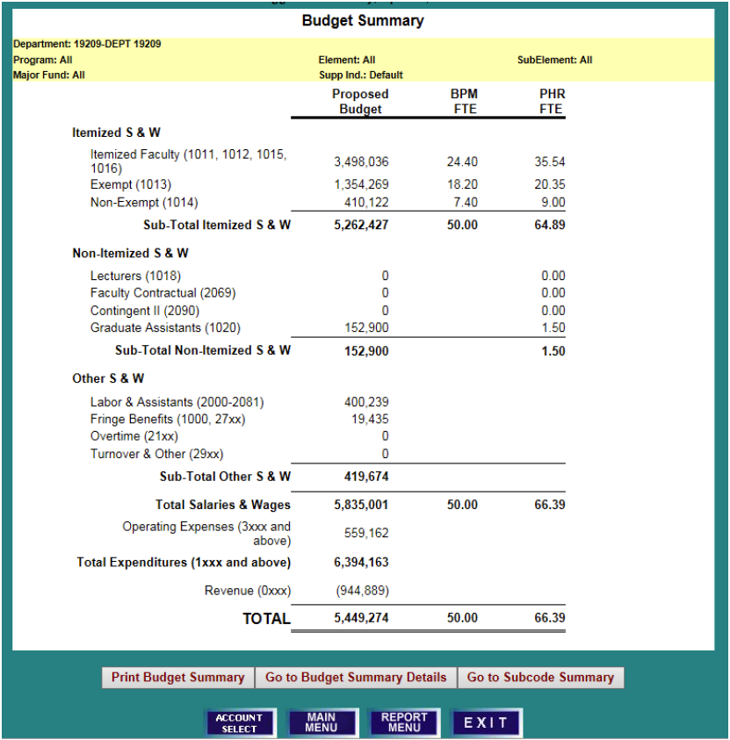

BUDGET SUMMARY DETAILS

- Click on the hyper-linked (blue letters and numbers) to drill-down to further details.

First Drill-down: From Department/Sub-Department to Accounts
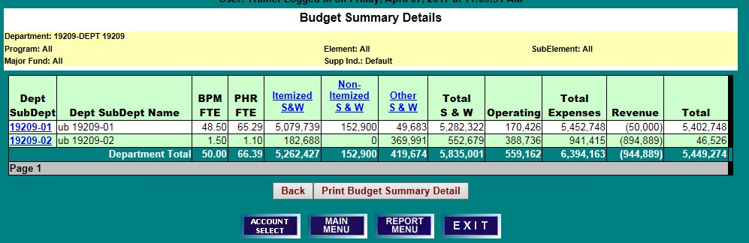

Second Drill-down: From Account Budget Summary to Itemized S&W Summary
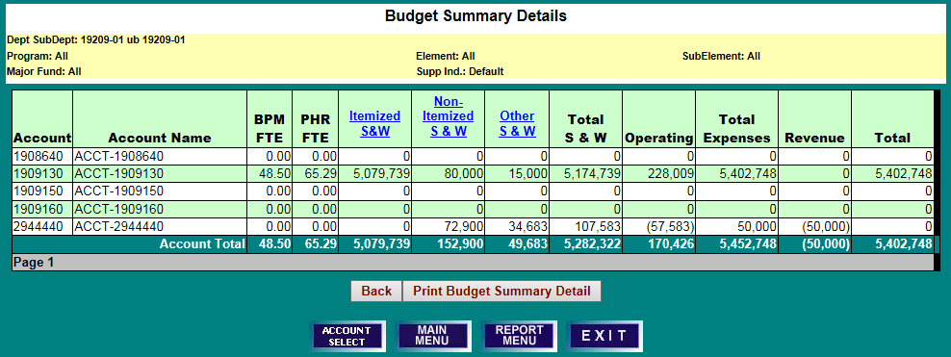

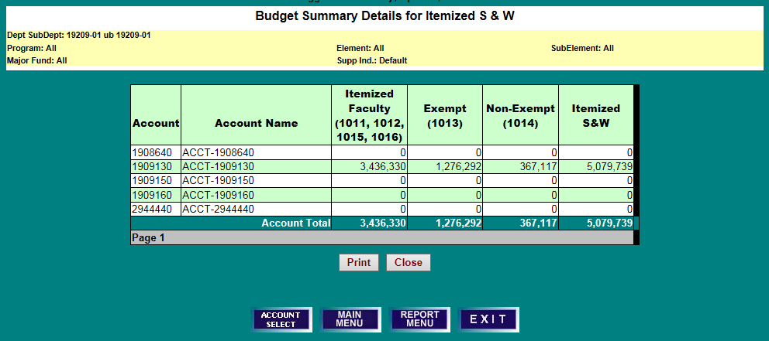

BUDGET SUMMARY DETAILS BY ACCOUNT

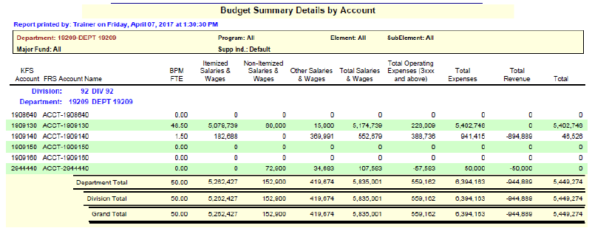

WORKING BUDGET CHANGES SUMMARY
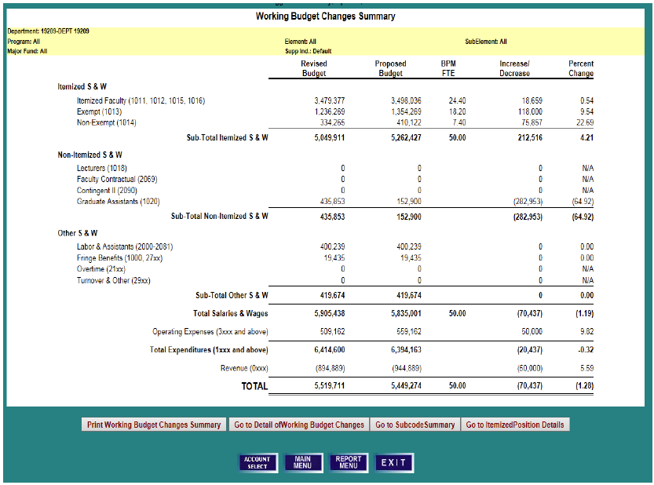

WORKING BUDGET CHANGES DETAIL

- To Print, Go to Further Details, Go to Subcode (Object Code) Summary, or Go to Itemized Position Details, first click on the hyper-linked letters in the green unit header line.
- Then click on the “Print” or “Go to” action desired.
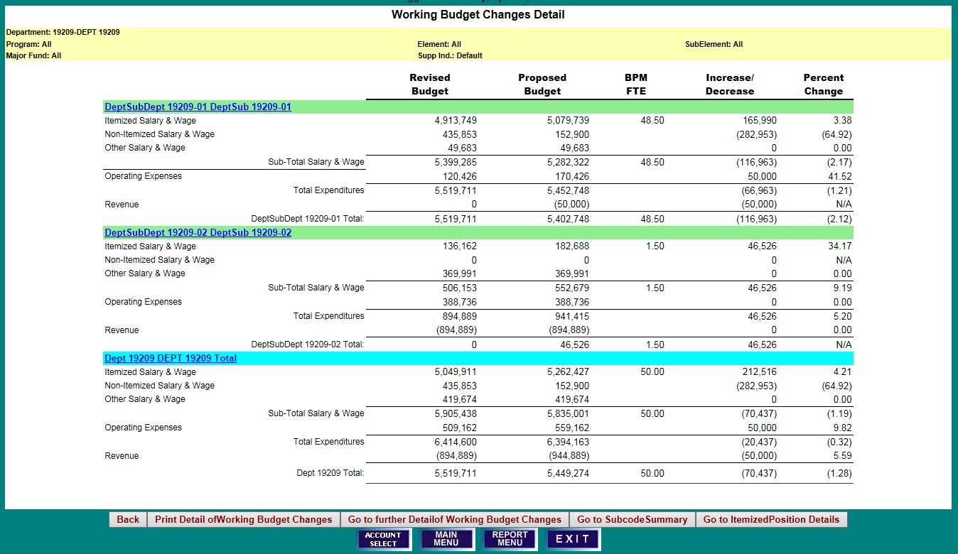

SUBCODE SUMMARY
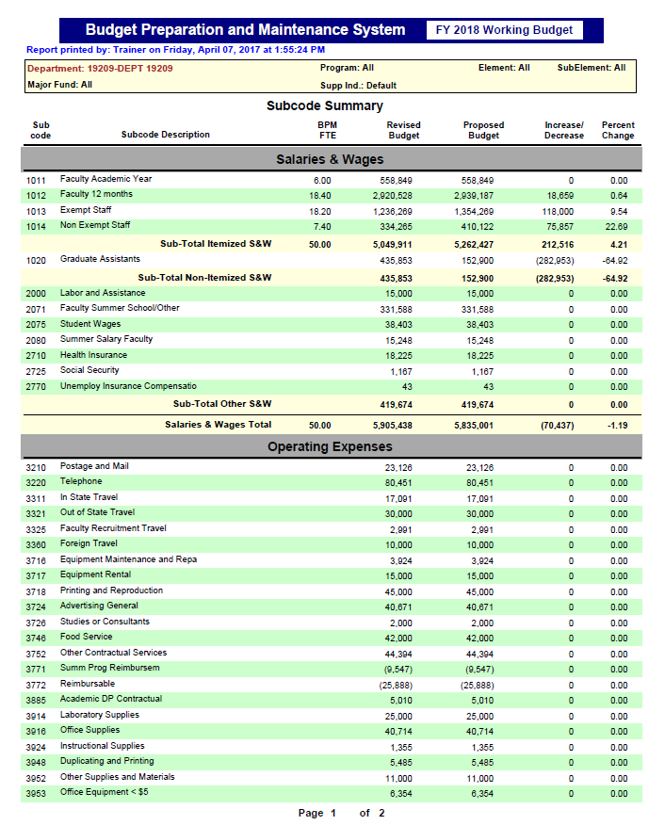

SUBCODE SUMMARY (CONTINUED)

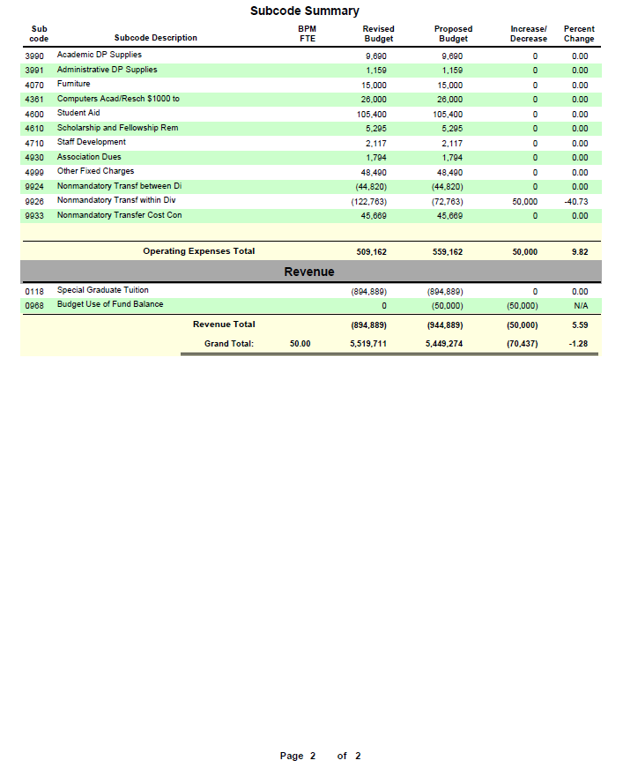

ITEMIZED POSITION DETAILS

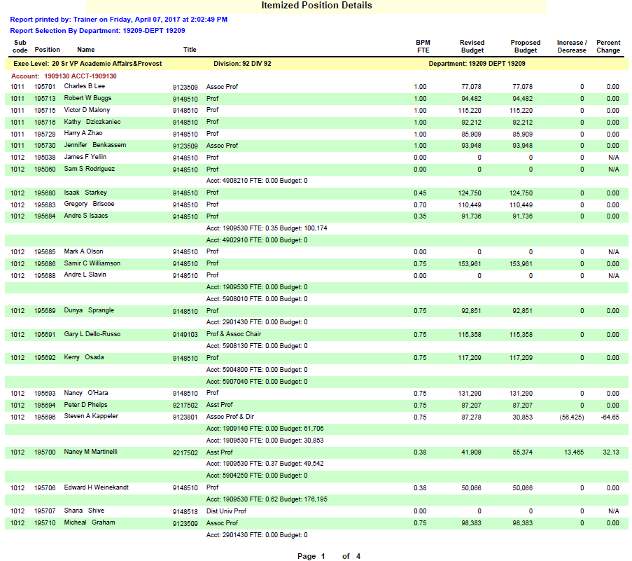

TITLE CODE SUMMARY

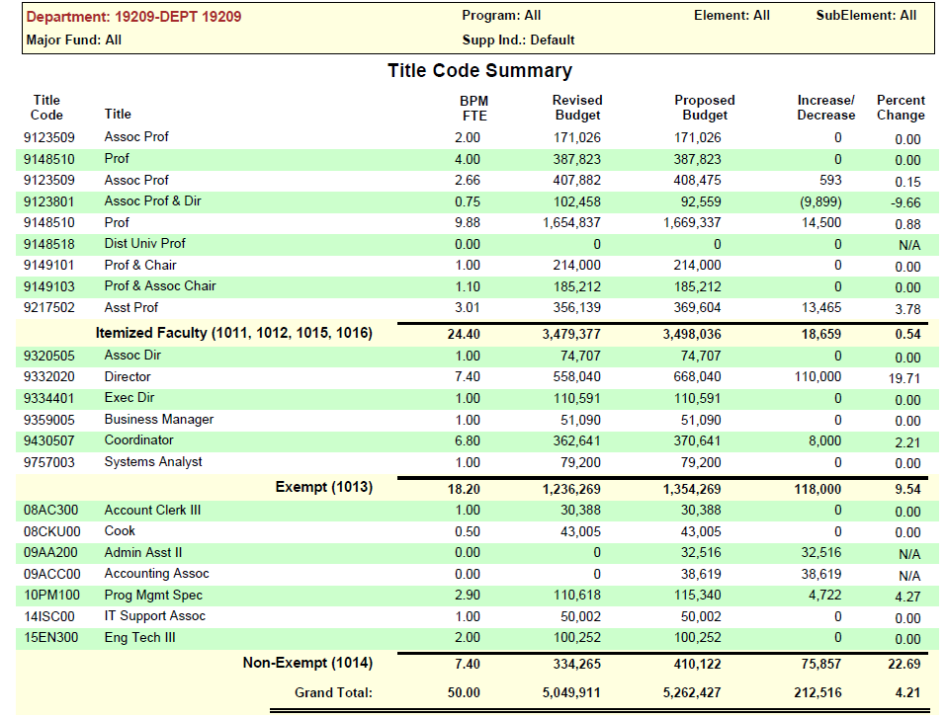

POSITION VACANCY

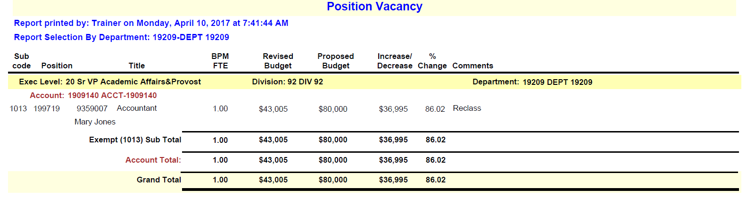

DETAIL BUDGET

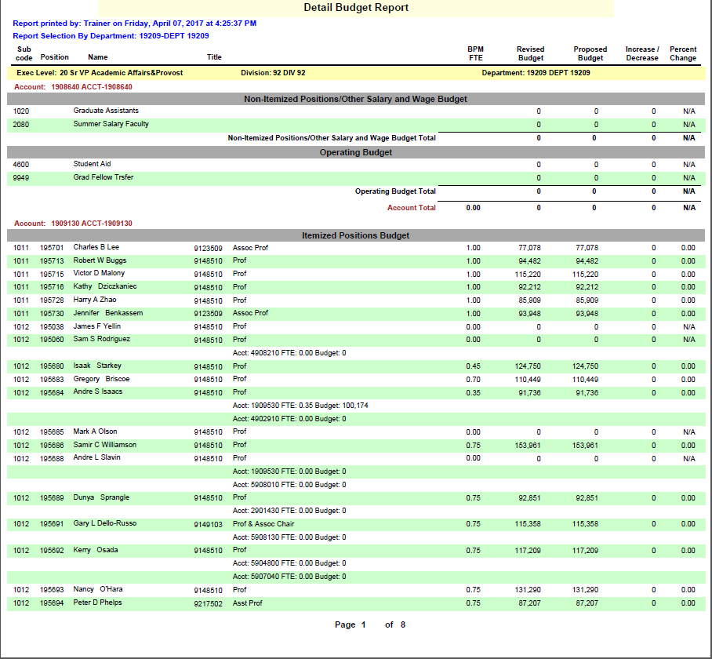

BPM FTE > 1

If this report shows any data, correct the FTE by moving the FTE to another position that needs Budget FTE.
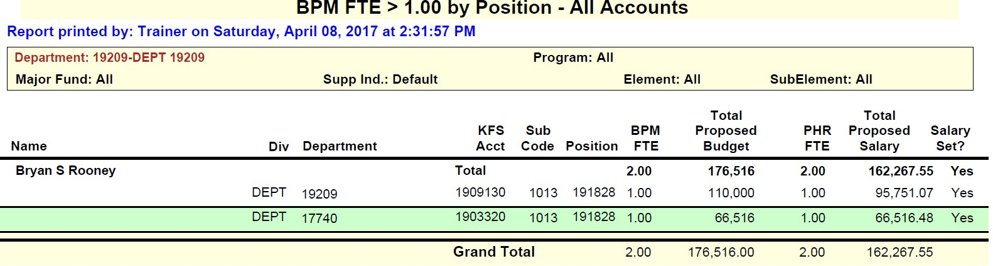

The message below should be received.

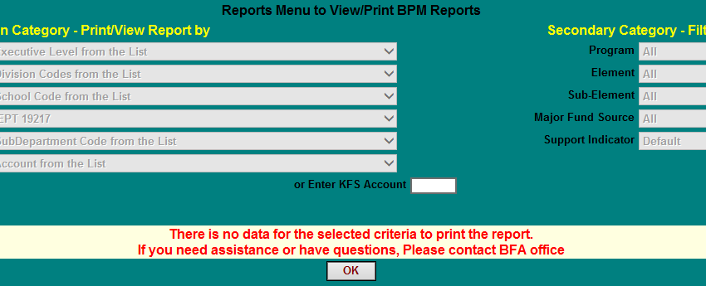

SALARY VARIANCE SUMMARY

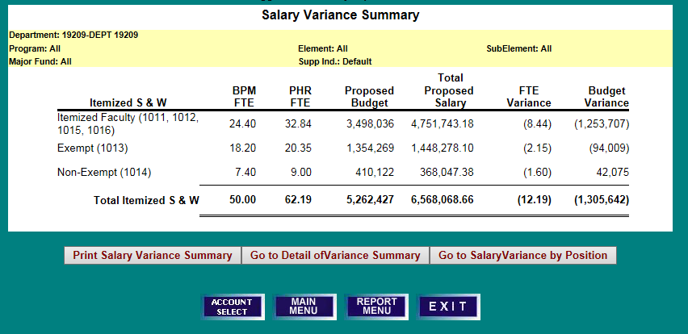

SALARY VARIANCE SUMMARY DETAILS

- To Print, Go to Further Details of Salary Variance Summary, or Go to Salary Variance by Position, first click on the hyper-linked letters in the green unit header line.
- Then click on the “Print: or “Go to” action desired.
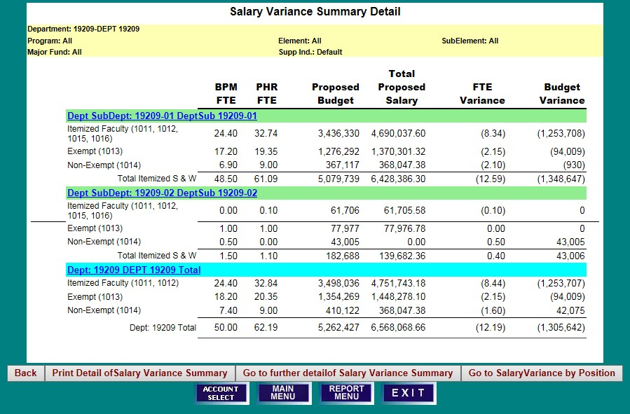

SALARY VARIANCE BY POSITION
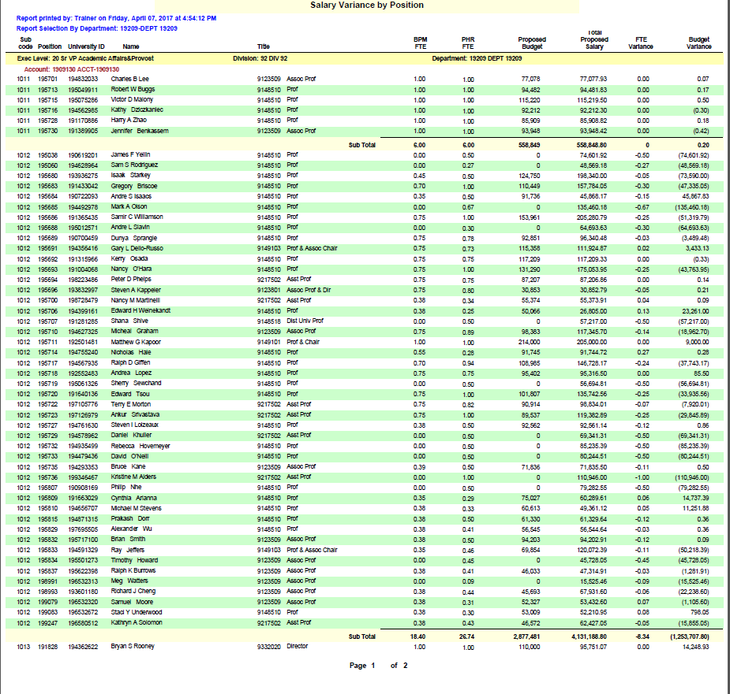

AUDIT TRAIL
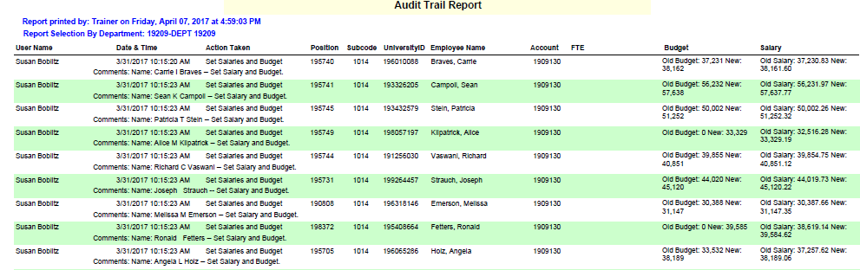

TWO-SIDED AUDIT TRAIL

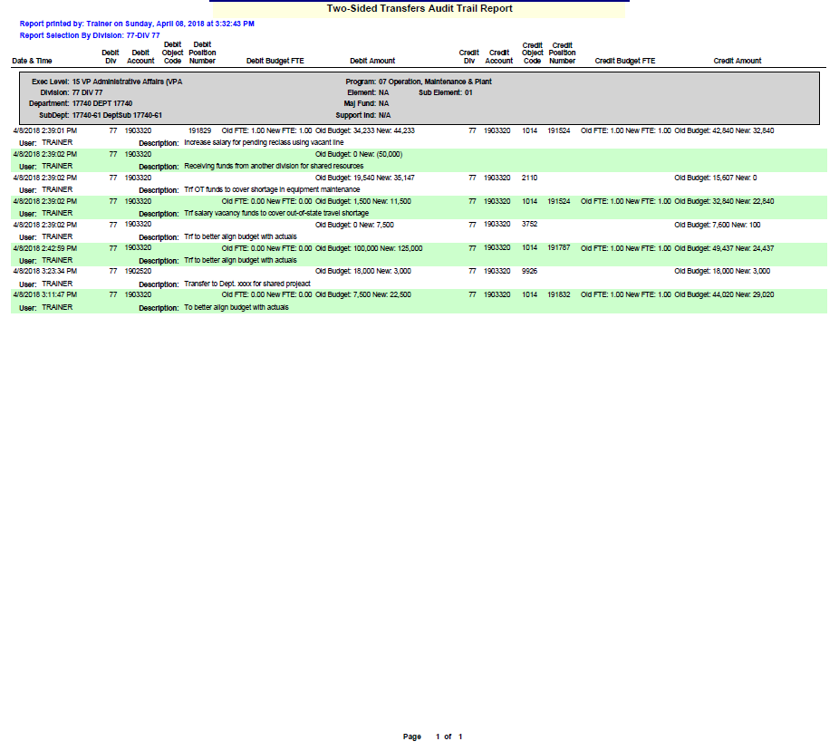

SALARY CERTIFICATION SUMMARY - ALL EMPLOYEES

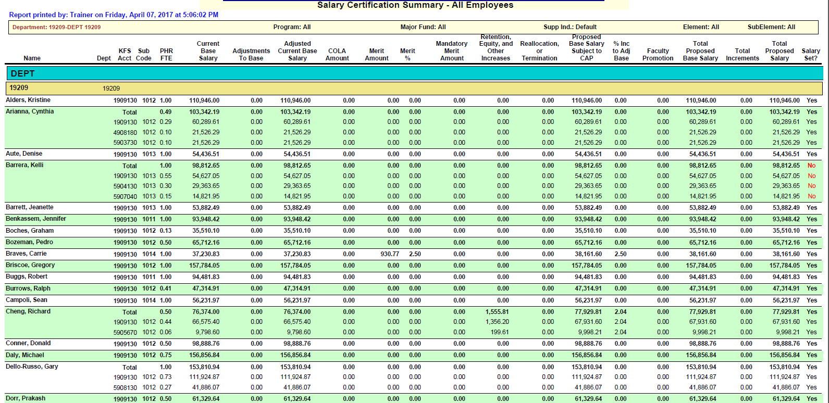

SALARY CERTIFICATION BY ACCOUNT - ALL EMPLOYEES
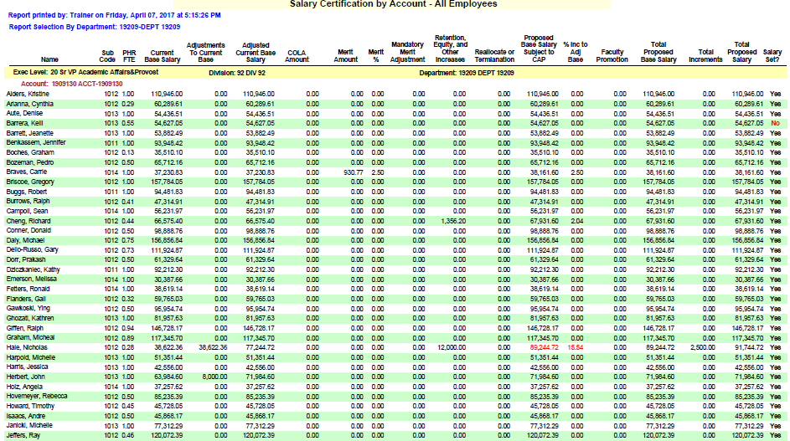

SALARY SUMMARY BY EMPLOYEE - ALL - % INCR > 15.00

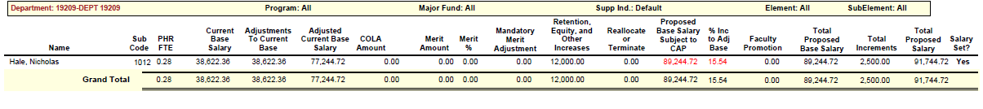

SALARY DETAILS BY EMPLOYEE - ALL ACCOUNTS

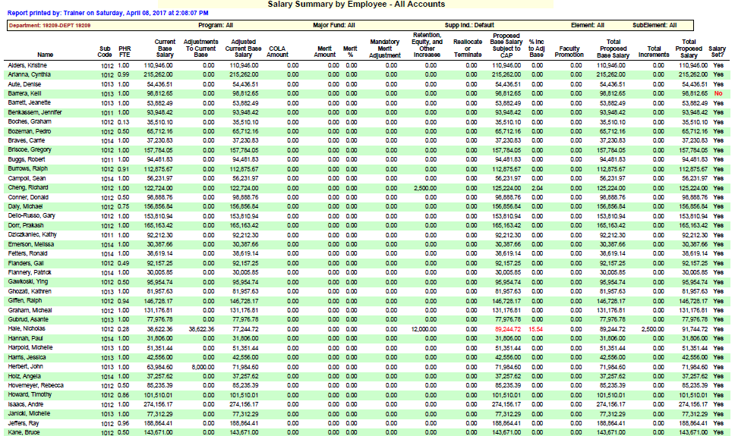

SALARY DETAILS BY EMPLOYEE - ALL ACCOUNTS

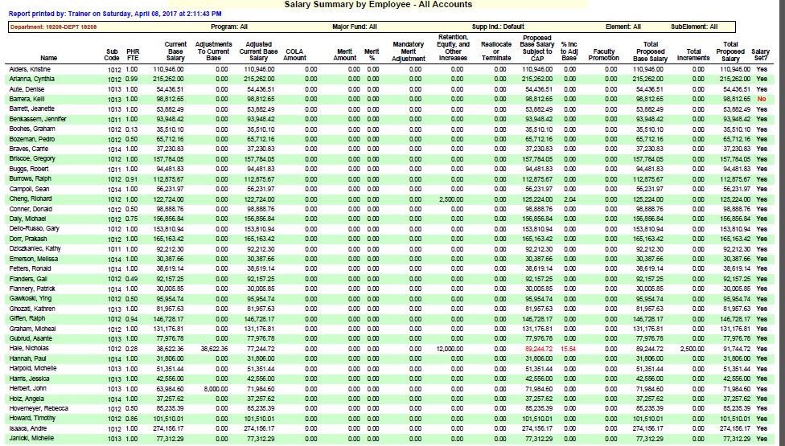

INCREMENTS ABOVE BASE DETAILS BY EMPLOYEE - ALL ACCOUNTS
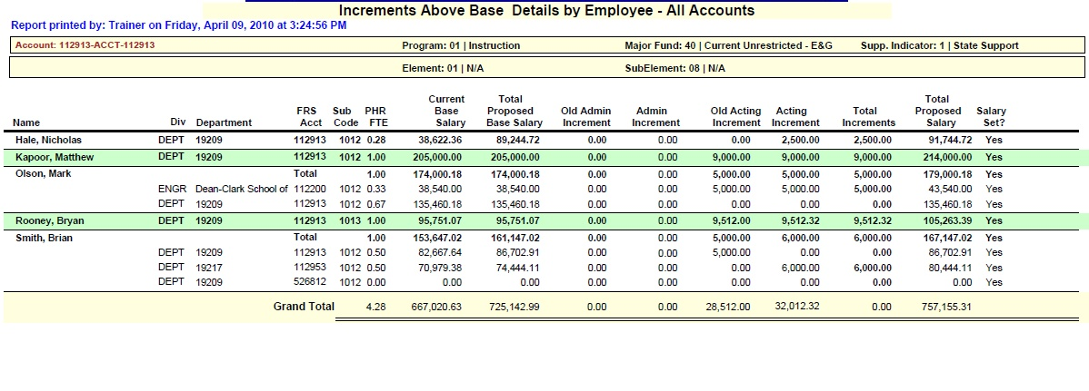

SALARY ADJUSTMENTS

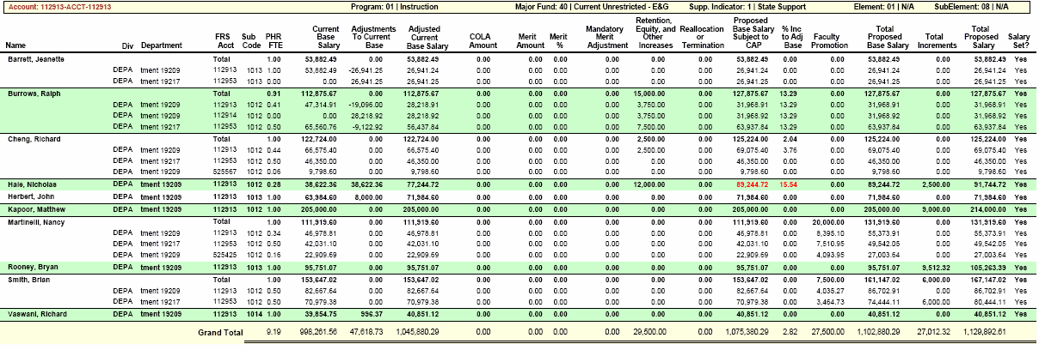

ADJUSTMENTS TO CURRENT BASE SALARY - ALL ACCOUNTS–FACULTY
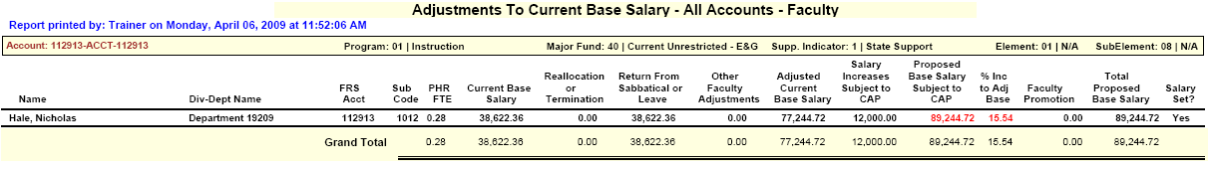

ADJUSTMENTS TO CURRENT BASE SALARY - ALL ACCOUNTS–EXEMPT
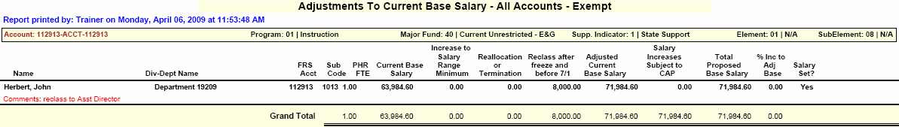

ADJUSTMENTS TO CURRENT BASE SALARY - ALL ACCOUNTS–NON-EXEMPT
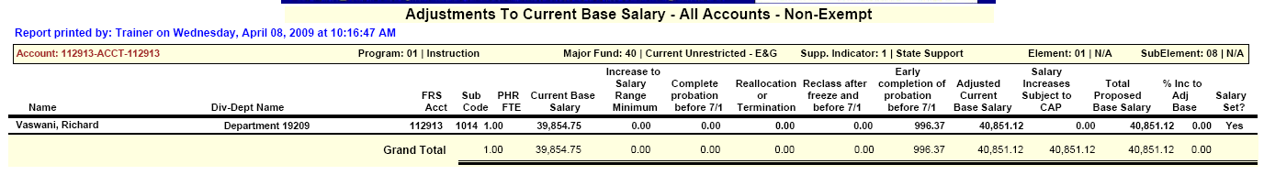

SALARY NOT SET BY ACCOUNT - ALL POSITIONS &

SALARY NOT SET BY EMPLOYEE - ALL POSITIONS

APPENDIX

SALARY SETTING SCREEN FIELD DEFINITIONS

ADJUSTMENTS TO CURRENT BASE SALARY | PURPOSE | RESPONSIBILITY
ALL TYPES OF EMPLOYEES
Reallocation of Current Base | Amounts (+ and -) transferred between accounts are calculated and automatically updated by BPM system from a reallocation of adjusted current base salary in the “Reallocate Salary” screen. Please see the example “Reallocate Salary to Multiple Funding Sources.” Adjusted current base salary is the base salary that is in effect at the close of business June 30th and is the starting point for any July 1st salary increases. | System update
FACULTY
Return From Sabbatical or Leave | Enter the amount needed to restore the current year salary to the normal pay level for a faculty member returning from sabbatical leave, or an extended leave without pay, at the beginning of next year. | User update
Other Faculty Adjustments | Enter the dollar amount of:  a) administrative increment that is being converted to base salary in the next fiscal year, or  b) base salary increase in the current year for a  promotion or reclass processed after the PHR freeze and effective before July 1.  Enter comments to explain the reason for Other  Faculty Adjustments. | User update
EXEMPT & NON-EXEMPT
Increase to Minimum of Salary Range | Enter the increase to employee salary required by changes to the Board of Regents’ approved salary range minimums. | User update
Reclass after freeze and before July 1 | Enter the dollar amount of the base salary increase in the current year for a promotion or reclass processed after the PHR freeze and effective before July 1. | User update
NON-EXEMPT
Completion of Original or Promotional Probation before July 1 | Enter a 2.5% increase to employee salary when probation is completed on schedule, after freezing PHR data for BPM, but before July 1. | User update
Early Completion of Original or Promotional Probation before July 1 | Enter a 2.5% increase to current base for an employee who completes probation early and before July This is limited to non-bargaining unit employees only. | User update

SALARY SETTING SCREEN DEFINITIONS
PROPOSED SALARY INCREASES | PURPOSE | RESPONSIBILITY
Proposed Salary Increases Subject to Cap
COLA | The Cost Of Living Adjustment is automatically calculated and loaded into BPM in years that COLA is applicable. The system re-calculates and loads this amount for any Adjustments to Current Base Salary that are processed. | System calculation
Merit - Faculty & Exempt | In years merit is applicable, enter either the percent or amount of merit increase for the employee, or for the employee/account if setting salary for a split-funded employee at the account level. | User update
Merit - Non-Exempt | A merit increase calculated as 2.5% of Adjusted Current Base Salary + COLA will be loaded into BPM, in years merit is applicable. | System calculation
Mandatory Merit Adjustment - Non-Exempt | In years merit is applicable, reduce employee salary by amount that exceeds the maximum of the pay range (BFA will notify unit of appropriate amount), eliminate Merit for any employee who does not meet expectations on his or her performance review, or eliminate merit for employees who will be on initial or promotion probation as of July 1st. Enter comments to explain the adjustment. | User update
Retention, Equity, & Other Increases - Faculty & Exempt only | Enter the amount of any other proposed base salary increase except faculty promotion. Enter comments to provide the reason for the increase. | User update
Reallocation of Proposed  Base | Amounts (+ and -) transferred between accounts are calculated and automatically updated by the BPM system for a reallocation between accounts processed on a split-funded salary AFTER the new fiscal year salaries are set, or for termination prior to July 1. | System update
Other Proposed Salary Increase NOT subject to CAP - Faculty Only
Faculty Promotion | Enter the dollar amount for a faculty promotion. This amount will be included in Proposed Base Salary, but excluded in identifying increases exceeding the increase cap. | User update
Increments Above Base
Administrative & Acting  Increments | Current year administrative and/or acting increment total amounts will be loaded into BPM for budget and reporting purposes only. The user can update the proposed year "New" amount that is displayed in the employee's total salary and choose to include it in the position budget. These amounts are NOT included in the proposed salary amount converted to PHR as July 1 salary. A PHR action must be completed in order for the employee to receive an administrative or acting increment. | System load  User update

