BPM – Citrix Virtual Workspace – Frequently Asked Questions (FAQs)
Contents
1. How to ensure Citrix Receiver is active 2
2. BPM Login Error - ‘The user is not authorized to work in Budget System’ 3
3. Multiple Monitors Error – BPM screen off center – unable to make user selections/inputs 10
4. Alternate Login – Citrix Workspace App (MUST HAVE CITRIX RECEIVER INSTALLED & DUO MOBILE APP) 13
5. BPM Time-Out Error – ‘Server Error in ‘/’ Application’ 17
6. How to expand the BPM window 18
7. Saving/Viewing Reports: 19
A. Viewing Reports 19
B. Saving Reports – (MUST HAVE CITRIX RECEIVER INSTALLED) 21
C. PDF File Format Not Saving 23
8. Citrix Workspace Will Not Close 24
9. Blocked Page Error 25

How to ensure Citrix Receiver is active

On the Virtual Workspace screen Click the gear icon in the upper right-hand side of the screen -> Click ‘Account Settings’ -> Click ‘Change Citrix Receiver -> Click ‘Detect Receiver’ -> proceed with launching the BPM application and logging in
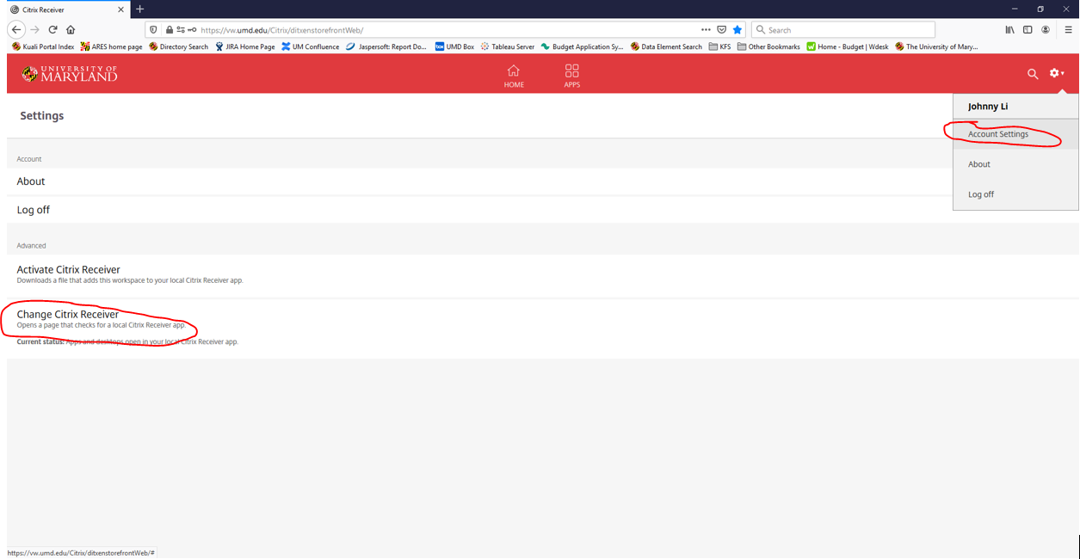
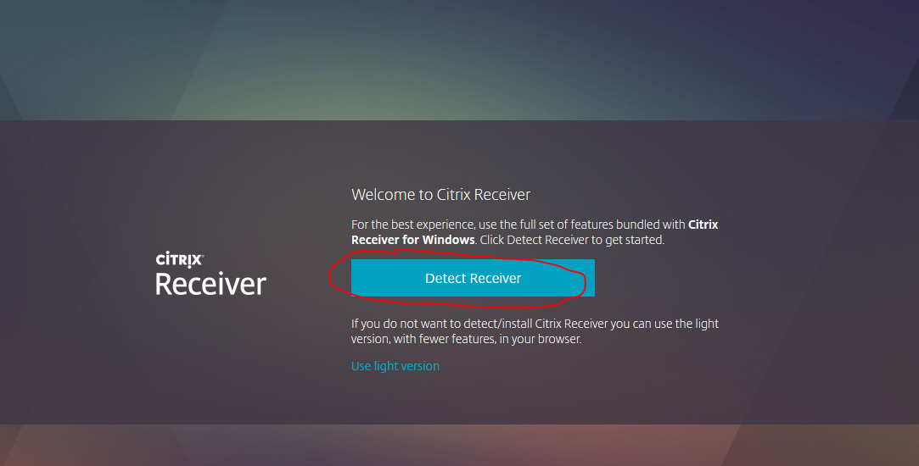

BPM Login Error - ‘The user is not authorized to work in Budget System’
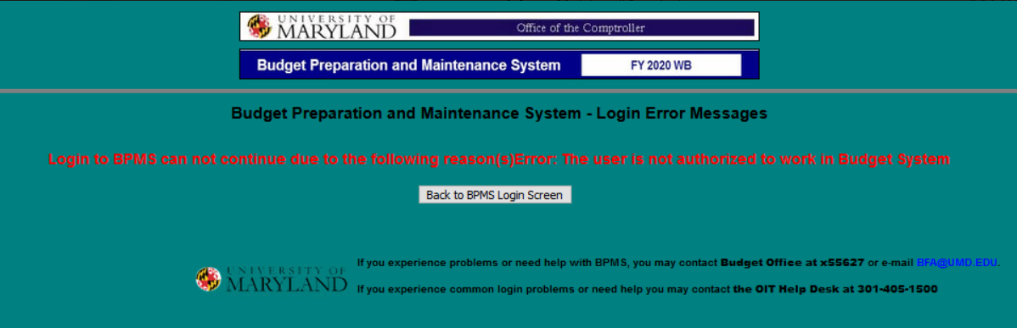
If the user has been granted access to BPM through BFA and still is encountering this error, follow the below steps to troubleshoot:

Logon to the Citrix application:

Go to: https://vw.umd.edu/ (same link on the BFA and Finance websites labeled as ‘BPM System’) 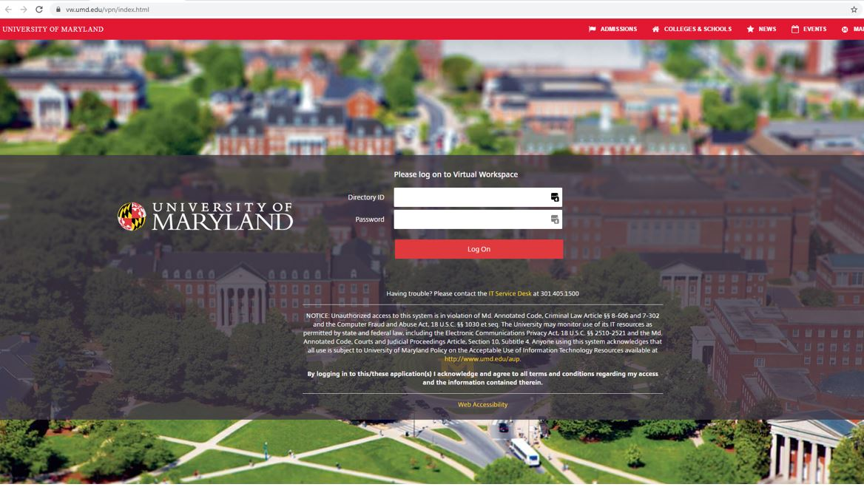

CAS- Central Authentication Service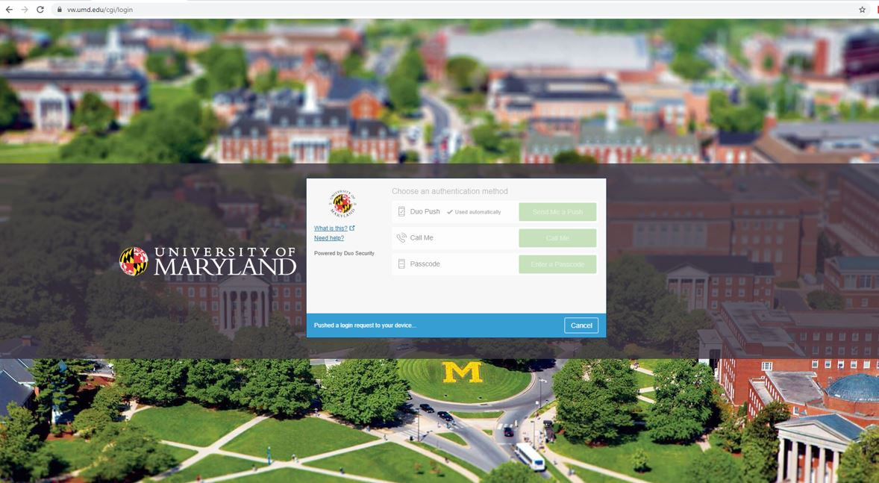

Click on ‘Detect Receiver’
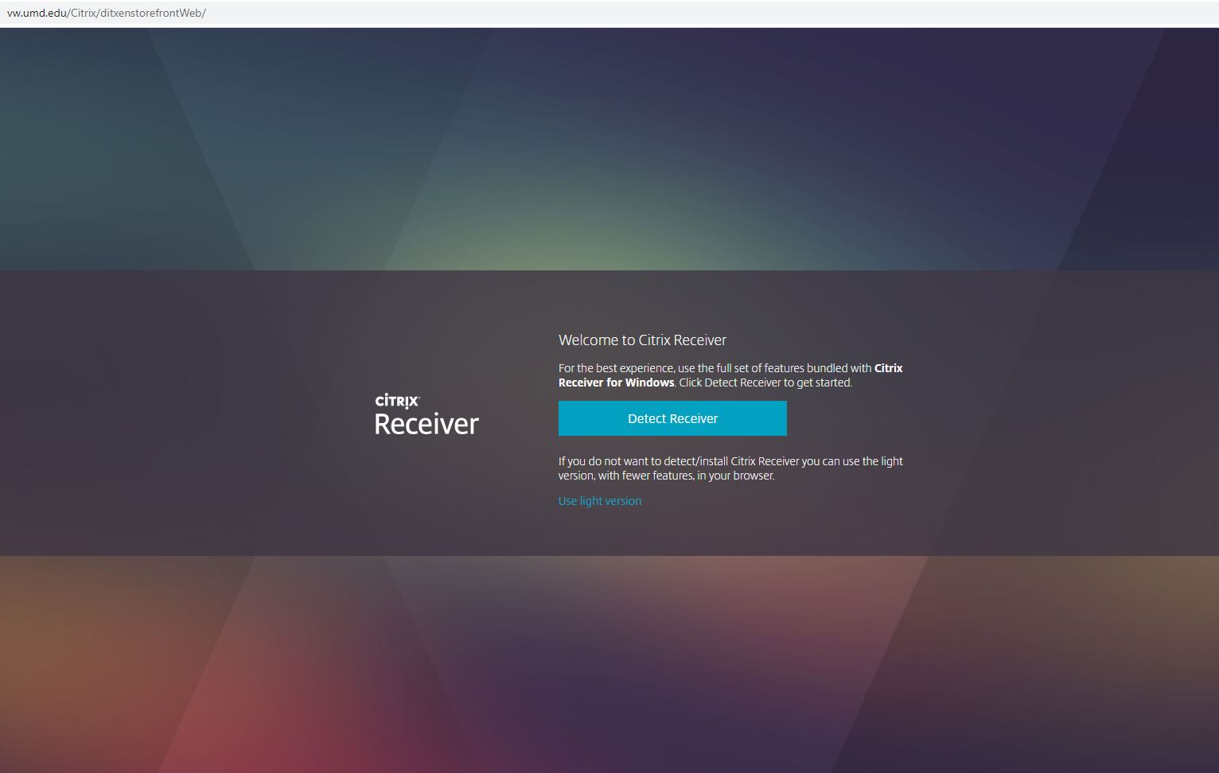

Click on APPS tile –
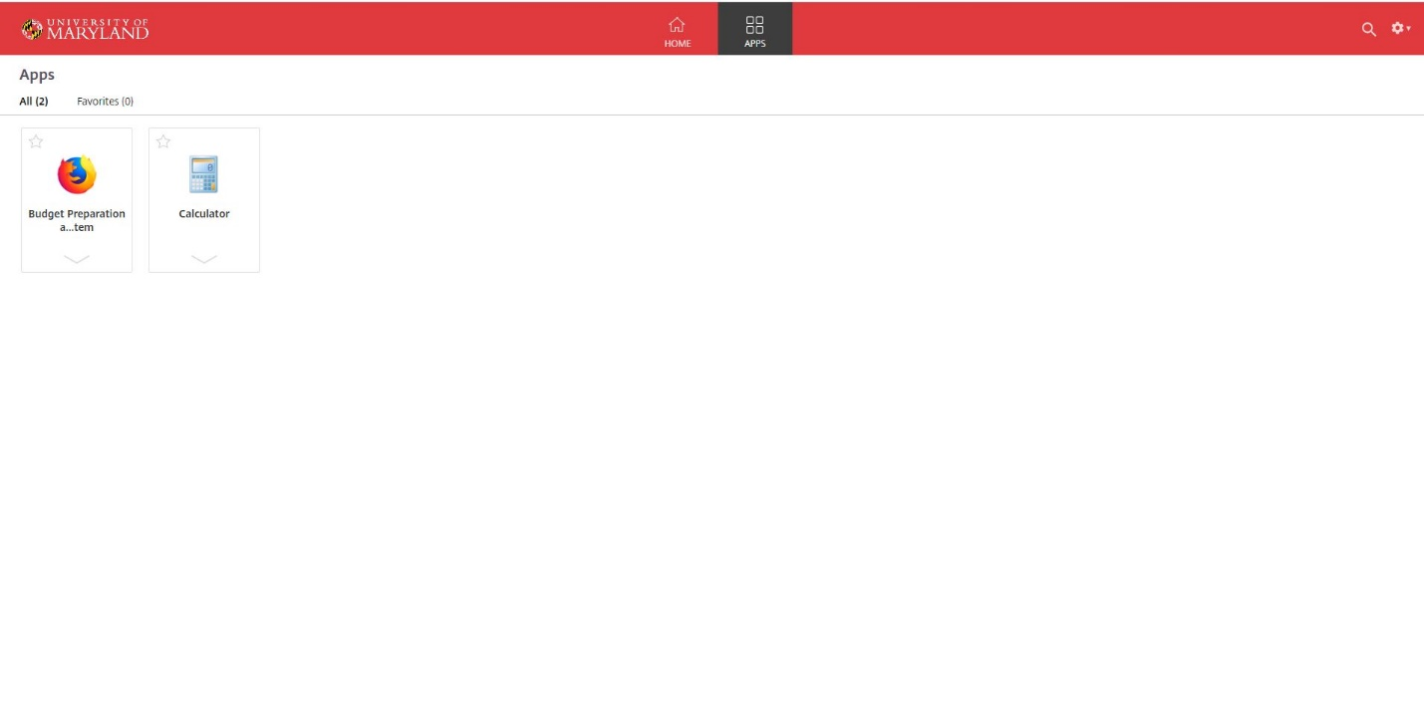

Click on Budget Preparation and Maintenance System

Enter Directory ID and Password
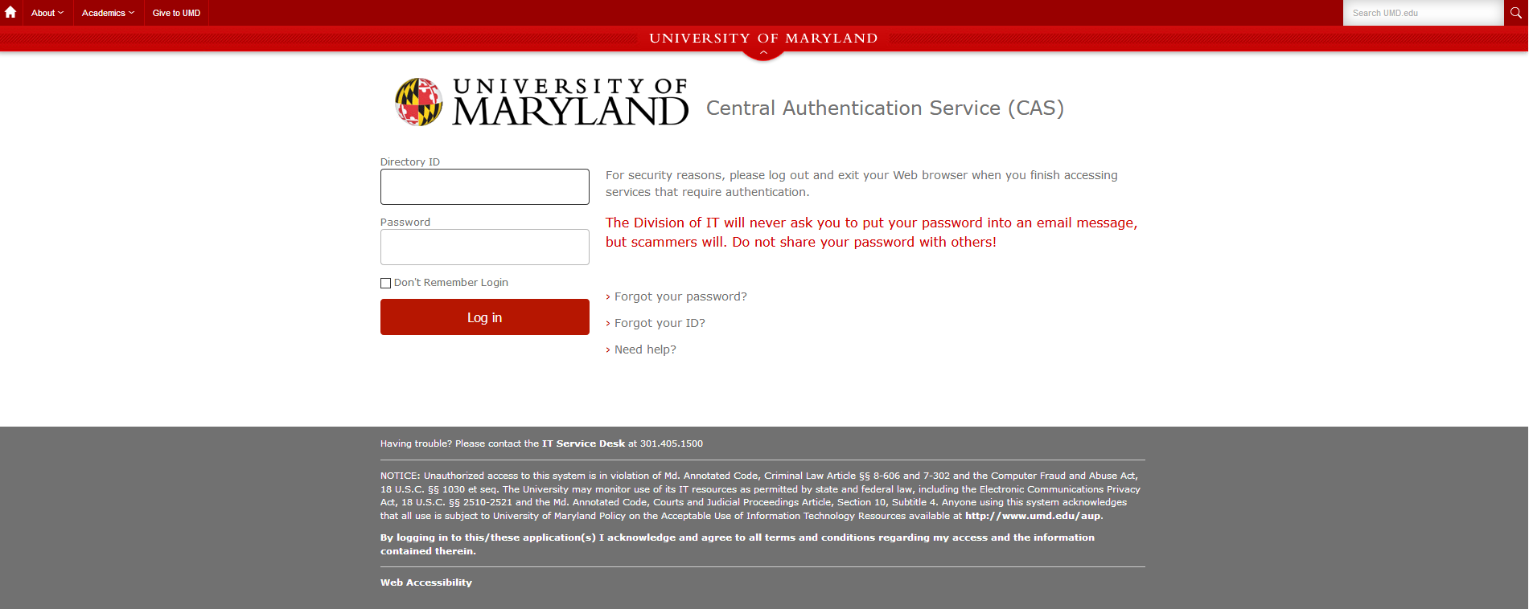

CAS- Central Authentication Service
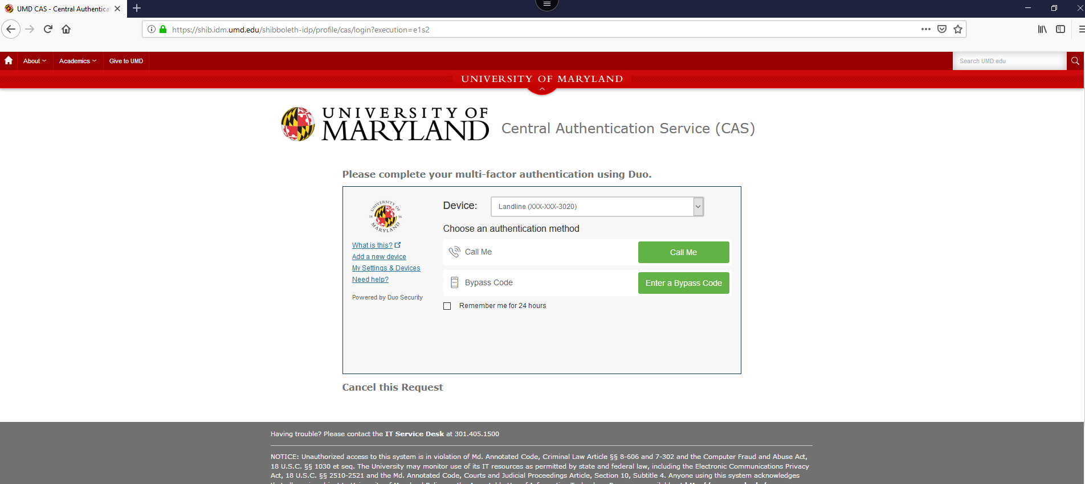

Clear the browser cookies and site data (the below example is in the Firefox browser)
Click the browser menu in the top right-hand side of the screen -> Click ‘Options’
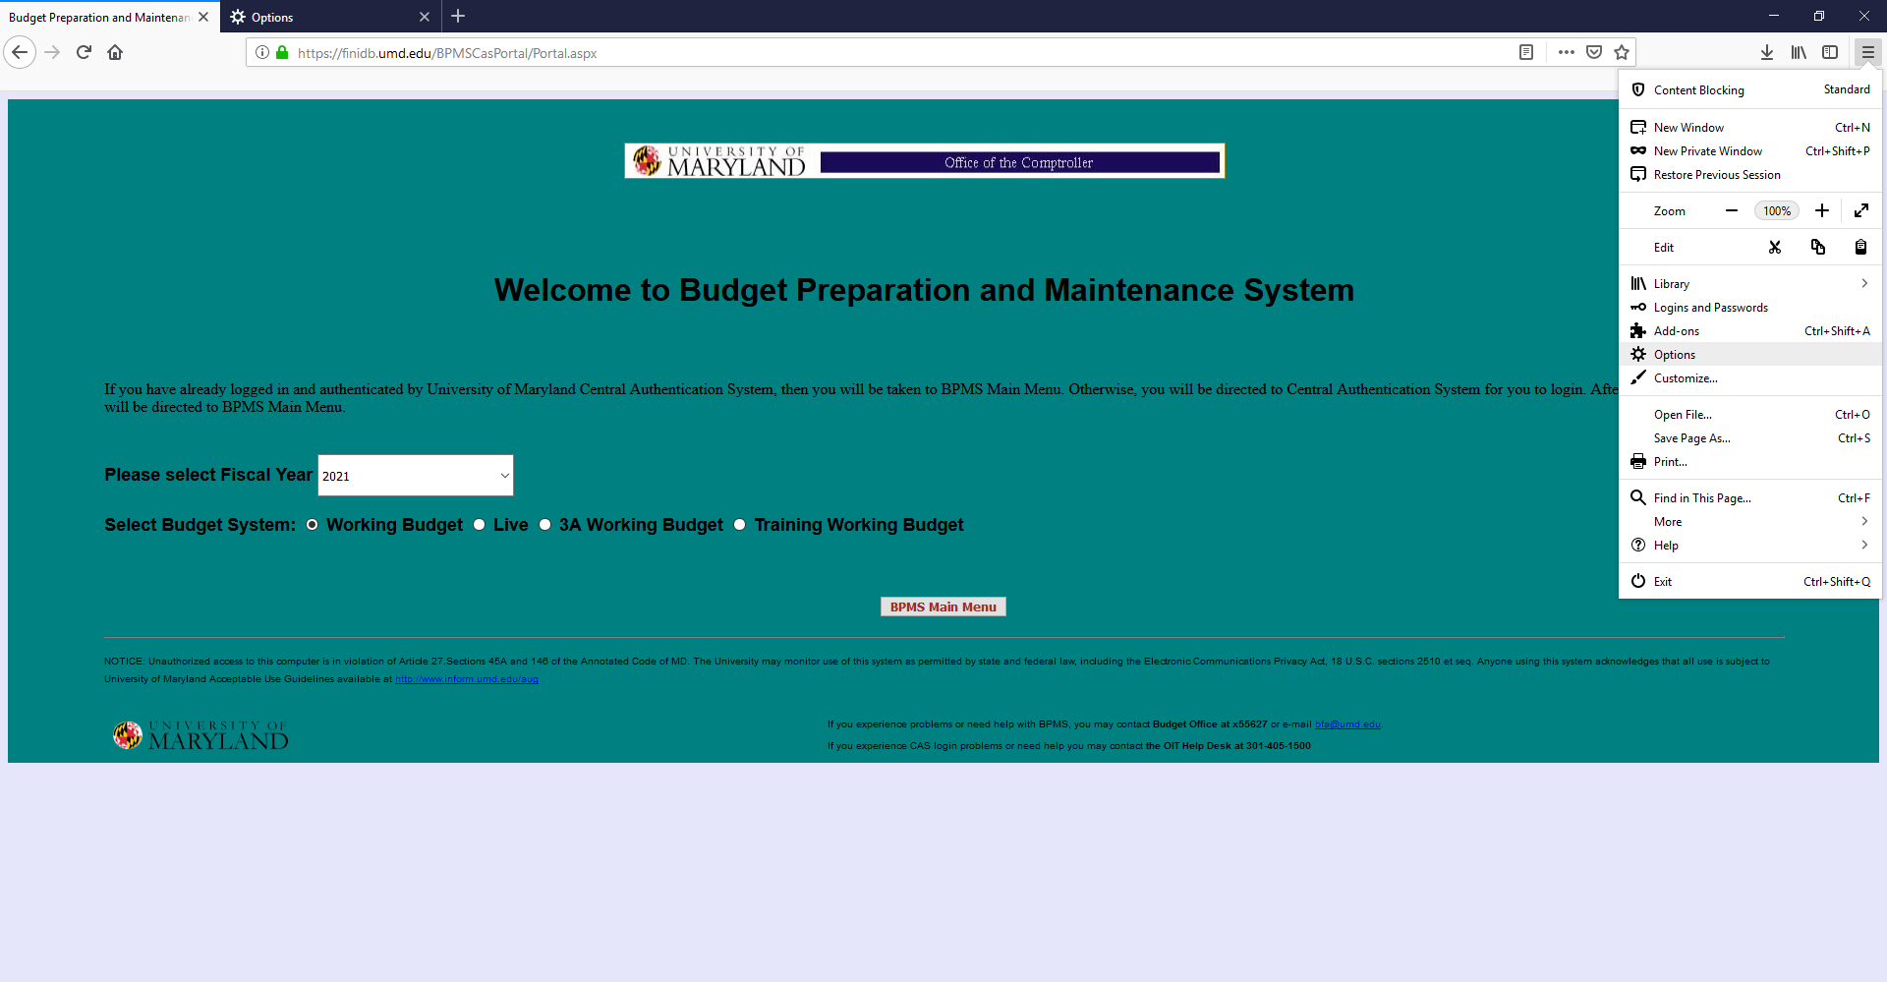
Click ‘Privacy & Security’ on the left-hand side of the screen
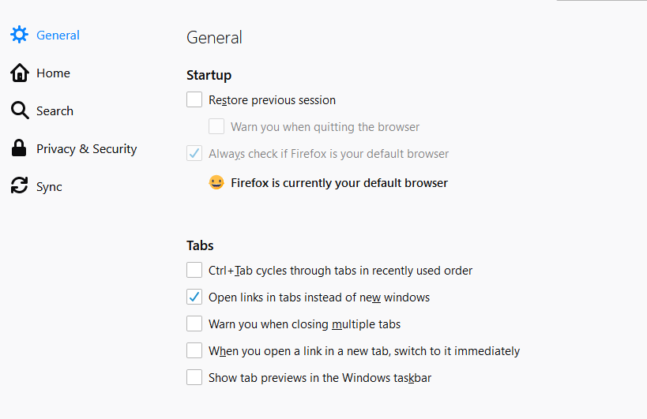

Scroll down and locate ‘Cookies and Site Data’ -> Check the box for ‘Delete cookies and site data when Firefox is closed’ -> Click ‘Clear Data’
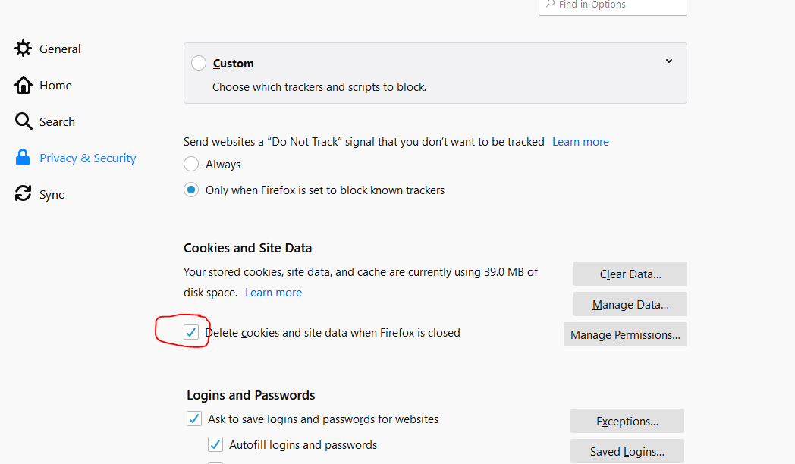

Click ‘Clear’ to confirm clearing the Cookies, Site Data, and Cashed Web Content
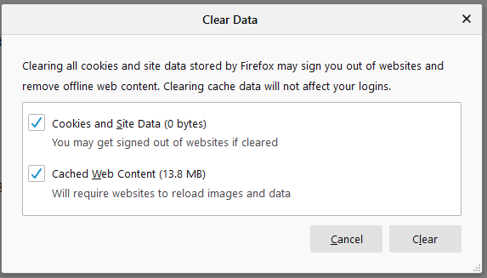

Close the ‘Options’ tab and close the BPM window. On the Virtual Workspace log off of the Citrix Receiver (Click the gear icon on the upper right-hand side of the screen and Click ‘Log Off’)
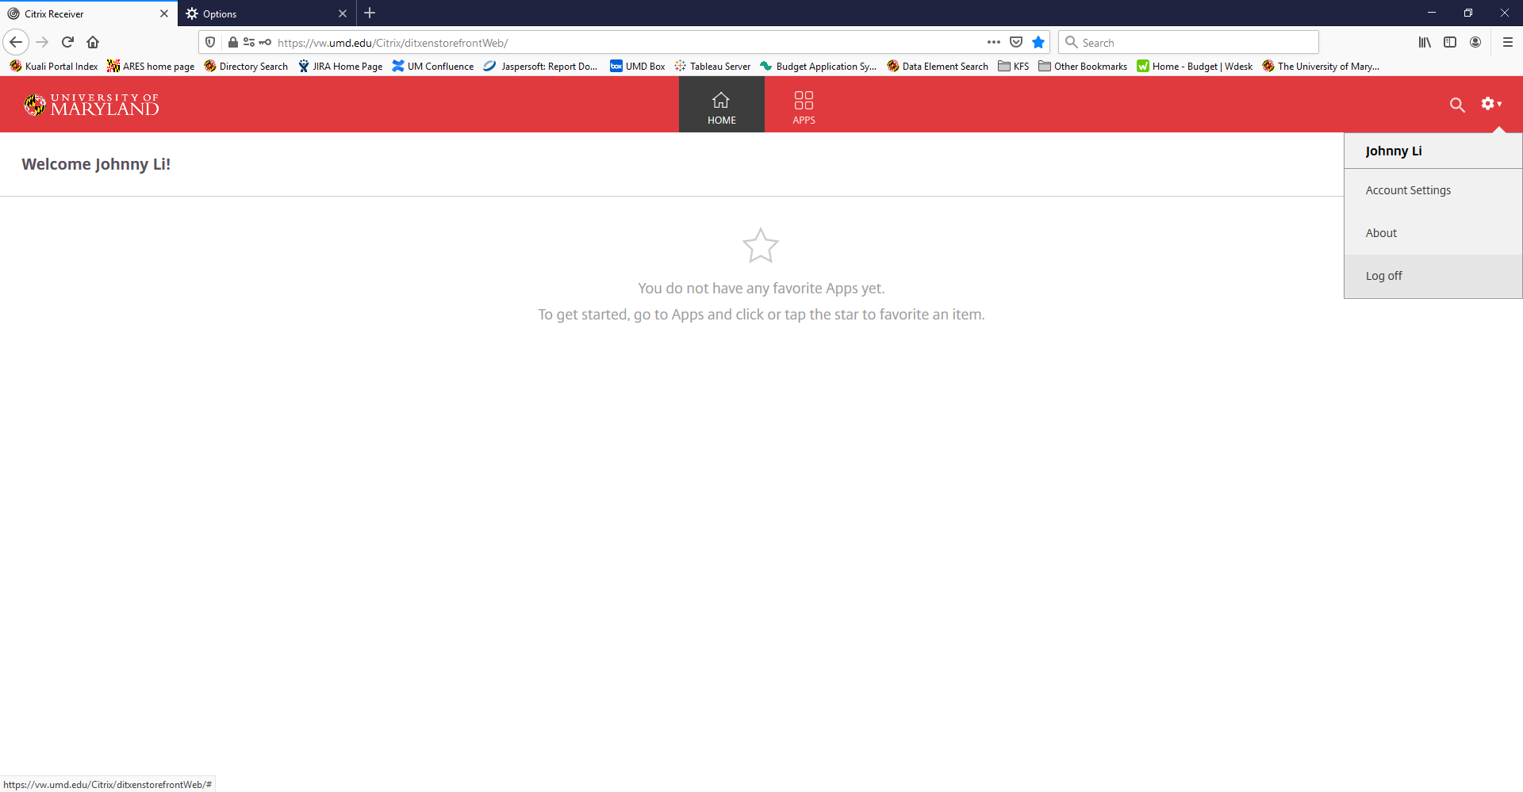

Close the browser completely -> Re-launch the browser and follow the normal login steps for BPM Citrix. If this does not resolve your error, please reach out to BFA (BFA@umd.edu) for further assistance.

Multiple Monitors Error – BPM screen off center – unable to make user selections/inputs

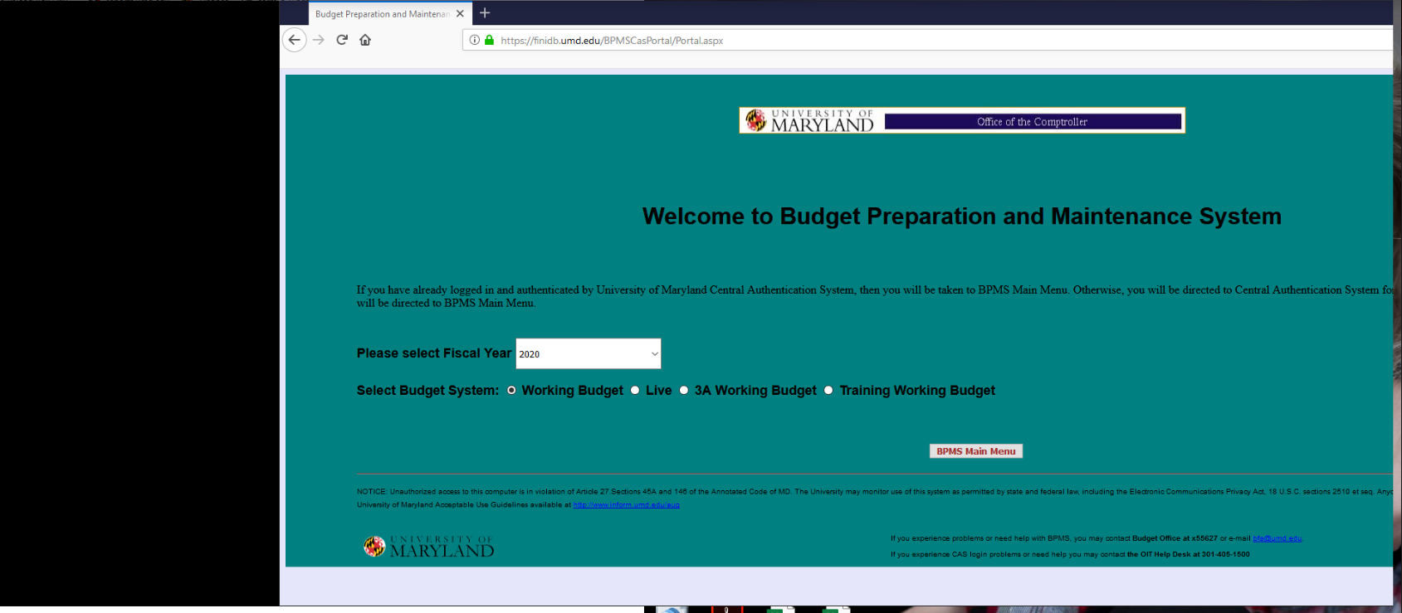
On the bottom right-hand side of the screen, Click the upward facing carrot icon
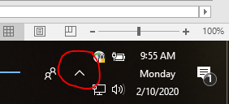
Right-click on the Citrix Workspace application -> Click ‘Advanced Preferences’
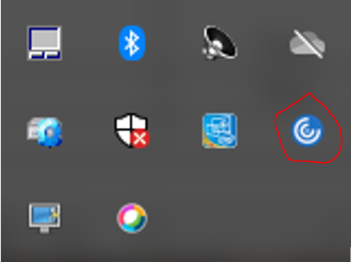

Click ‘High DPI’
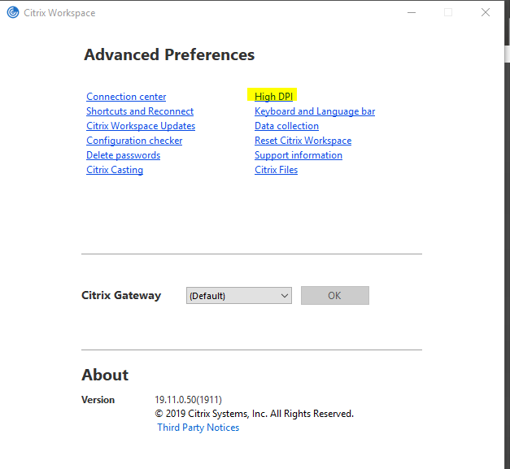
Click the radio button for ‘No, use the native resolution’ -> Click ‘Save’
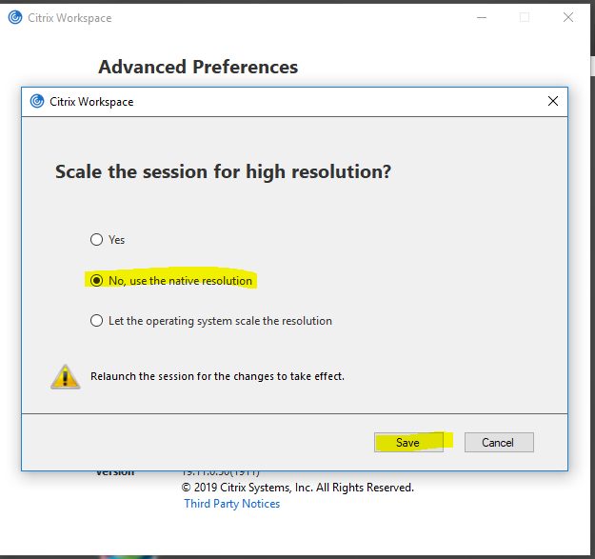

Click the ‘X’ icon on the upper right-hand side of the menu
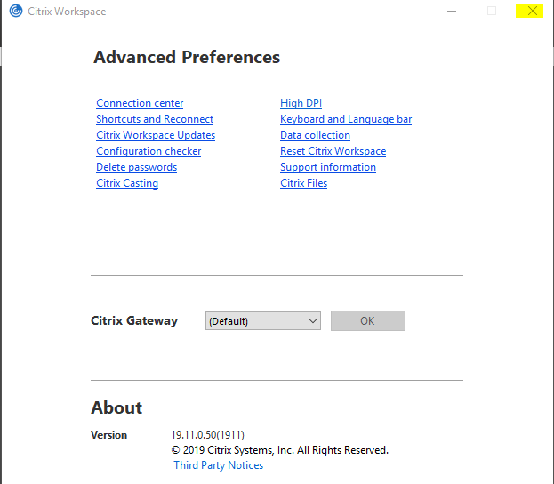
Re-login to BPM through Citrix, the screen misalignment should now be resolved

Alternate Login – Citrix Workspace App (MUST HAVE CITRIX RECEIVER INSTALLED & DUO MOBILE APP)

On the bottom right-hand search menu of your desktop type ‘Citrix’ -> Double-Click the icon for ‘Citrix Workspace’
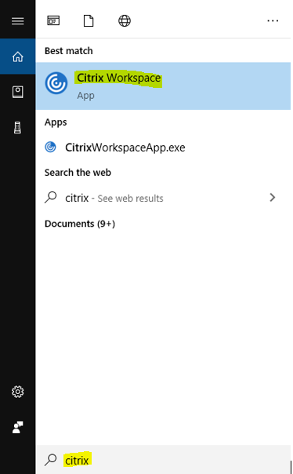
In the ‘Add Account’ screen type in ‘vw.umd.edu/’ -> Check the box for ‘Do not show this window automatically at sign-in’ -> Click ‘Add’
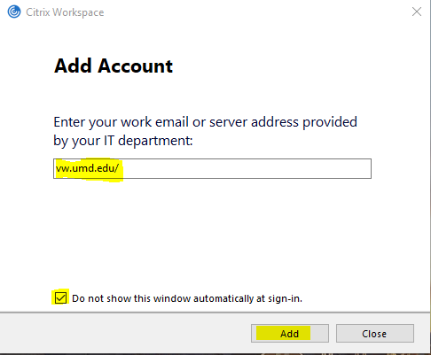
Enter your University email address (include @umd.edu) and password -> Go to your Duo mobile app and approve the CAS login request
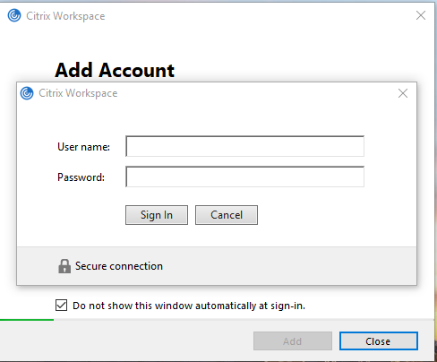
Click on APPS tile –

Click on Budget Preparation and Maintenance System

Enter Directory ID and Password

CAS- Central Authentication Service

BPMS Main Menu
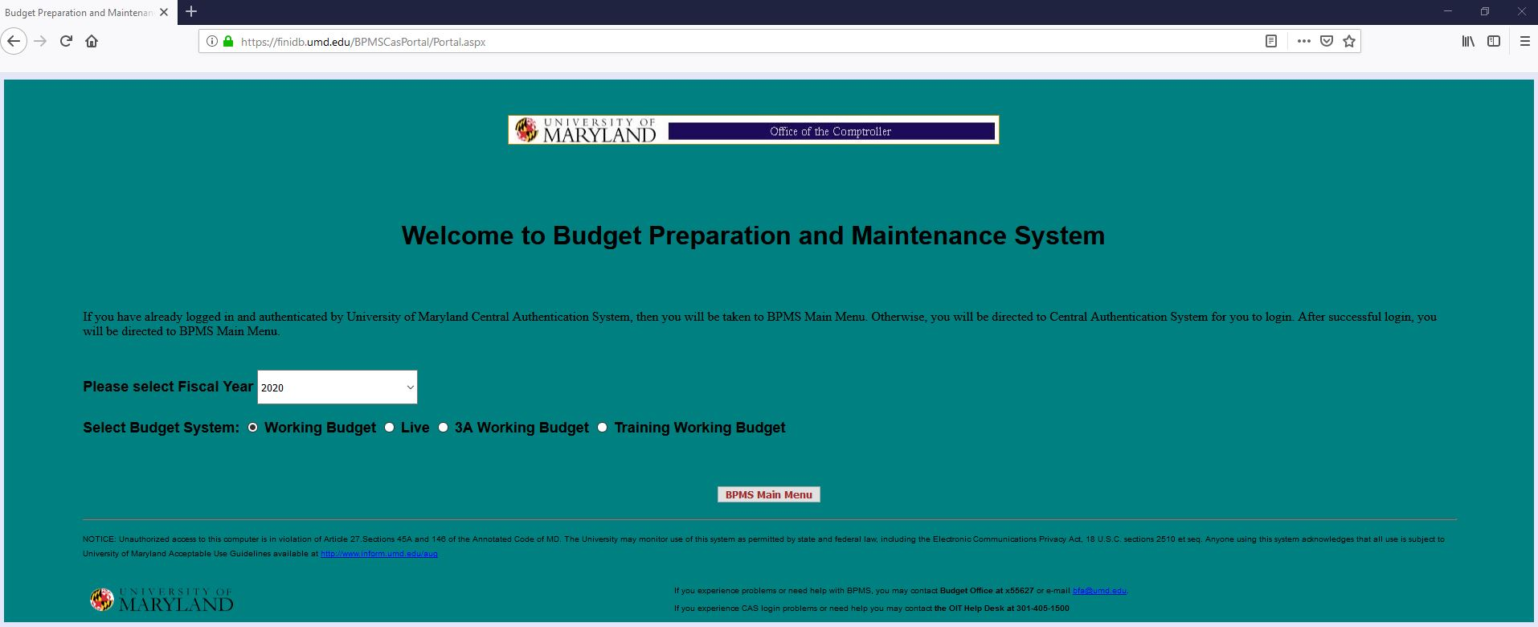

When finished using BPM, please exit the application by Clicking the ‘Exit’ Button and log off of Citrix by Clicking the ‘Log off’ button located under the gear icon in the upper right-hand corner of Citrix

BPM Time-Out Error – ‘Server Error in ‘/’ Application’

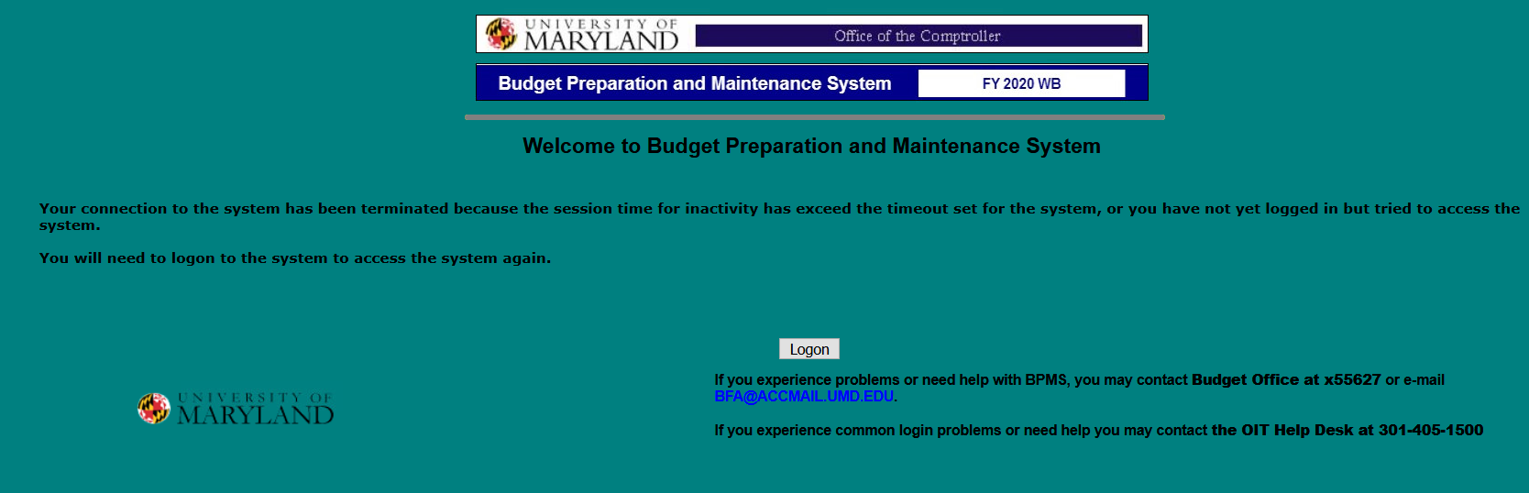
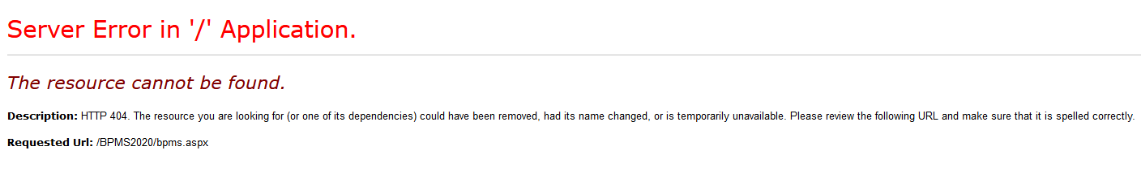
Click the second ‘X’ at the top right-hand side of the page
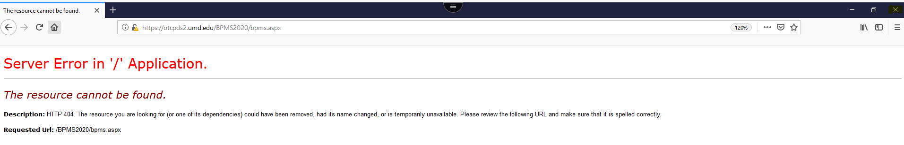
Re-launch the BPM Application from the apps menu
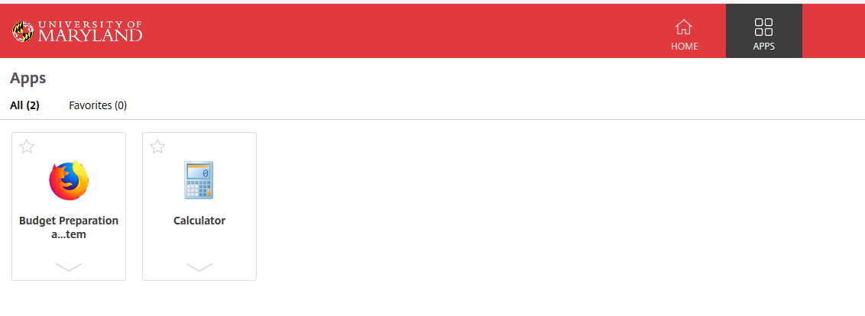

How to expand the BPM window

Click the second box icon on the upper right-hand side of the screen
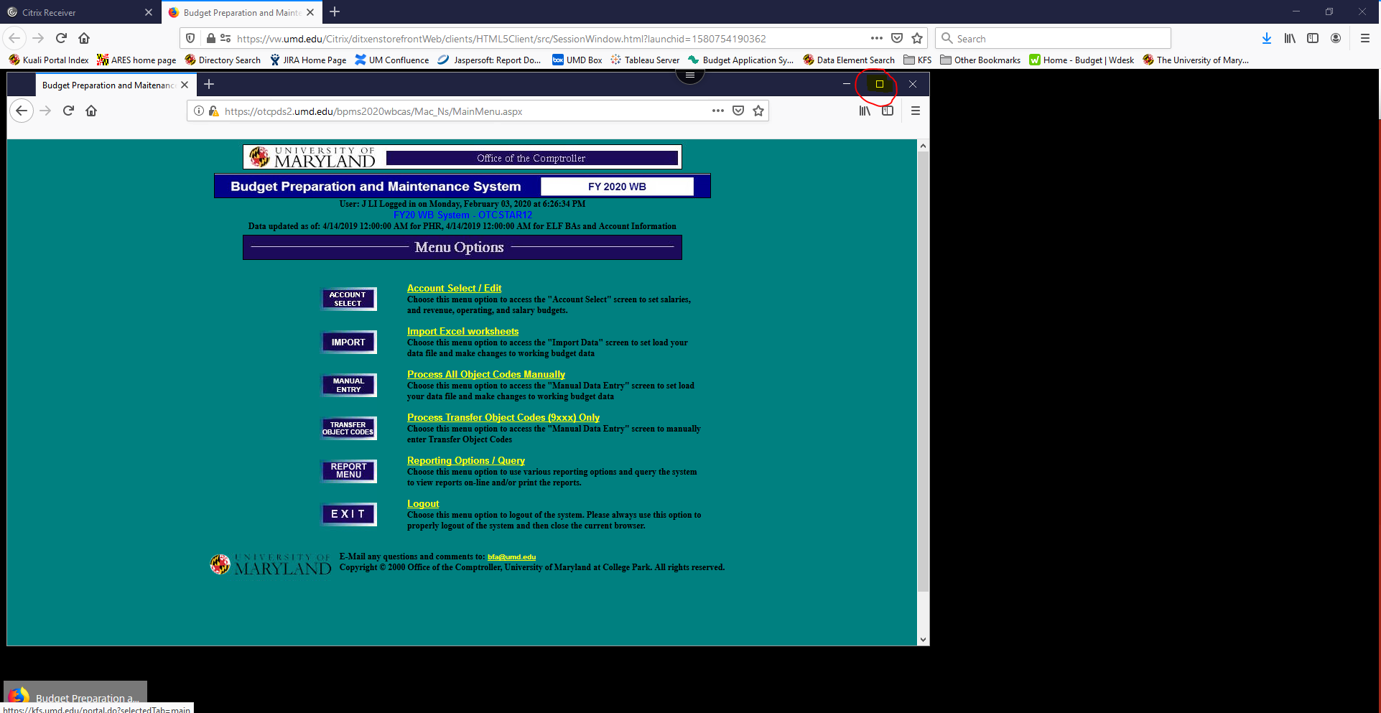

Saving/Viewing Reports:

Viewing Reports
Click ‘Print Report’ -> Select ‘HTML Format – Report viewed as a Web Page’ for the format -> Click ‘View Report’ -> the report will launch into a new screen where it can be viewed, saved, and printed from the browser (Citrix Receiver needs to be installed for save and print options)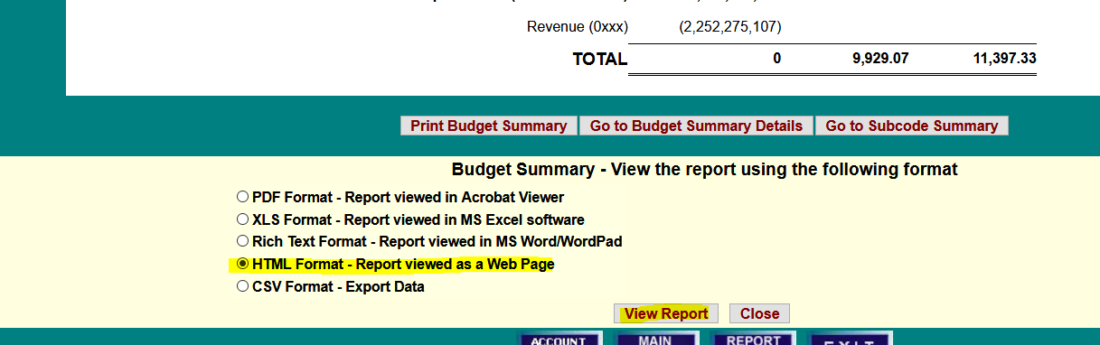

In the upper right-hand side of the screen, Click the Menu icon -> Click Print
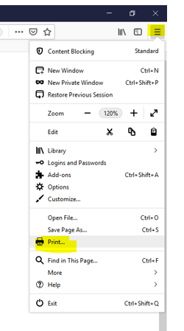

Click ‘Print’ -> Select an option for ‘Name’ (usually PDF or to an installed printer) -> Click ‘OK’ -> Locate a desired location on your ‘Local Disk (C: on directory ID)’ to save the file to -> Click ‘Save’
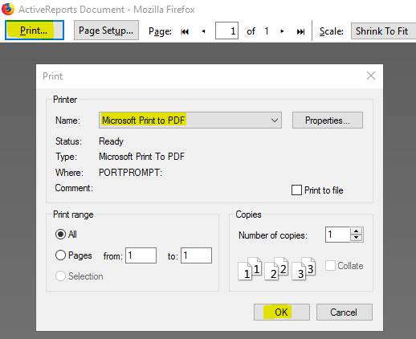
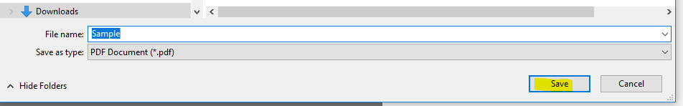
Once the file is saved you can navigate to the folder on your computer and open it for viewing

Saving Reports – (MUST HAVE CITRIX RECEIVER INSTALLED)
Click ‘Print Report’ -> Select the desired format -> Click ‘View Report’ -> Click the radio button for ‘Save File’ -> Click ‘OK’ 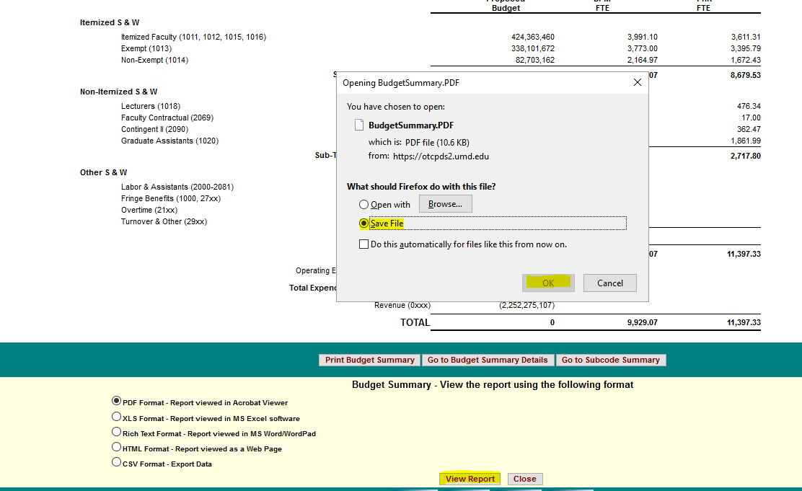

If prompted for ‘An online application is attempting to access files on your computer.’ Check the box for ‘Do not ask me again for this site’, then Click ‘Permit all access’
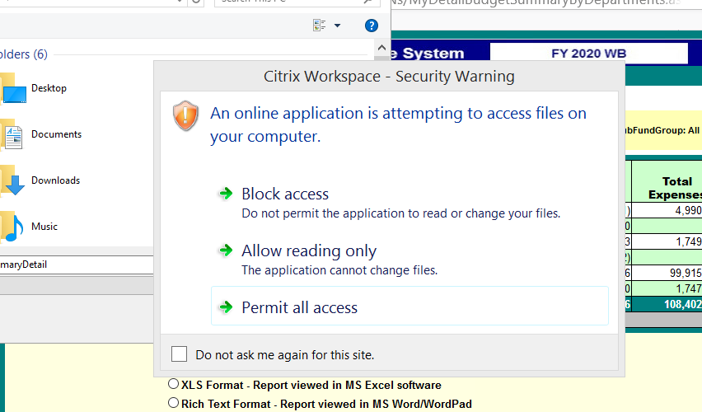
Navigate to the folder that most closely resembles your directory ID or computer name i.e. ‘C: on directory ID johnnyli’

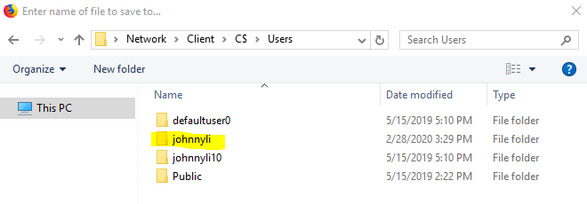

At this point you will see the common folders on your local computer where the report can be saved. Some areas users typically save files are the ‘Desktop’, ‘Documents’, and ‘Downloads’
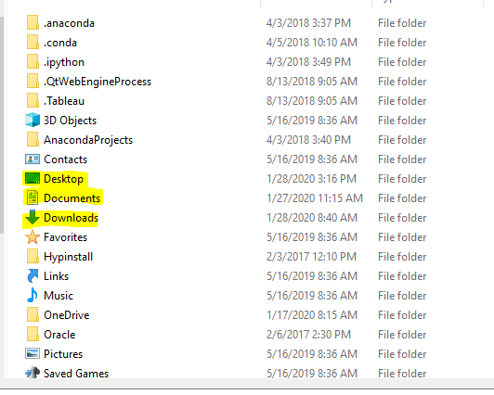
Once the file is saved you can navigate to the folder on your computer and open it for viewing/printing

PDF File Format Not Saving

If you save a PDF report to a local drive and are unable to locate it in the destination, follow the following steps:
Select ‘PDF Format’ -> Click ‘View Report’ -> Select ‘Save File’ -> Click ‘OK’
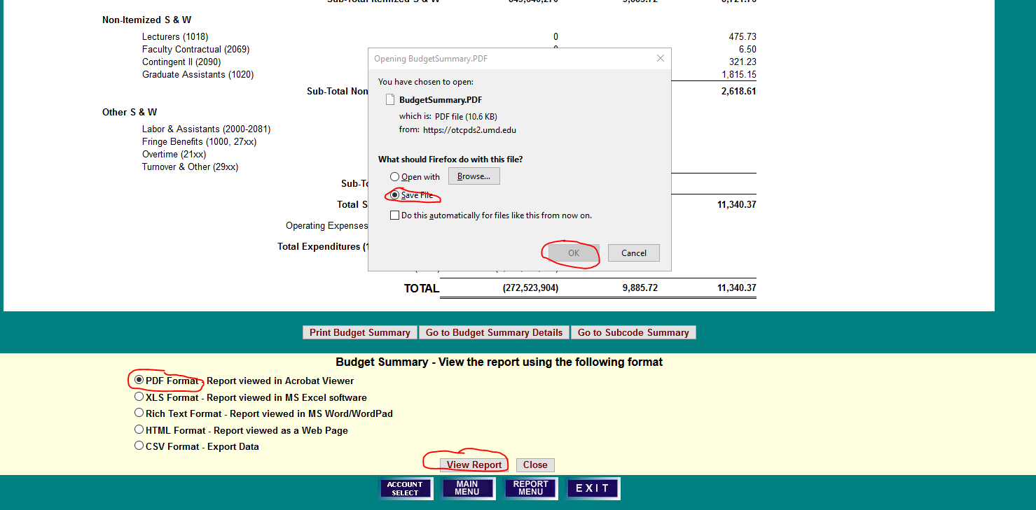

For ‘Save as type’ Click the downward facing carrot -> Select ‘All Files’ -> Click ‘Save’
The file should now be present in the selected destination folder
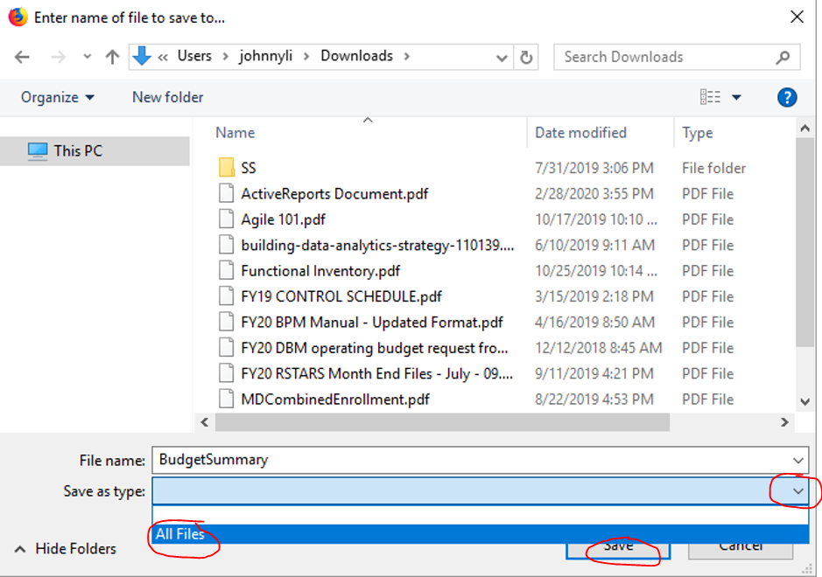

Citrix Workspace Will Not Close

When the Citrix Workspace App (as shown below) will not remain closed after Clicking ‘Closed’
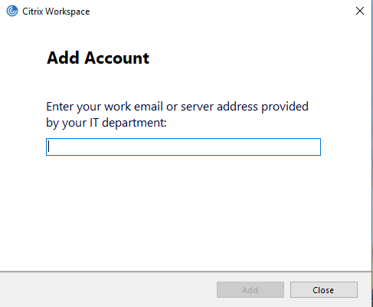

On the bottom right-hand side of your screen Click the upward facing carrot icon
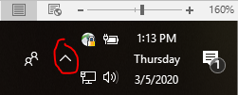

Right-Click on the Citrix Icon -> Click ‘Exit’ -> the Citrix Workspace application should now remain closed
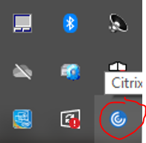

Blocked Page Error

When within BPM, the application is running in a Virtual Workspace. You will not be able to access other websites within the same browser. If you need to access other websites, open a new browser in a separate window.
