BPM System Citrix Workspace Connection:

To All BPM Users:
The Budget Preparation and Maintenance System (BPM) will implement the Citrix Workspace connection beginning on 01/27/20. This additional login layer is necessary to properly protect the BPM System from potential security threats. Both layers of login will be using the University of Maryland’s Central Administration Service (CAS), which requires multi-factor authentication (MFA).
To accommodate this change, the BPM links on the BFA website (http://otcads.umd.edu/bfa/) and Finance website (https://finance.umd.edu/) will be updated to direct through the new login portal. Follow the below steps for the login process:
Go to: https://vw.umd.edu/ (same link on the BFA and Finance websites labeled as ‘BPM System’) 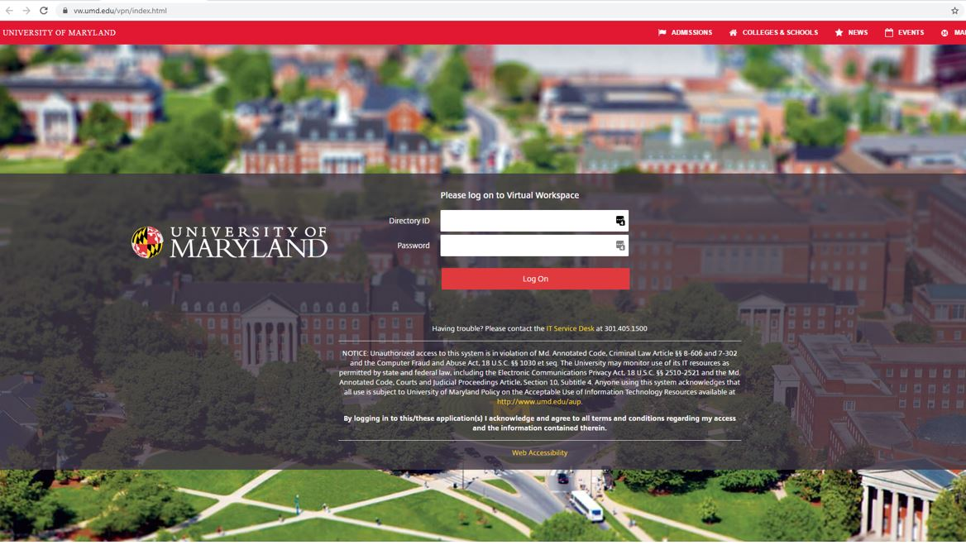

CAS- Central Authentication Service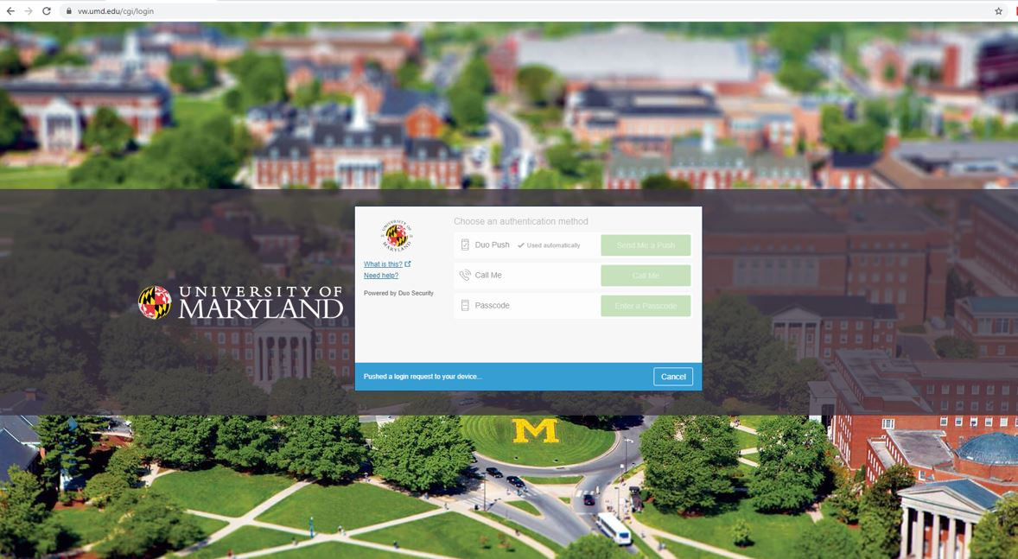

Click on ‘Detect Receiver’ (when prompted to open link for the Citrix Receiver, Click ‘Open’)
(If you have not installed the Citrix Receiver before, refer to ‘Note 1’ at the bottom of this document for installation instructions before continuing)
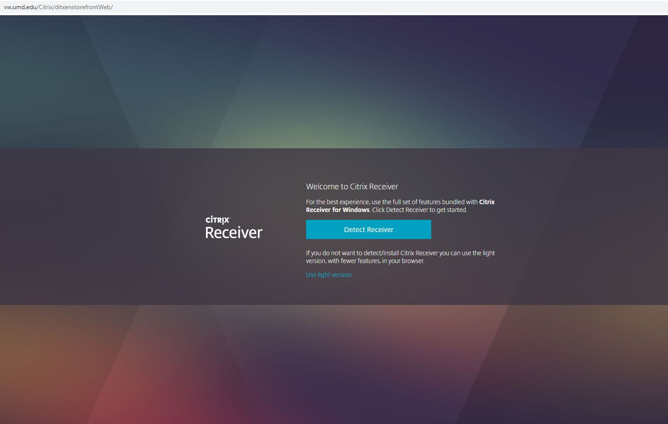

Click on APPS tile –
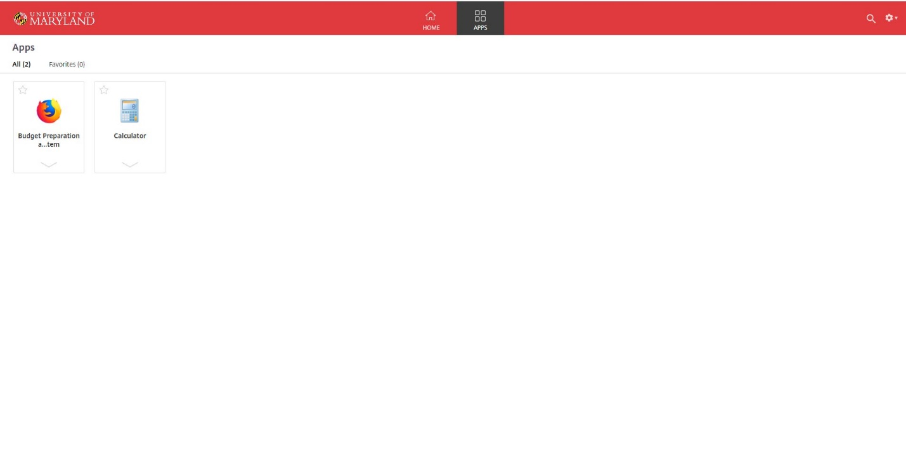

Click on Budget Preparation and Maintenance System

Enter Directory ID and Password
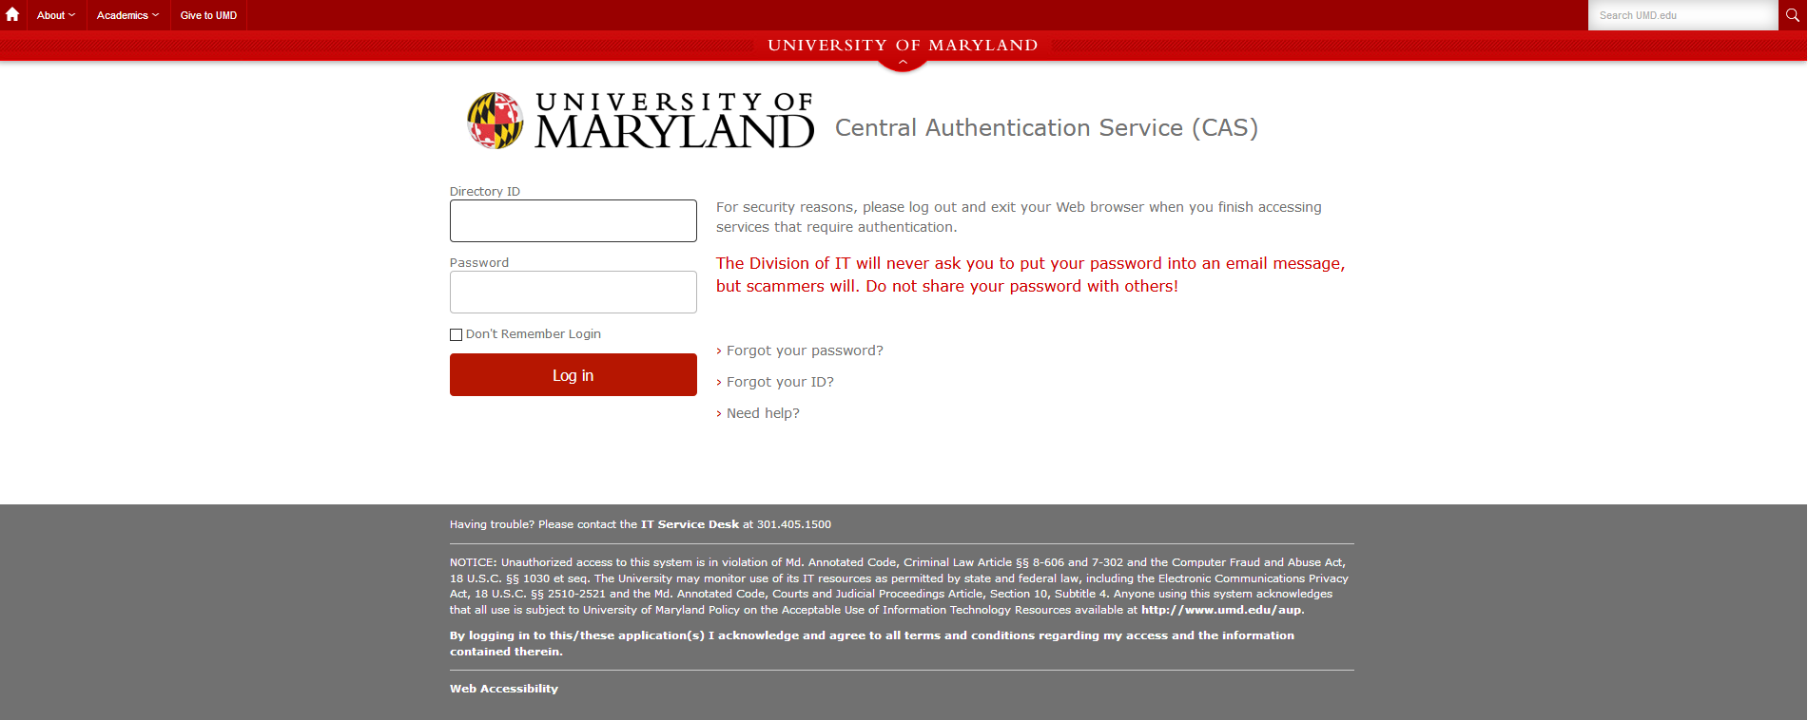

CAS- Central Authentication Service
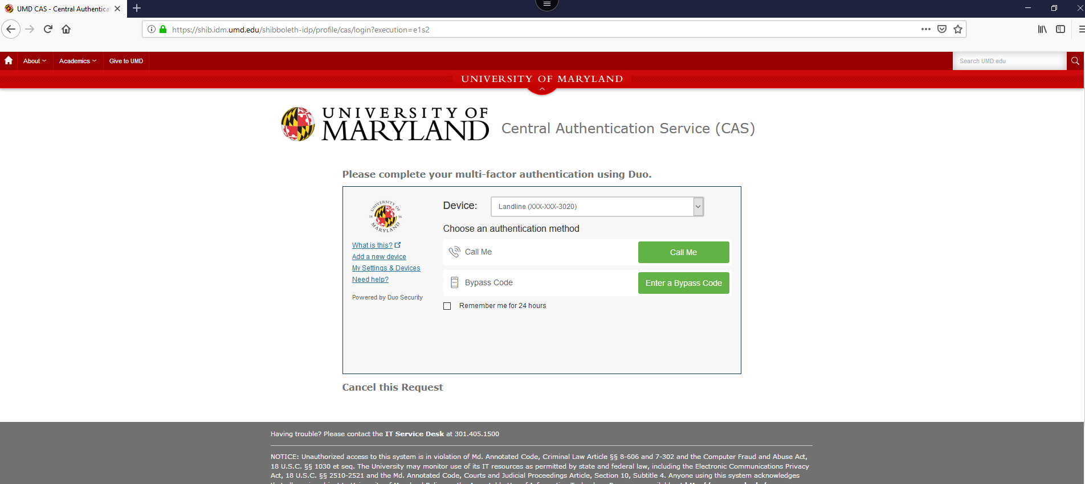

BPMS Main Menu
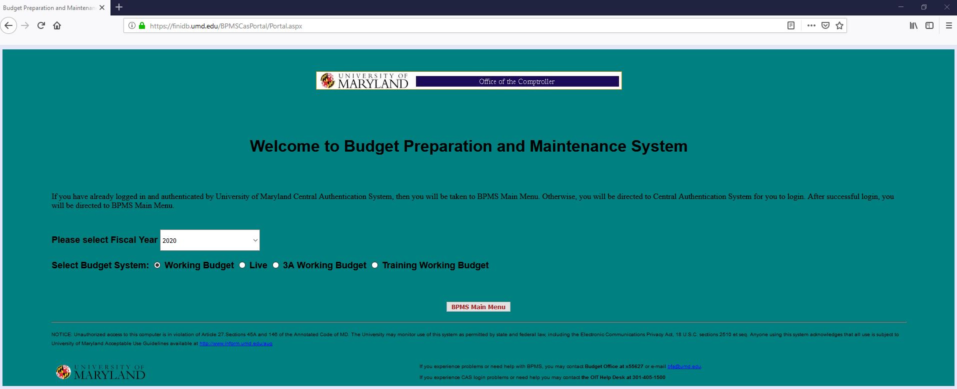

When finished using BPM, please exit the application by Clicking the ‘Exit’ Button and log off of Citrix by Clicking the ‘Log off’ button located under the gear icon in the upper right-hand corner of Citrix
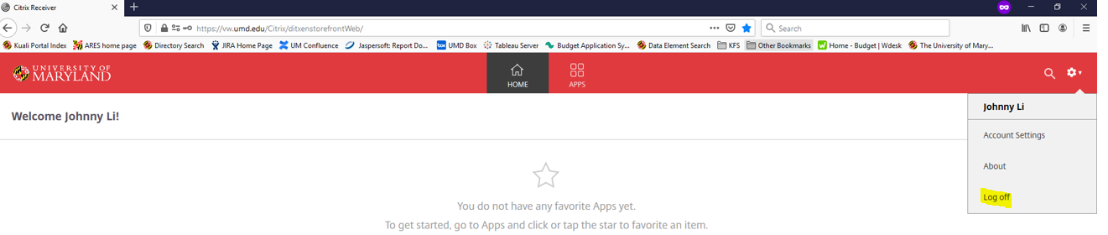
If you have bookmarked the BPM site, you may need to update the link for the new login screen. If you have questions, please feel free to email the Budget Office at BFA@umd.edu or call at (301) 405-5627

Note 1: Installing Citrix Receiver –
Go to: https://vw.umd.edu/

CAS- Central Authentication Service

Click on ‘Detect Receiver’

If you have not already downloaded the Citrix Receiver, Check the box for ‘I agree with the Citrix license agreement’ and Click ‘Download’ 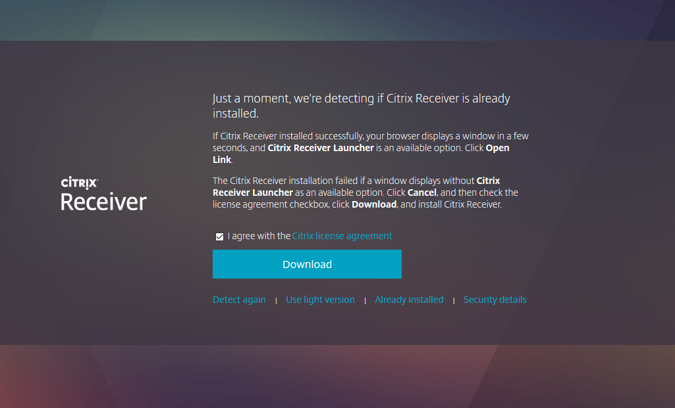

Click ‘Save File’ 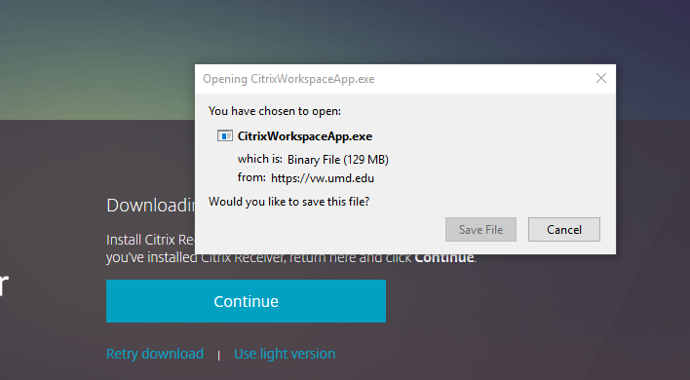

Locate the downloaded file on your computer (typically saved on your Downloads, Desktop, or Documents folder) -> Double-Click to launch the application -> When prompted to allow the Citrix Workspace application to make changes to your computer Click ‘Yes’
(If you receive an error that you do not have admistrative rights to install applications on your machine, please contact your computer helpdesk personnel to grant you access to install the application)
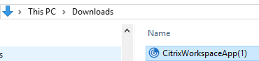

Click ‘Start’
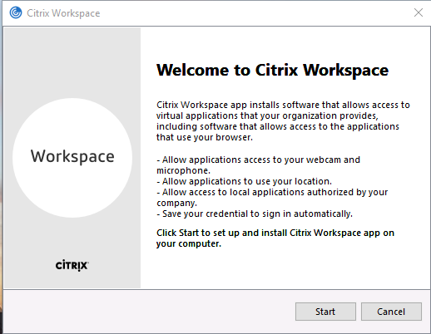

Click ‘I accept the license agreement’ and Click ‘Next’
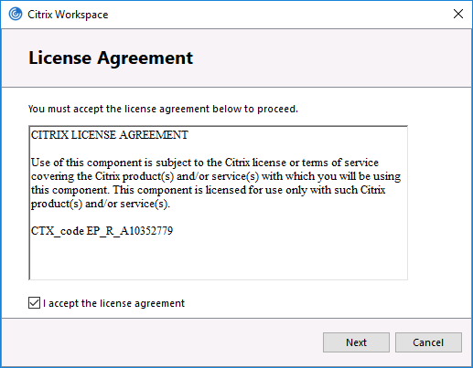
Click ‘Install’
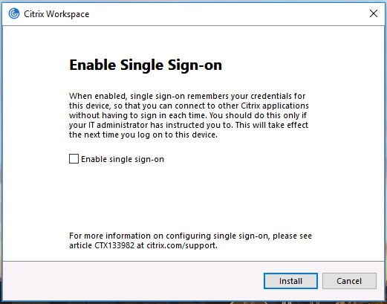

Click ‘Finish’ and Restart your computer
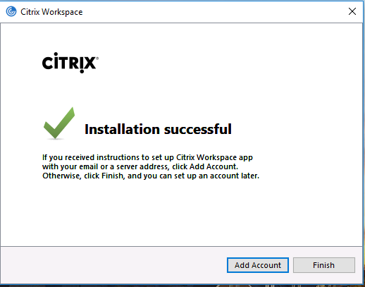
If the below screen is encountered, Click ‘Close’. The Citrix Receiver Workspace has now been installed. Proceed with the login instructions at the beginning of this document.
